Amazon Competitor Database

CSE 581

**Arva Kagdi**

**852998333**

2019

**ABSTRACT**

**In this project we have designed, created and tested an Amazon Competitor Database which is a clone for Amazon online shopping. This database stores all the necessary information such as customers details, orders created by customers, return requests, shipping and suppliers’ information, all the products available etc. We develop an Entity – Relationship diagram that contains all the information on entities created. We populate the database and obtain business reports, we check security as well as better performance, which is achieved by assigning passwords, encryptions.**

**Database Design:**

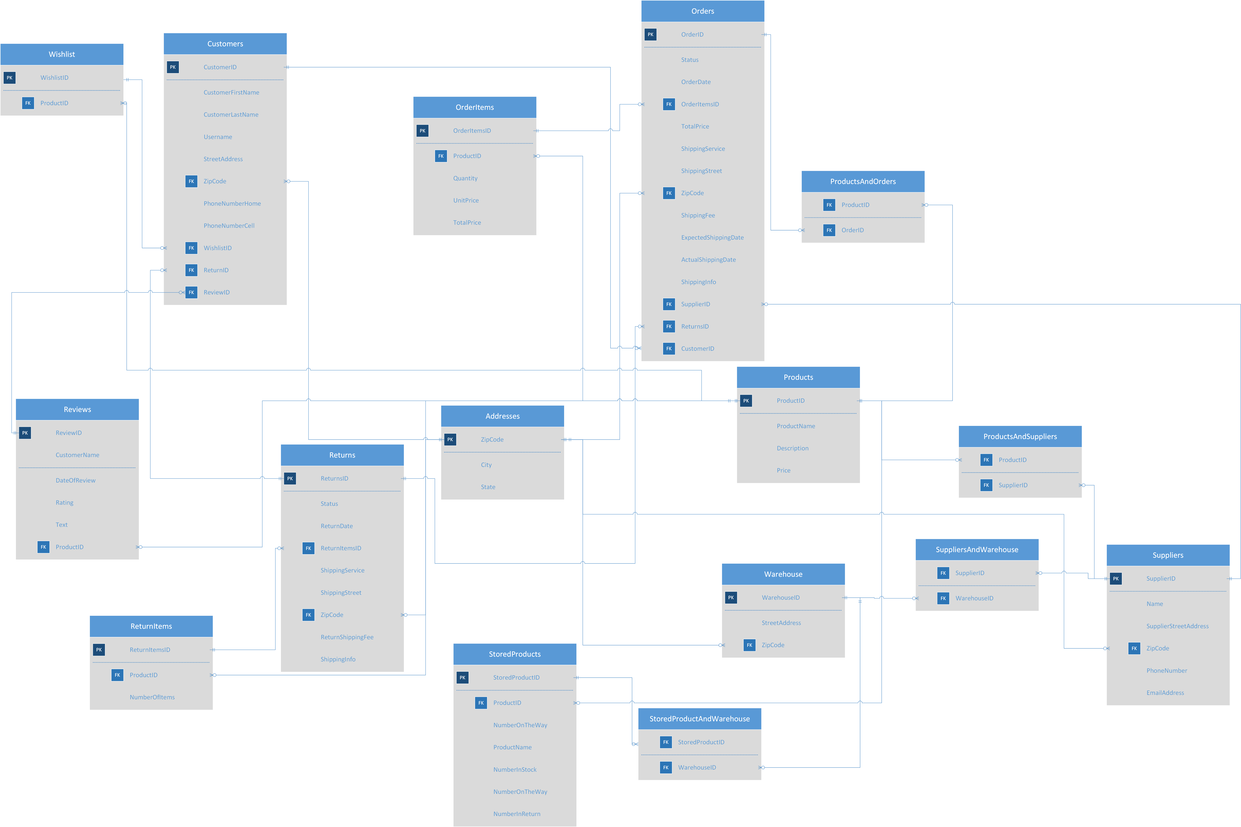

Above is the ER diagram for Amazon Competitor which is reduced to the 3NF. We have in total 16 tables. Let’s discuss each in detail:

***Orders:***

Order table is the main central element for our database as it contains all the details of each order placed and is connected to all other tables in some way. First column OrderID which is the primary key and cannot be null. It is a unique ID for all orders. Status tells us if the order is ready to ship or is already shipped, delivered or if there is a return requested for the order. It is of datatype ‘varchar’. OrderDate shows the date when the order was placed. OrderItemID is the foreign key to the table that contains items details of the order. The relation between the tables is one to many as one order can have multiple products. TotalPrice is the cumulative price for the entire order with datatype ‘money’ and cannot be null. ShippingService gives details on carrier service delivering the item. ShippingStreet gives address whereas ExpectedShippingDate is the estimated shipping date that is provided to the customer while placing the order with ‘datetime’ datatype and this value cannot be null. ActualShippingDate is updated when the product is shipped so this value can be null by default and updated when required. ShippingInfo can vary depending on carriers and suppliers and gives updates on the shipment. SupplierID,ReturnsID and CustomerIDs are foreign key to the table with one to many relationships. Orders and Products has many to many relationships as one product can be in many orders and one order can have multiple products and hence, we have a linking table to connect both the tables. ReturnsID is by default null and is created only when a return is requested. Shipping info can also be null.

***Customers:***

Customer table gives us details about all the customers associated with Amazon. CustomerID is a primary unique key that identifies each customer. We have all customer details in CustomerFirstName, CustomerLastName, username that a user creates while making an account and street address of the customer. ZipCode is a foreign key that stores city and state from the zip code entered. We also have phone numbers of home and cell. WishlistID, ReturnID and ReviewID are foreign key to customer table. Wishlist is created when a customer saves a product for ordering later. ReturnID is generated when a customer wants to return a product. Also, customer can give reviews of the product they have bought. Customer is also a foreign key to Orders with a one to many relationship as one order can be of only one customer, however one customer can have multiple orders. All the customer details are passed to order table to proceed with the order.

***OrderItems:***

OrderItems contains details on all the items included in an order. It is connected to order through OrderItemsID which is a unique primary key and cannot be null. ProductID is foreign key to this table with one to many relationship and all the details of the product that the customer wants is obtained through product table. OrderItems table contains quantity of every product in order, unit price and total price of every individual product which it send to Order table.

***Products:***

Products table has a list of all the product available on Amazon. It has product name, description of all the products and its price.

***Suppliers:***

Suppliers table contains SupplierID which is the primary key for the table that identifies each supplier that supplies product through our platform. The table contains name of the supplier, street address, phone number and email address. It also has zipcode as the foreign key so that we can obtain city and state of the supplier. This table is connected to two linking tables named SuppliersAndWarehouse and ProductAndSuppliers as the relation between supplier and warehouse and supplier and products is many to many. One supplier can have many products and one product can have multiple suppliers. Similarly, a supplier can have his products in multiple warehouses and one warehouse can have multiple supplier’s products.

***Warehouse:***

Warehouse is where all the products are stored. There are multiple warehouses across US where the products are stored. Warehouse table contains details of all warehouses that supply products through different supplier to our platform. This table contains WarehouseID which is a primary key to the table that gives a unique ID to each warehouse. It also contains street address and zipcode which is a foreign key to Addresses table which provides with state and city of the warehouse. If multiple warehouse has the same product the originating warehouse is decided by the distance depending on the zipcode. It is foreign key to a linking table between warehouse and suppliers.

***StoredProducts:***

This table includes details on products available in every warehouse and distribution of products. StoredProductID is the primary key for the table which is a non-null value and unique for every product. ProductID is the foreign key to StoredProducts. It contains details on product name, Number of quantities of a product in stock, number of products on the way for delivery and number of products which are being returned. These quantities can be null by default as it is possible that we do not have quantity present now, or none of the items are being shipped or returned.

***Addresses:***

ZipCode is the primary key for this product and it is connected to tables like Orders, Customers, Suppliers, Warehouse. It takes the zipcode and gives the respective city and state. This table helps reduce the design to 3NF. City and state datatype are varchar and cannot be null.

***Wishlist:***

Wishlist contains details of products kept in Wishlist by the customer. WishlistID is the primary key for the table and ProductID is the foreign key which provides with the information on products for wish listing it.

***Reviews:***

Review table lets customer give reviews to the items they purchased and for other customers to view, who are willing to buy that product. It contains ReviewID as the primary key with non-null values. It also has customer name that provides the review. However, it is null by default as the customer may or may not wish to provide the name. DateOfReview provides with the date when the review was made with datetime datatype with no null values. Rating can be anywhere between 1-5. Text includes any comments customer has regarding the product. It can be left null. It also has ProductID as the foreign key with one to many relationship.

***Returns:***

Returns table is another important table that has details on all the return orders. ReturnID is the primary key. Status shows if the product is returned or not. ReturnDate is the date by when the product should be returned to the supplier. ReturnItemsID is the foreign key with one to many relationship with the table. It also has shipping service and street address details. Again, zip code is the foreign key that provides state and city. ReturnShipping fee is any amount of fee that is charged to return the item if any. It can be null. ShippingInfo gives details on the shipping progress and carrier details. ReturnID is connected as a foreign key to Customers and Orders.

***ReturnItems:***

This table contains list of the items to be returned from an order. It has ReturnItemsID as the primary key which is a unique ID for every return created. ProductID is the foreign key to the table with one to many relationship. Product details for return are obtained through ProductID.

***ProductsAndOrders:***

This is a linking table between products and orders having many to many relationship.

***ProductsAndSuppliers:***

This is a linking table between products and suppliers having many to many relationship.

***SuppliersAndWarehouse:***

This is a linking table between Suppliers and Warehouse having many to many relationship.

***StoredProductsAndWarehouse:***

This is a linking table between StoredProducts and Warehouse having many to many relationship.

***Creating Database and Tables:***

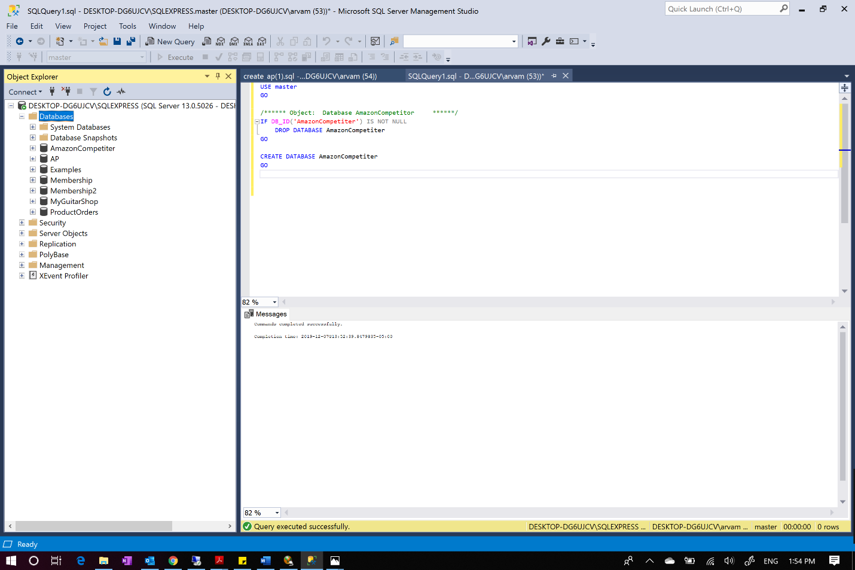

Creating a database named ‘AmazonCompetitor’ as shown above

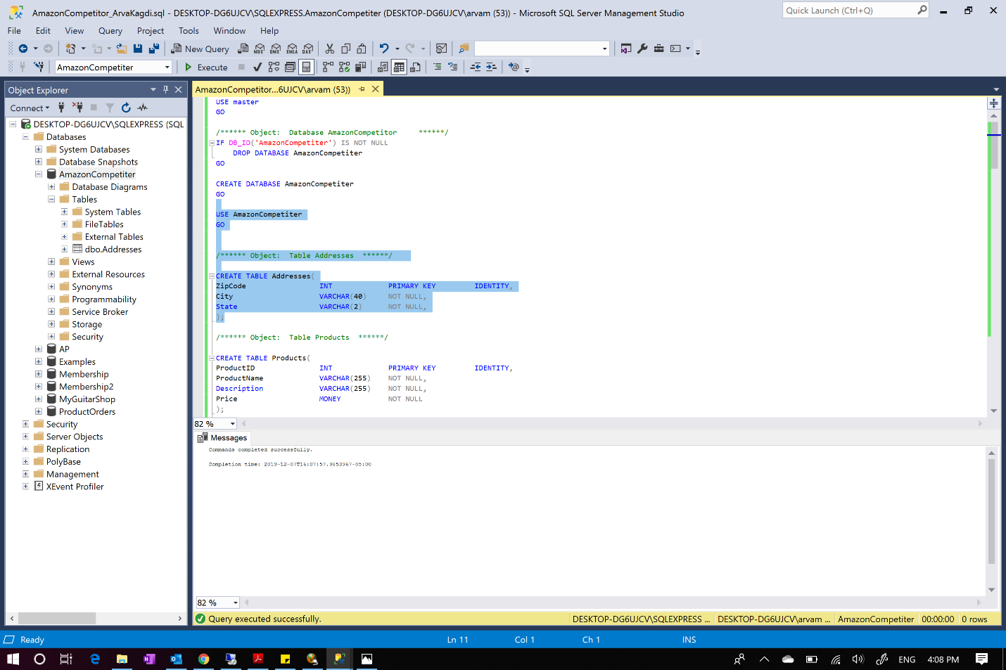



Figure shows that the database was successfully created



Creating table Addresses

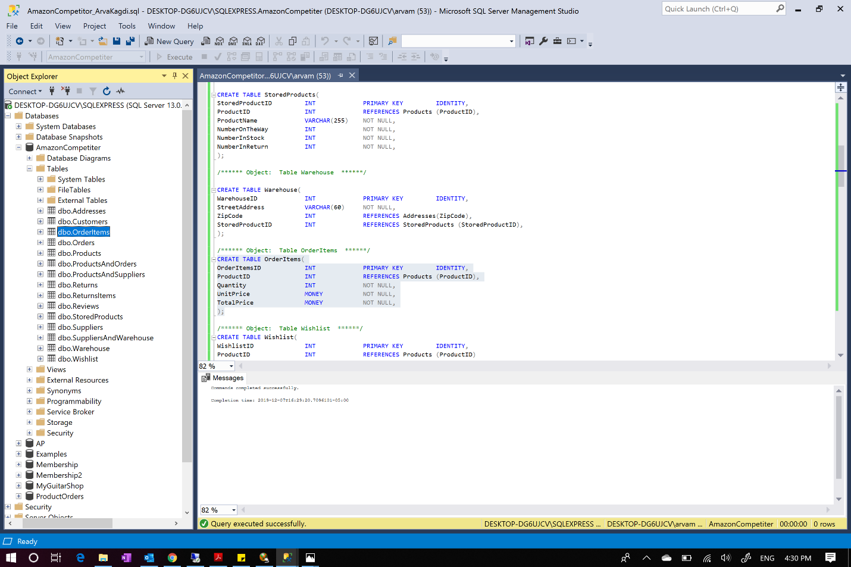

Creating table OrderItems

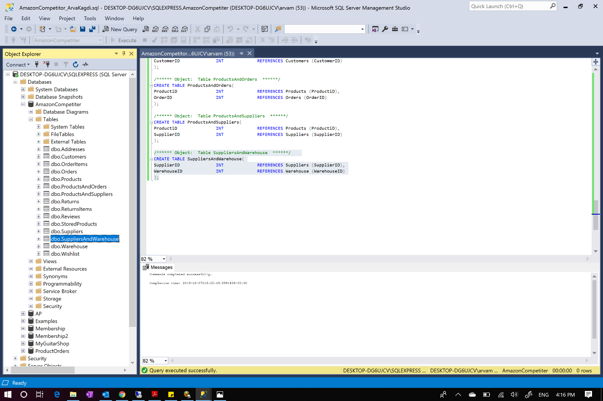

Creating table SuppliersAndWarehouse

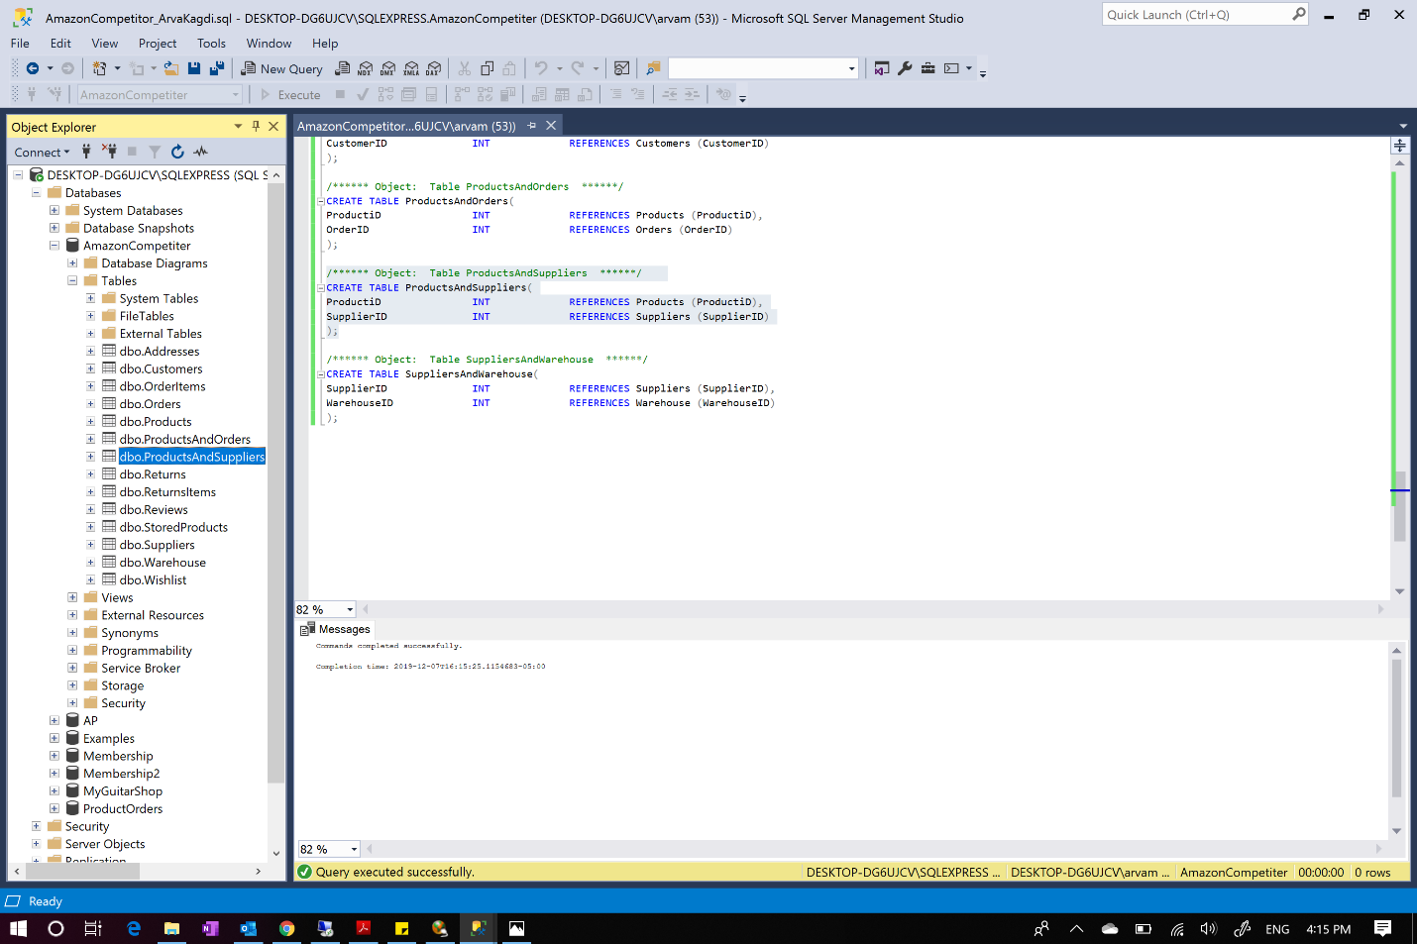

Creating table ProductAndSuppliers

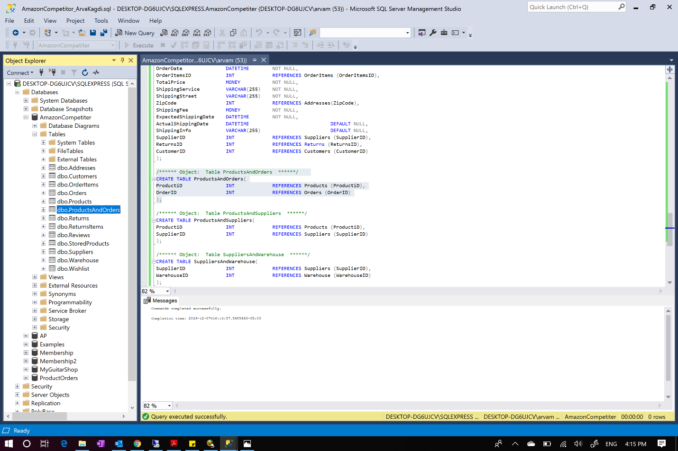

Creating table ProductAndOrders

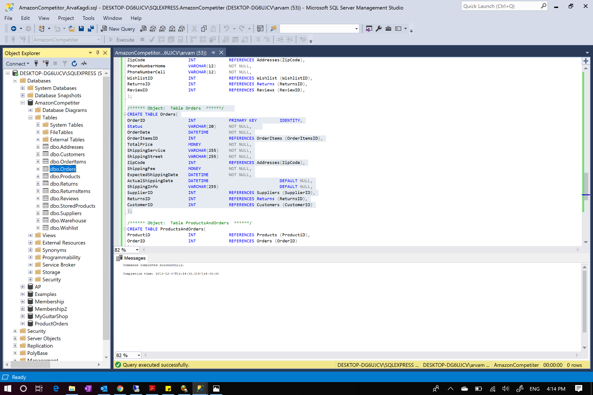

Creating table Orders

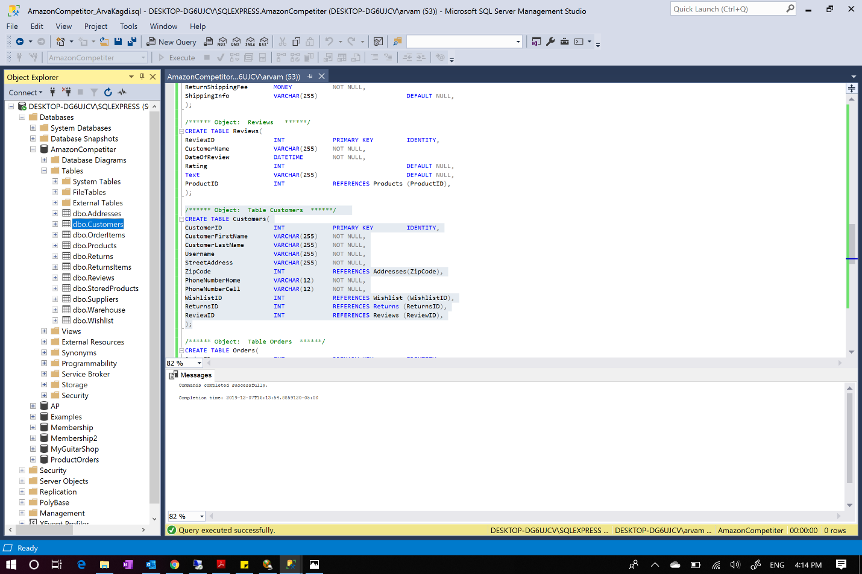

Creating table Customers

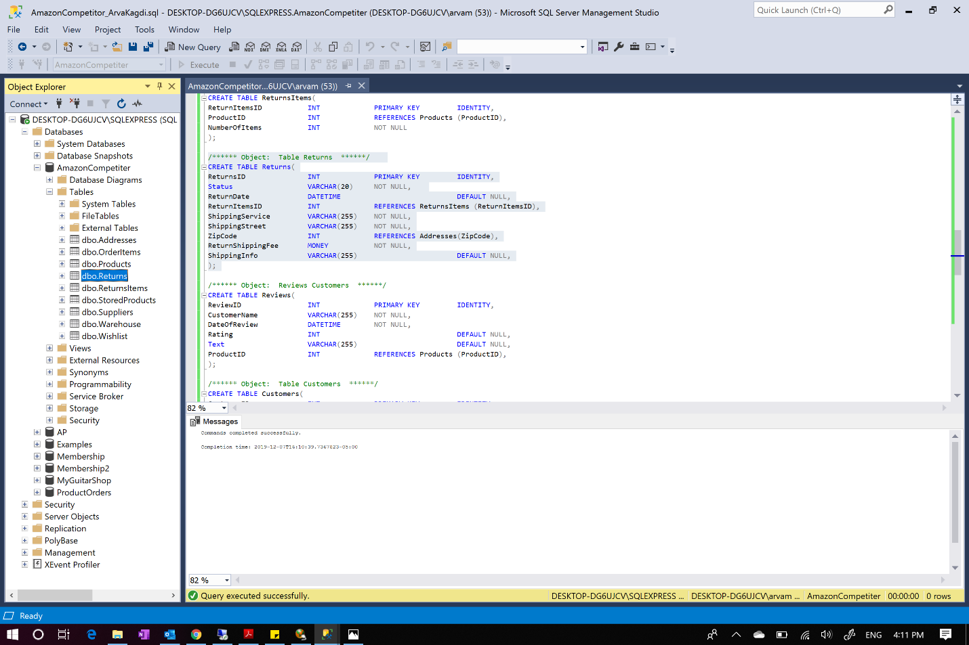

Creating table Returns

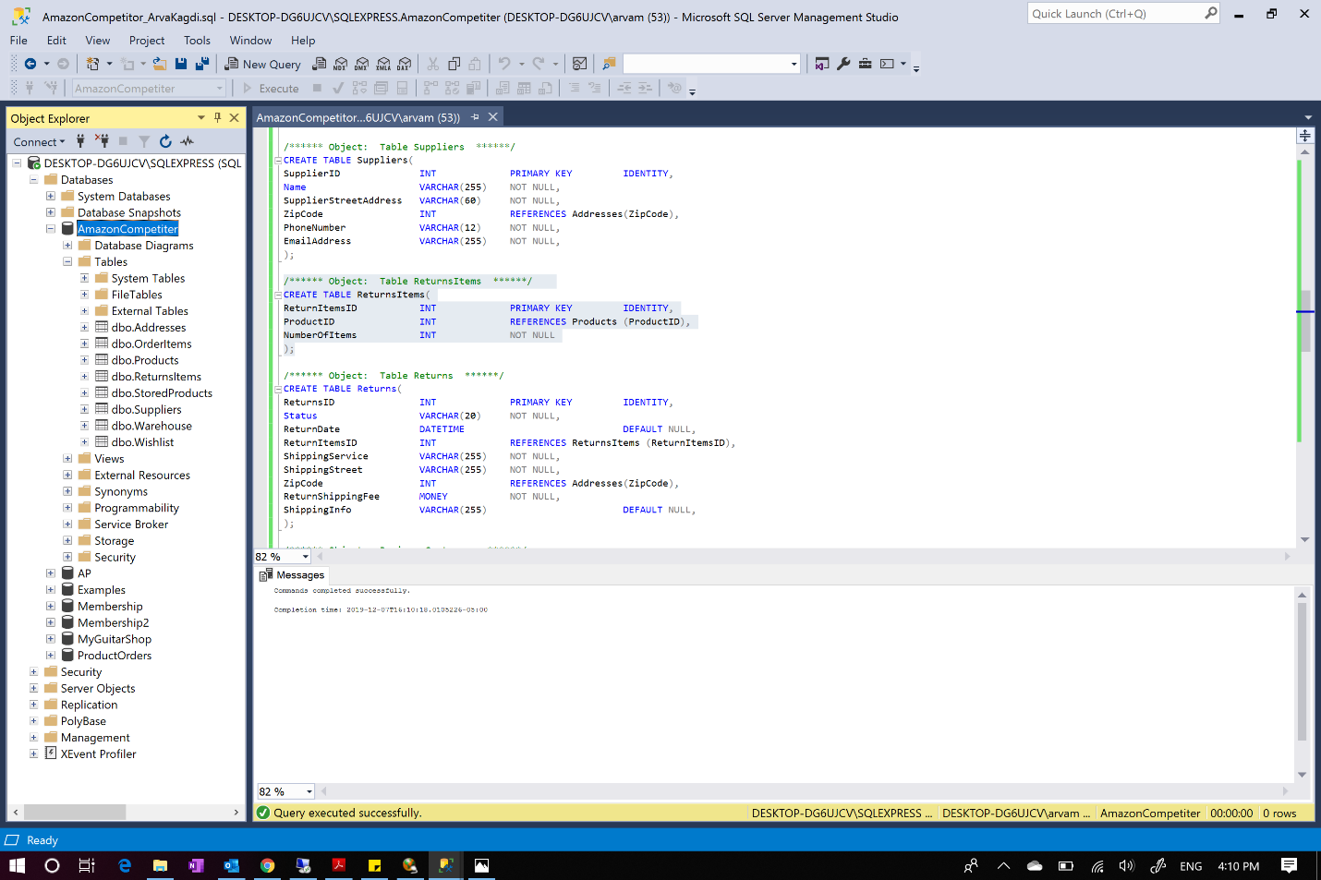

Creating table ReturnsItems

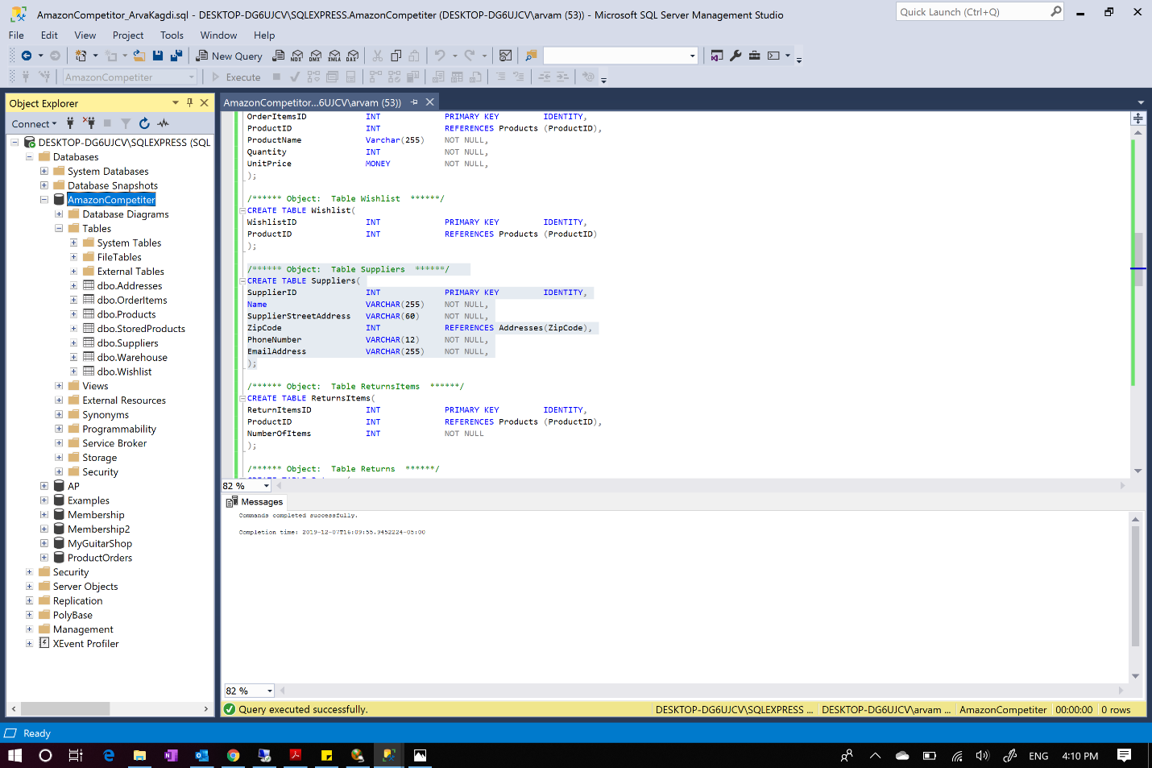

Creating table Suppliers

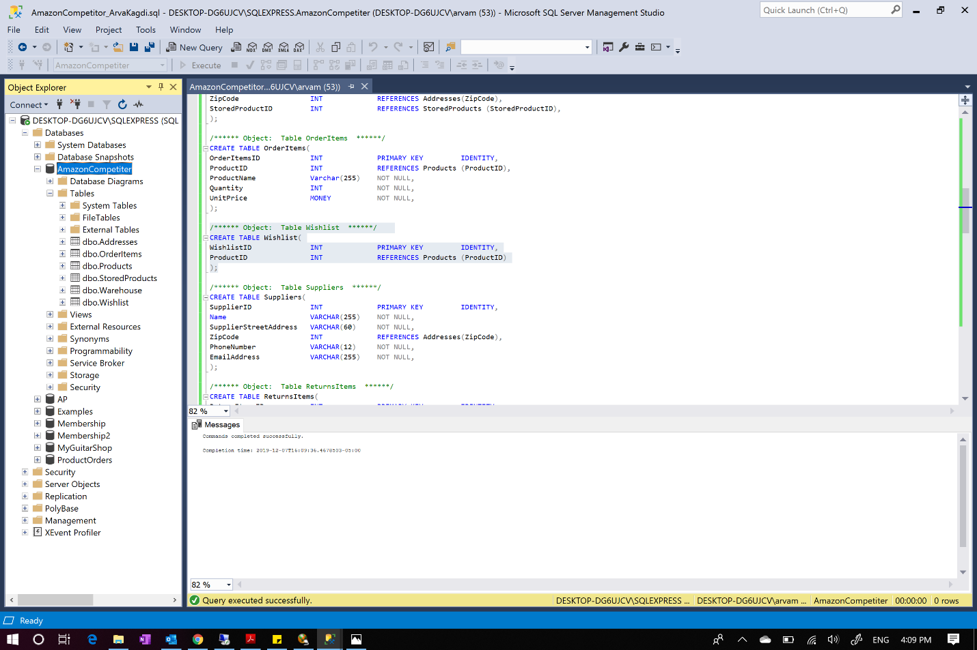

Creating table Wishlist

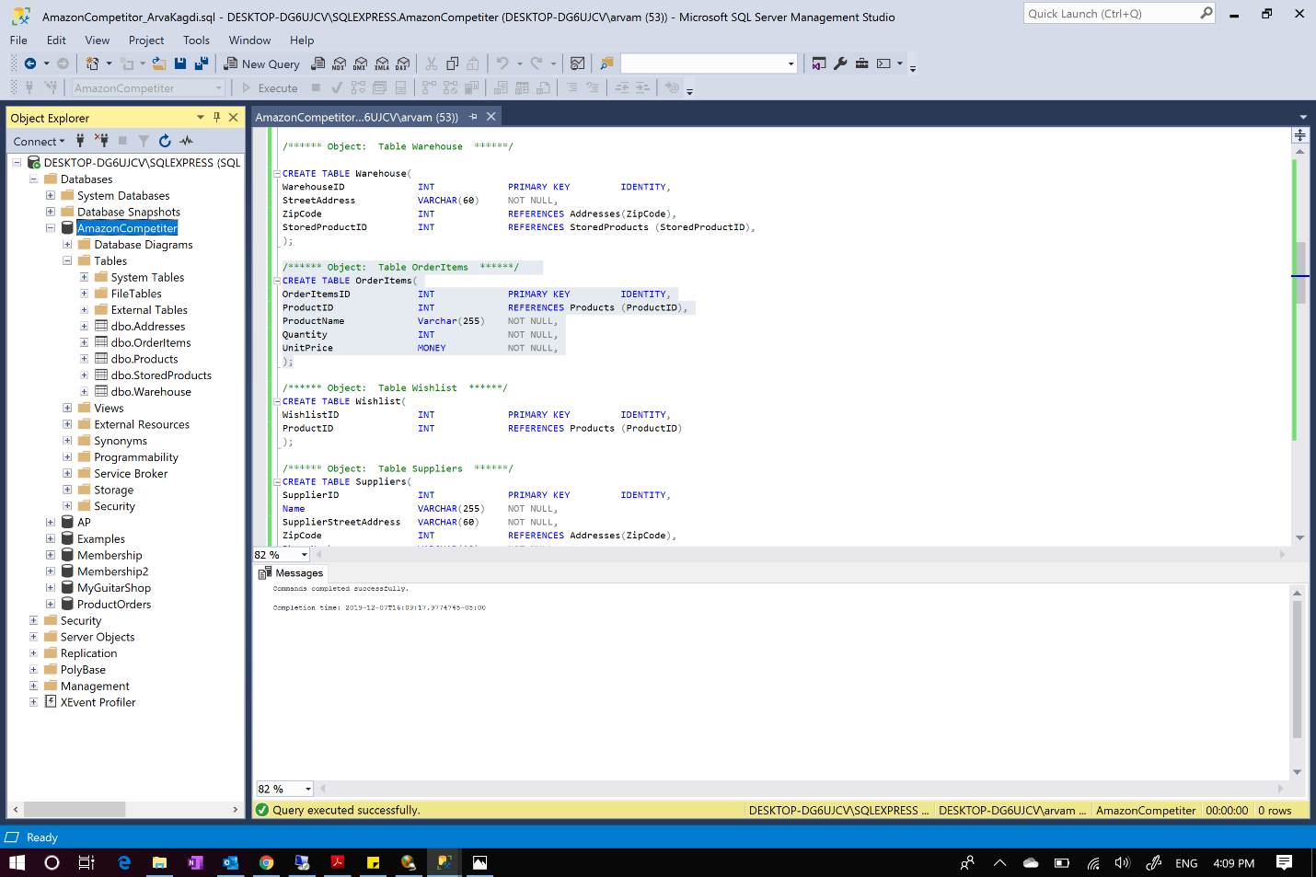

Creating table OrderItems

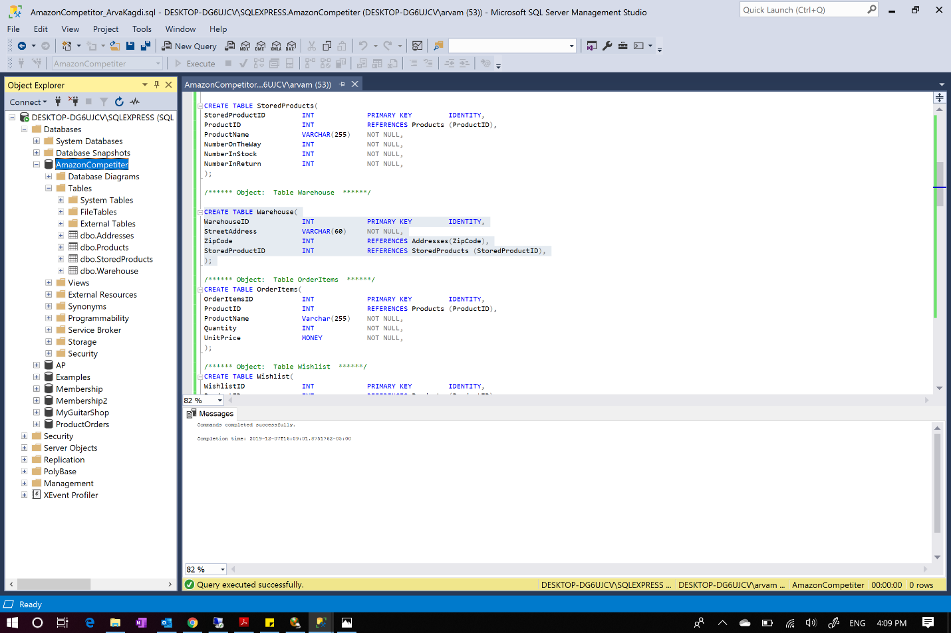

Creating table Warehouse

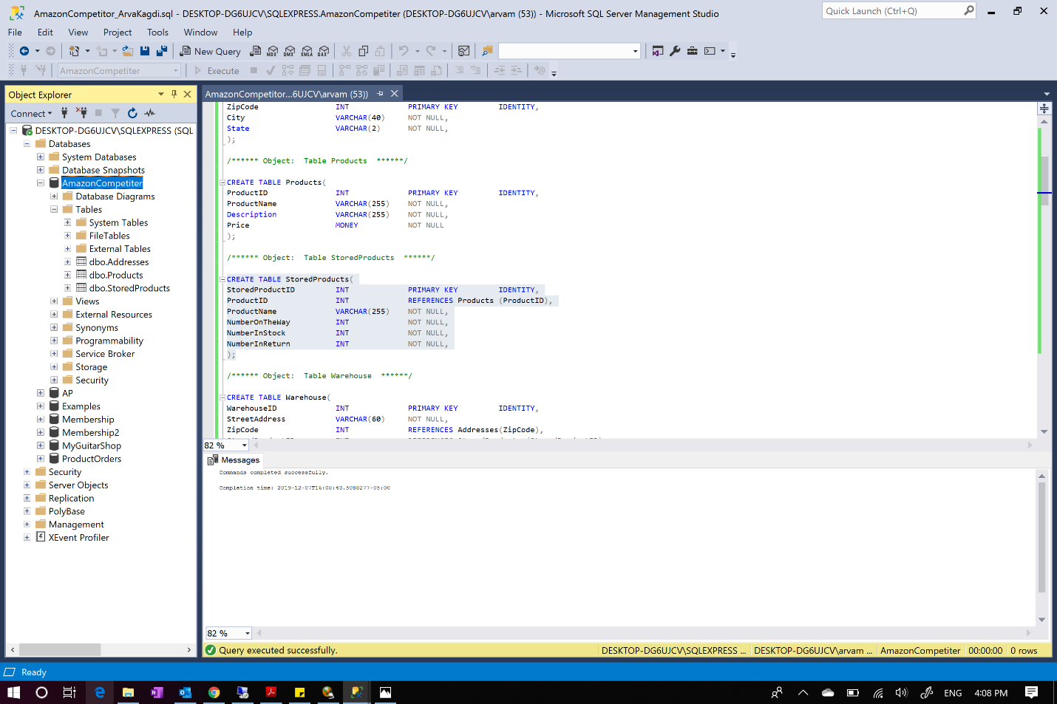

Creating table SroredProducts

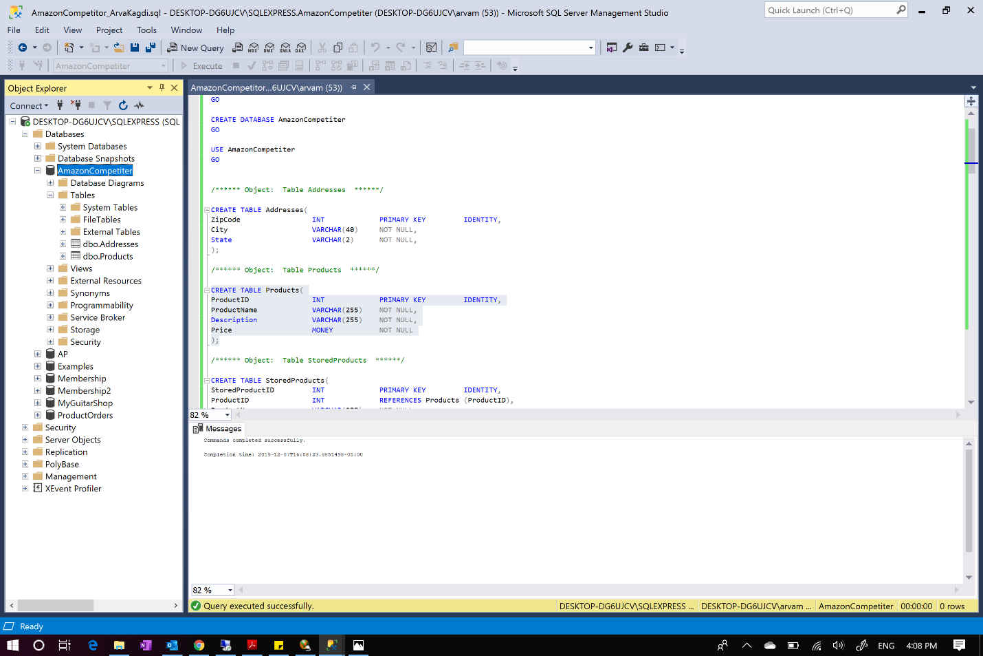

Creating table Products

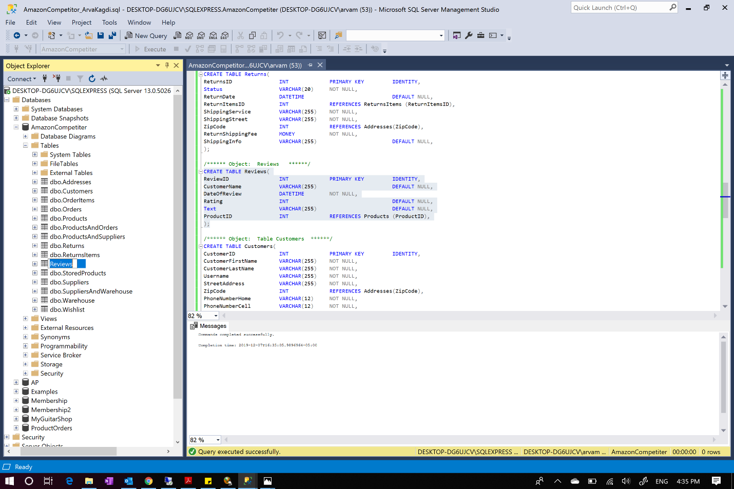

Creating table Reviews

***Populating all the tables with 10 or more values. Below are the screenshots for each tables along with the successful execution and the data shown:***

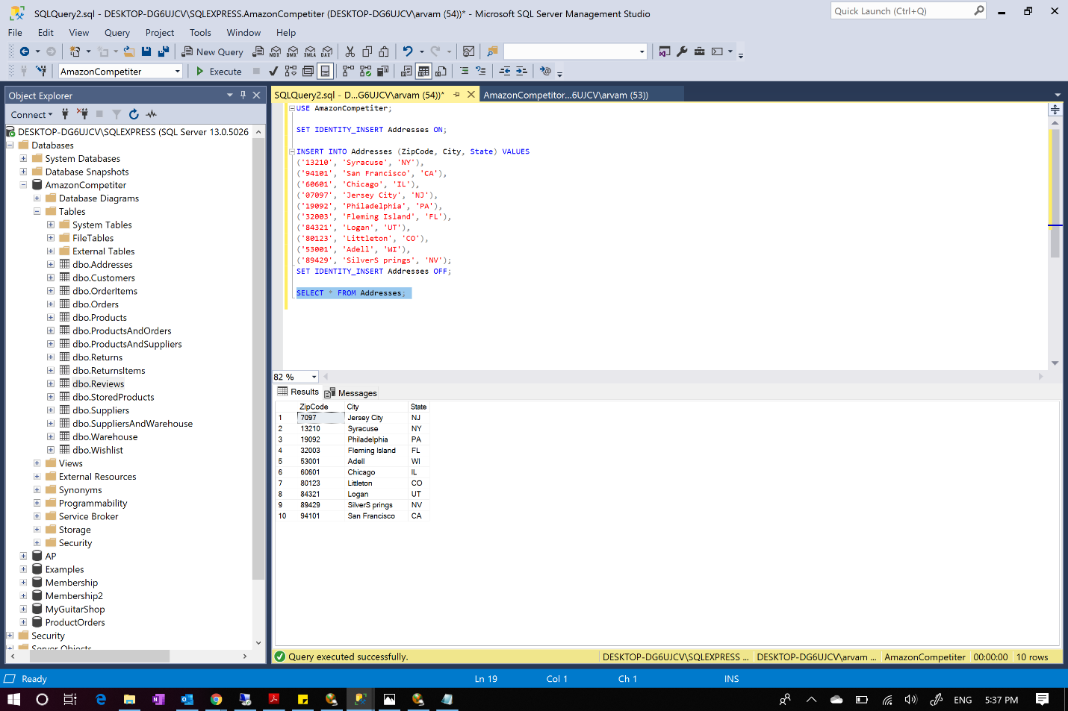

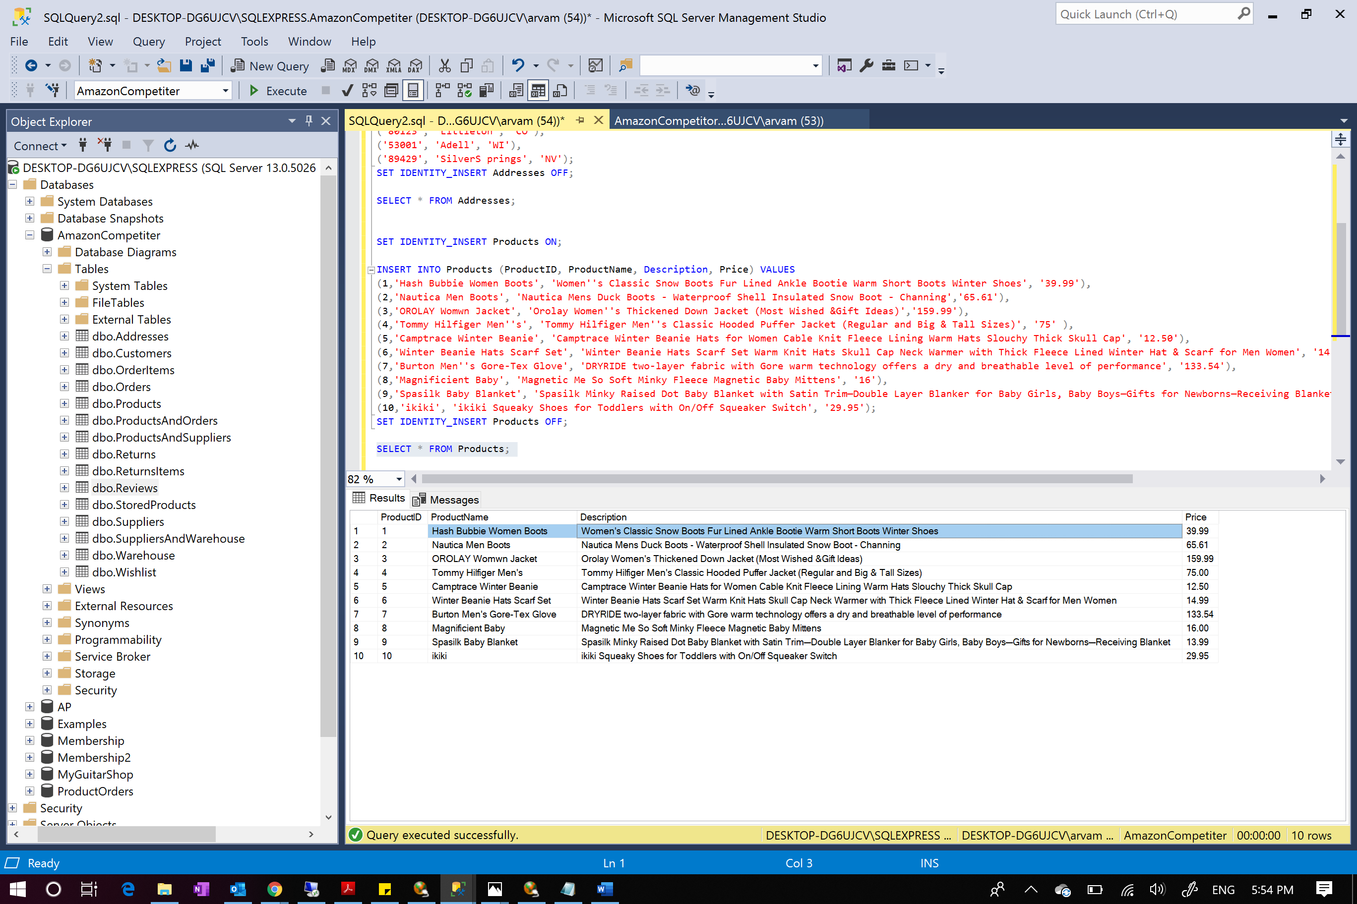

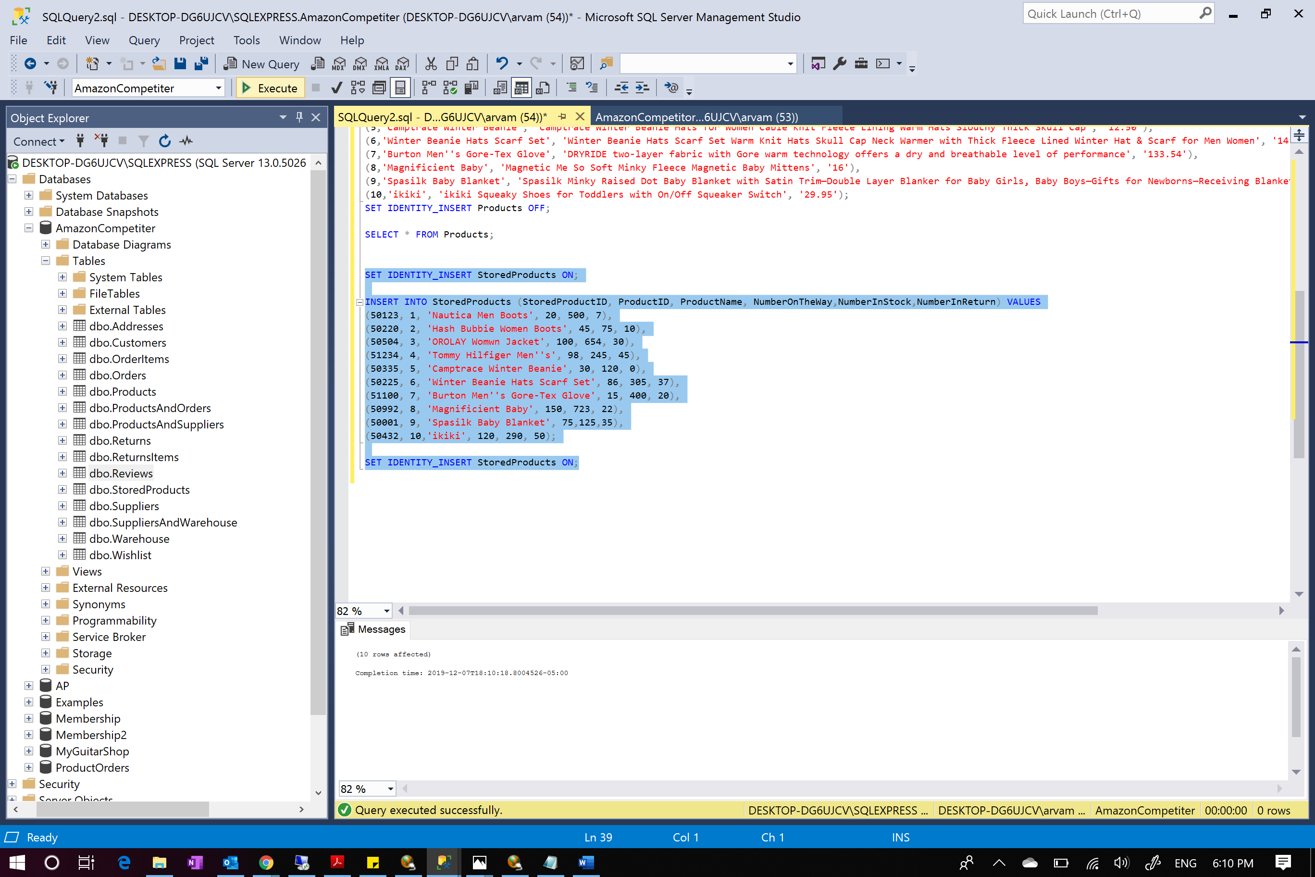

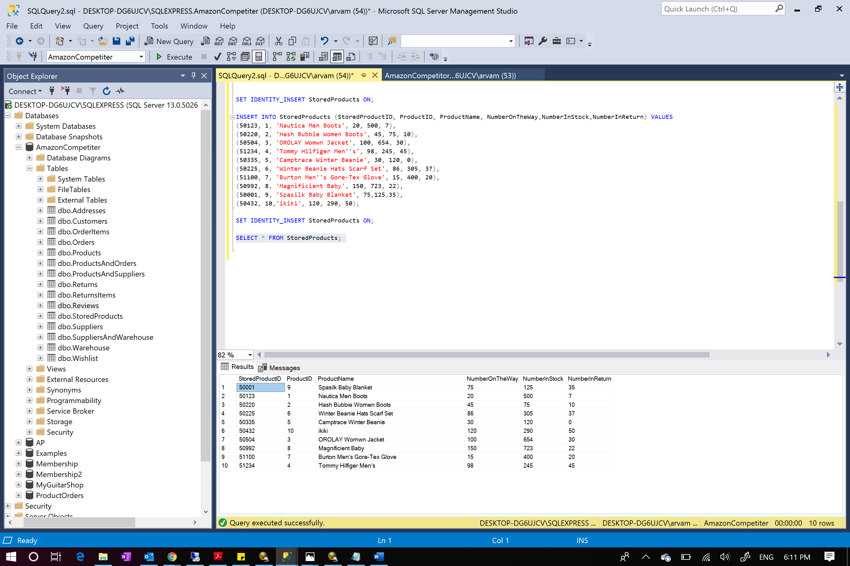

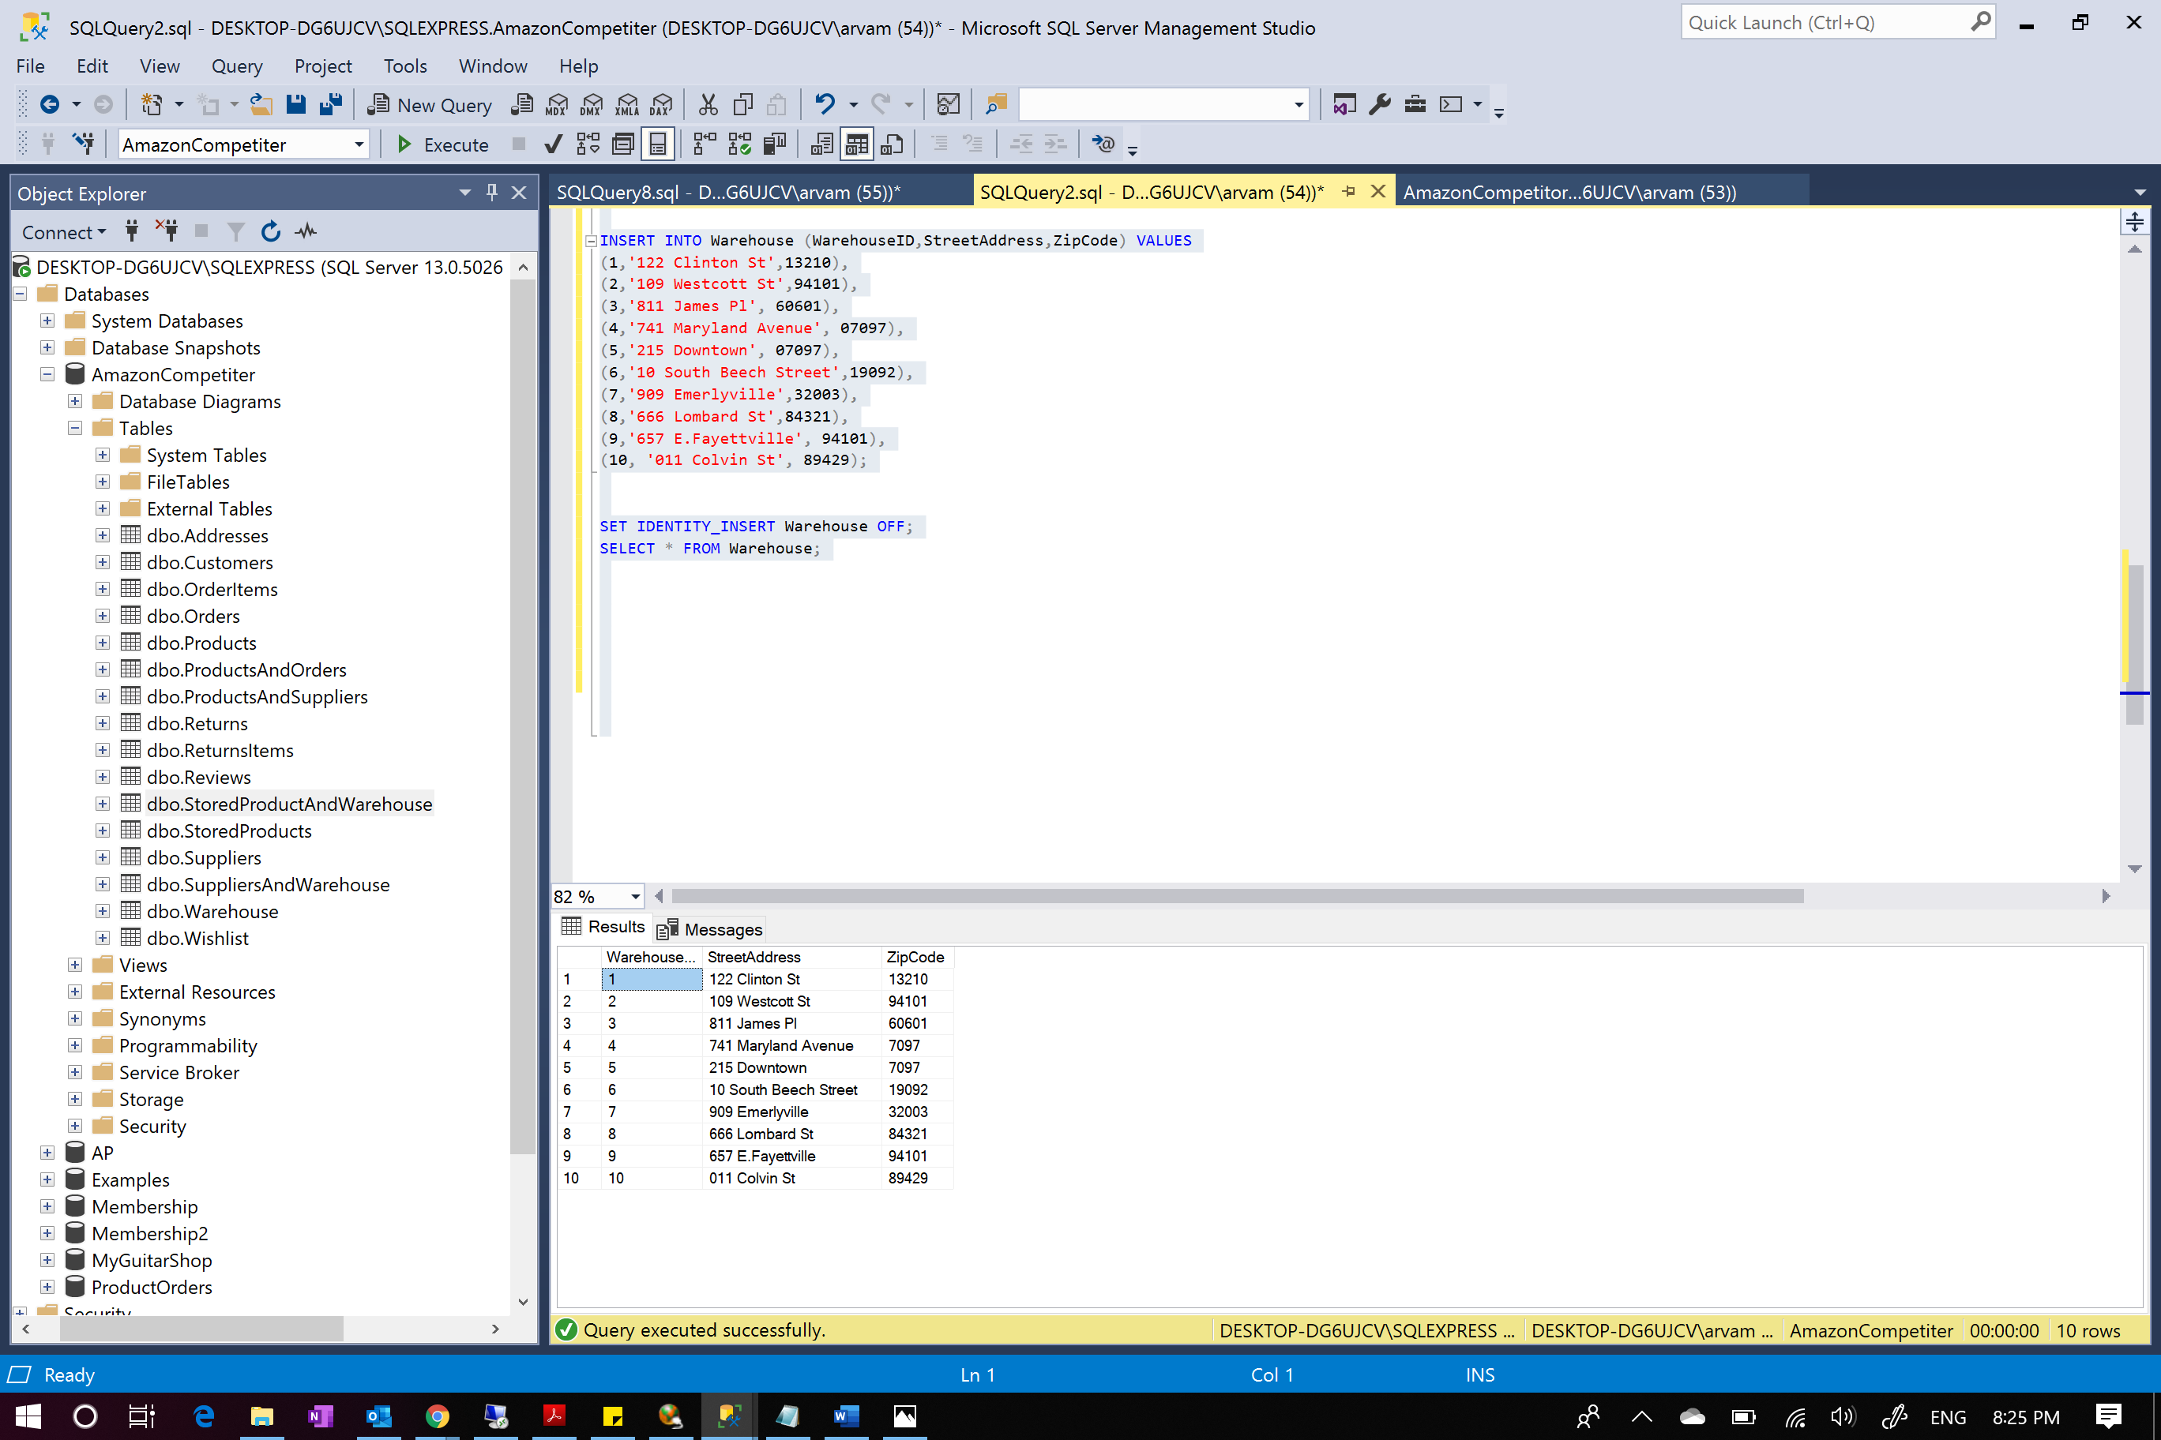

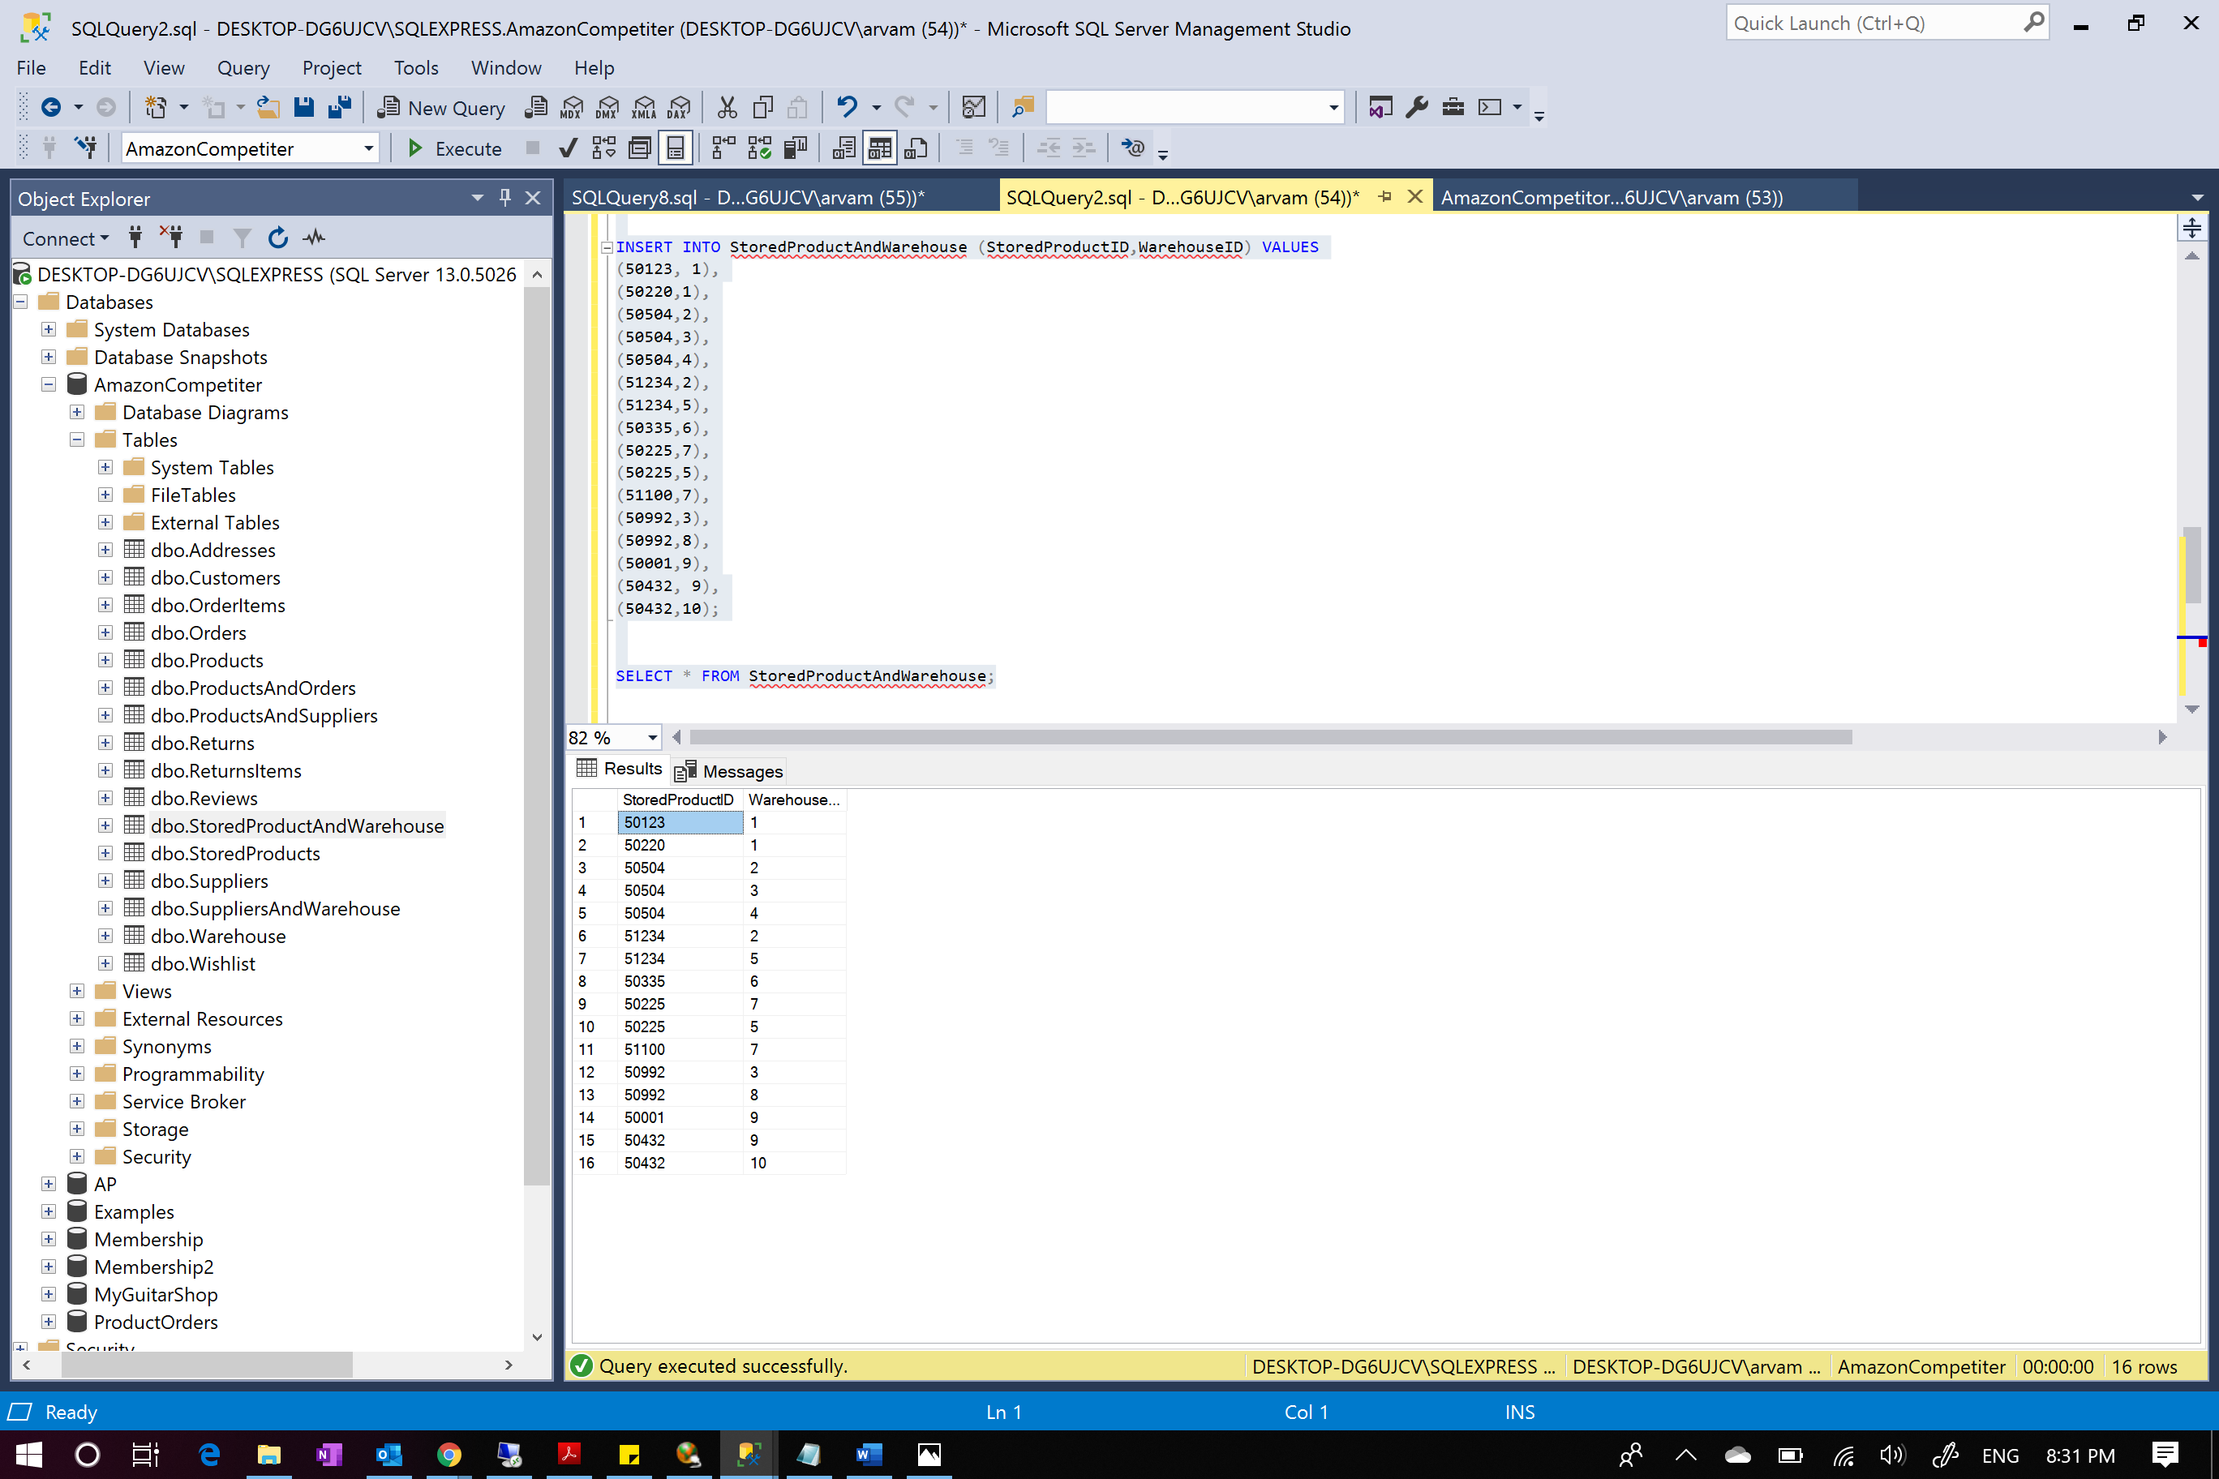

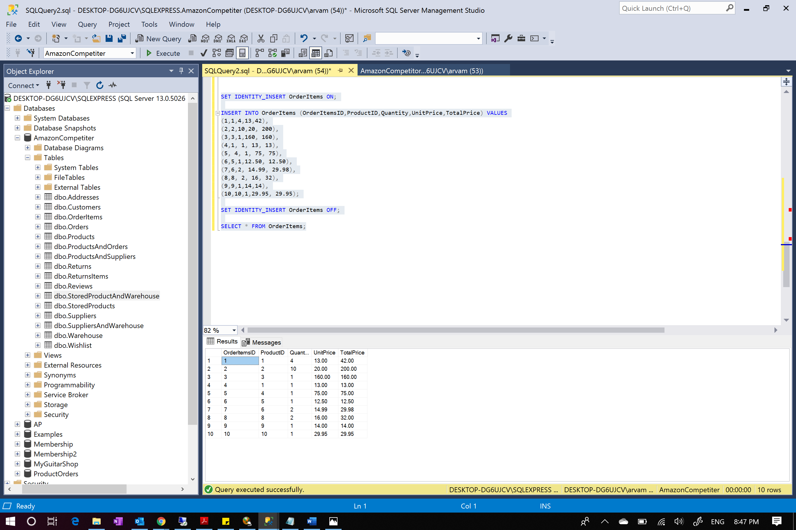

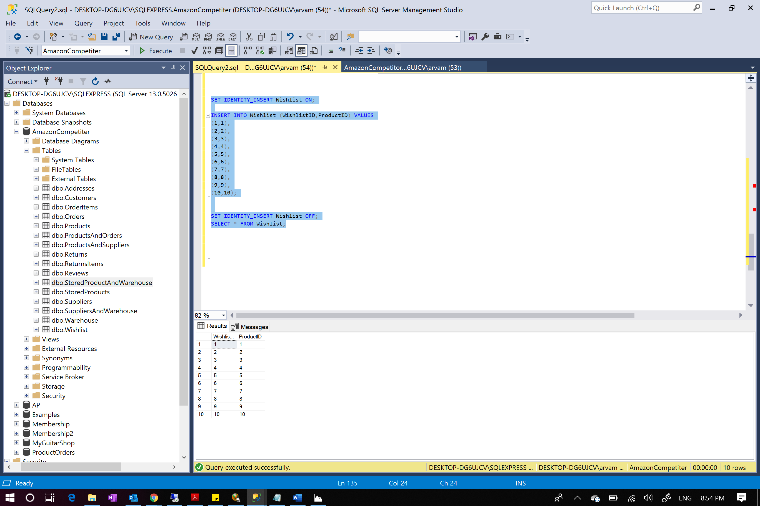

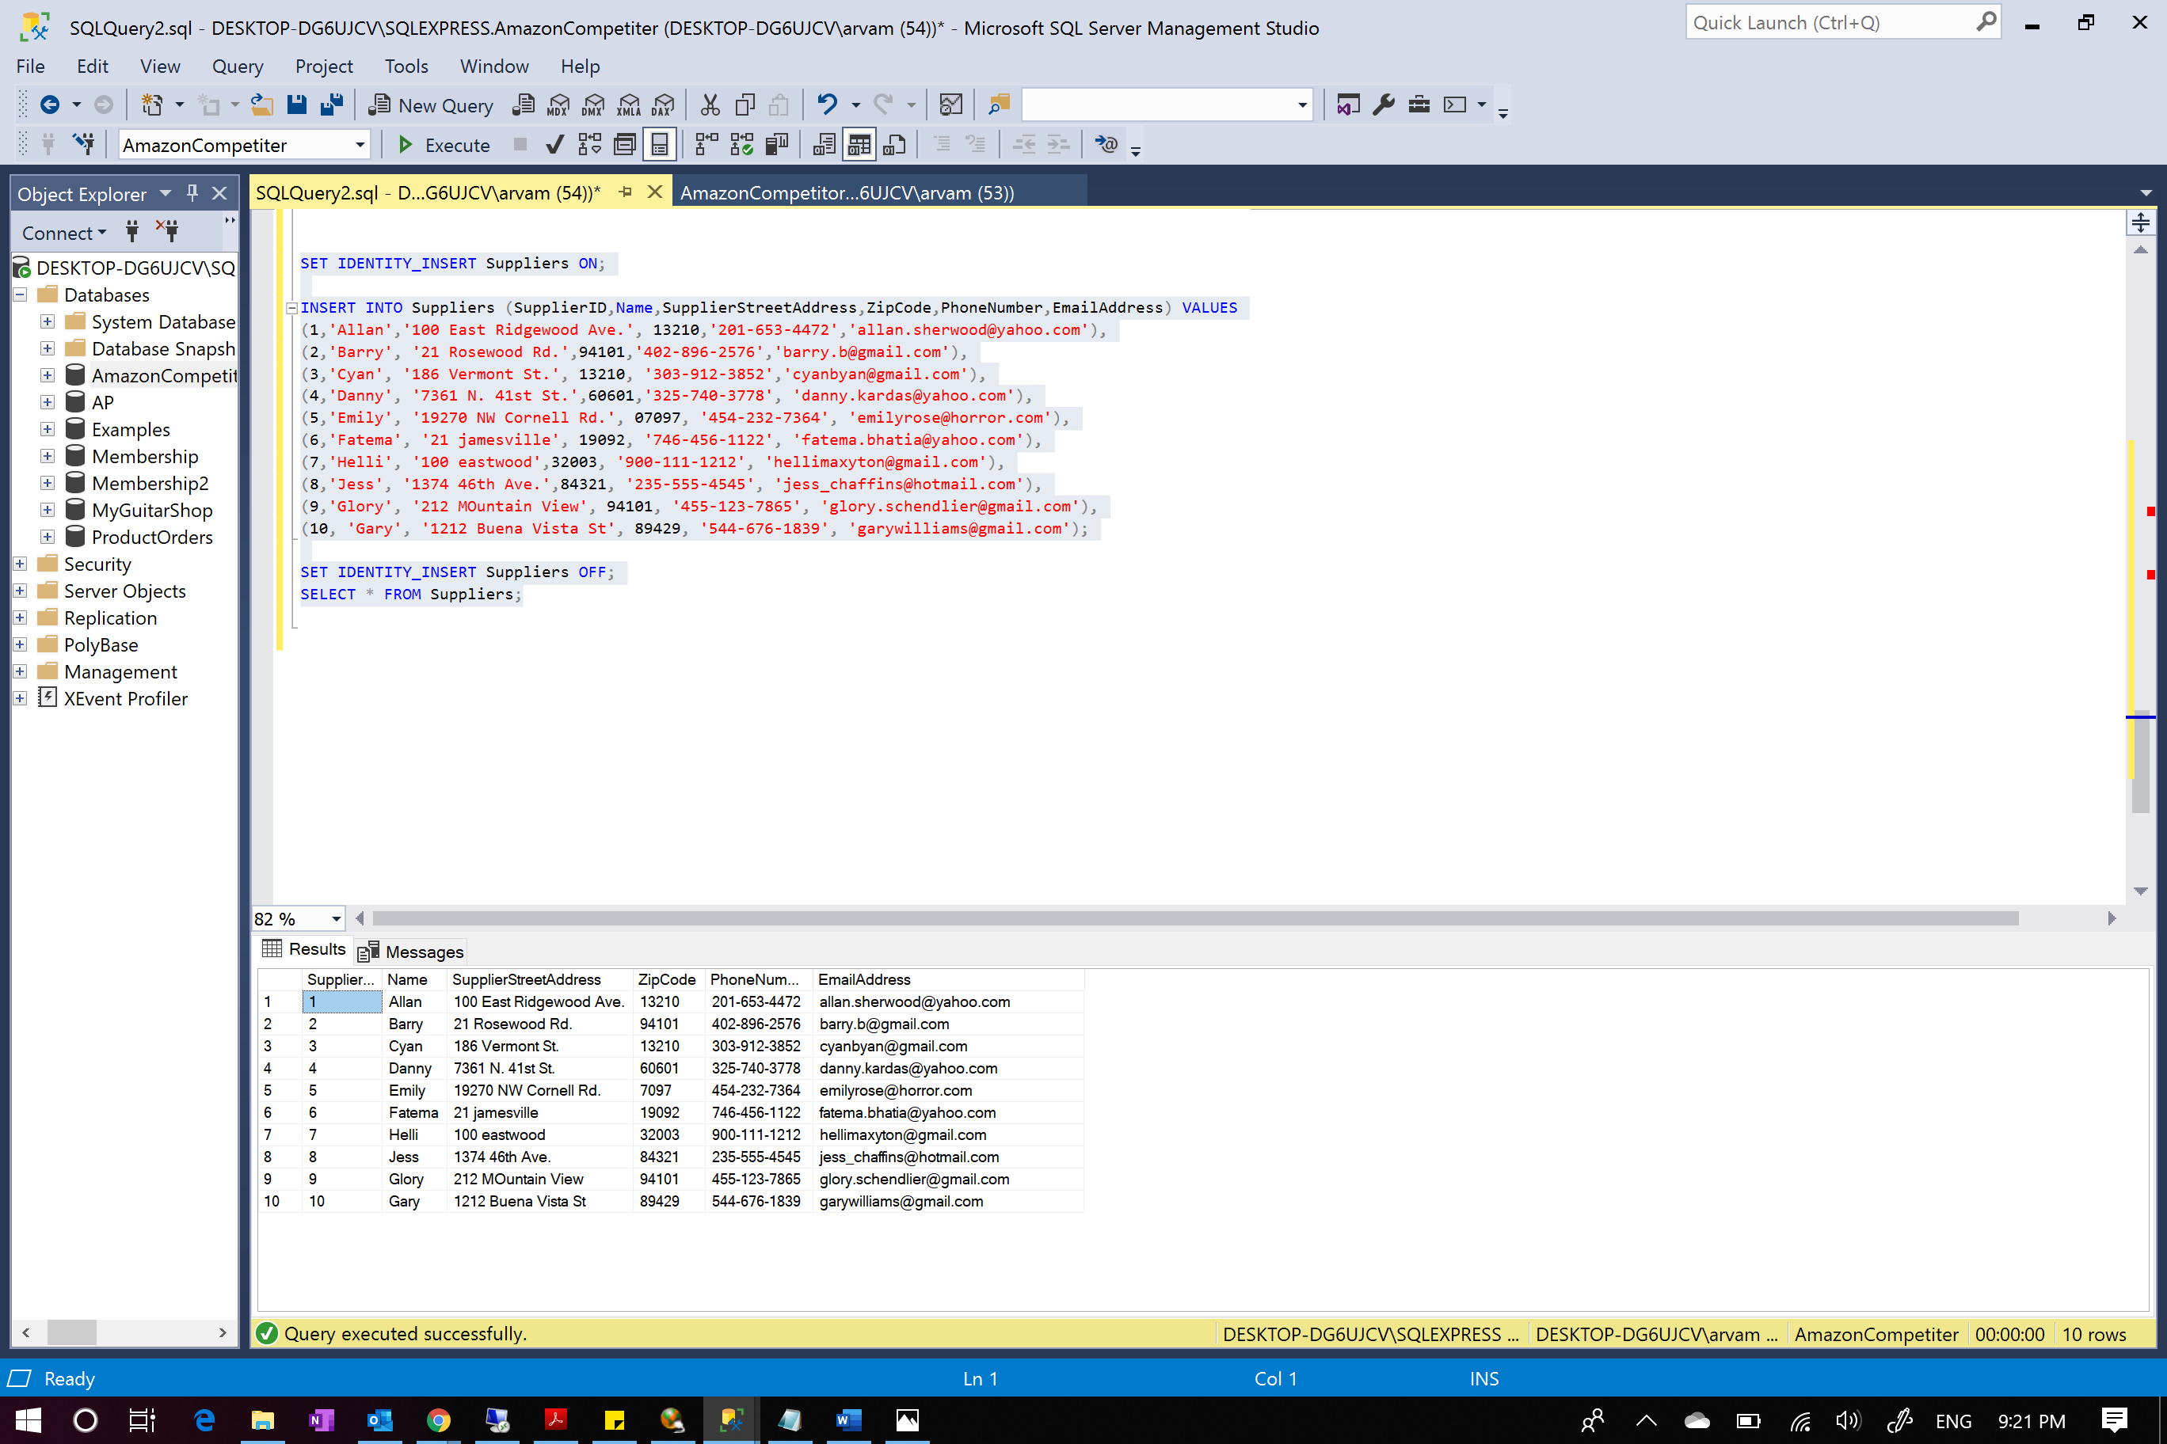

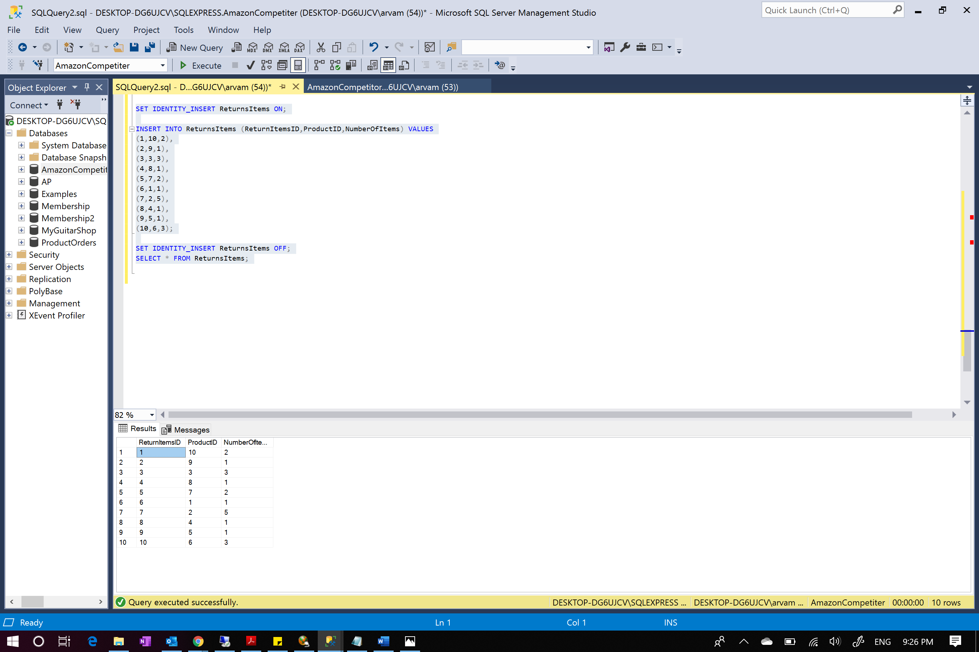

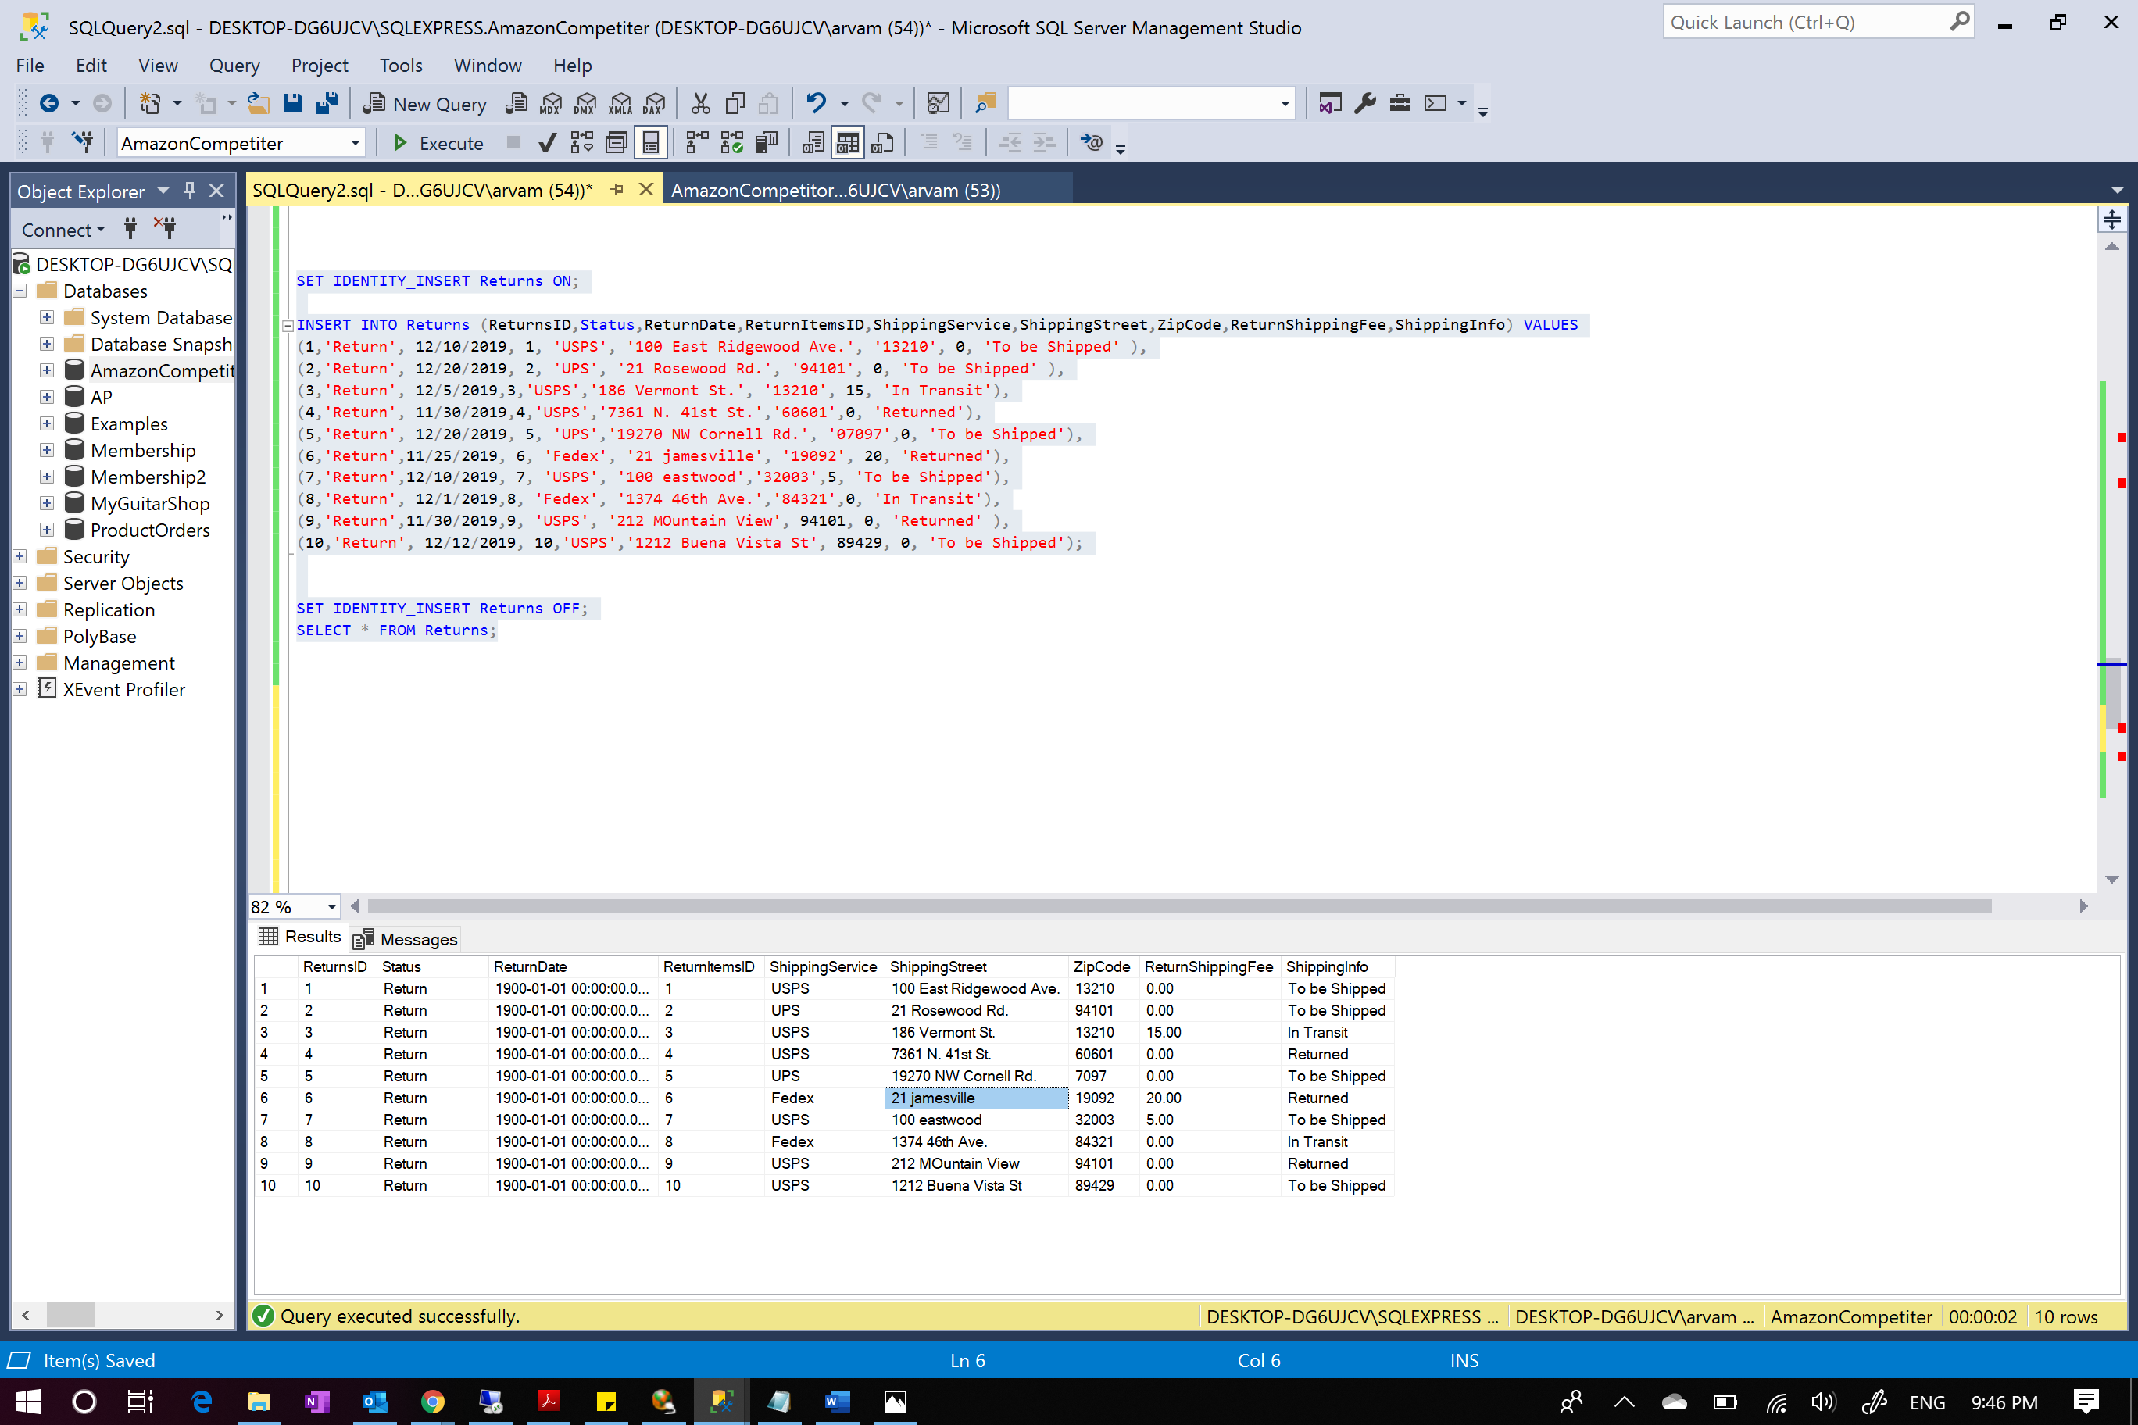

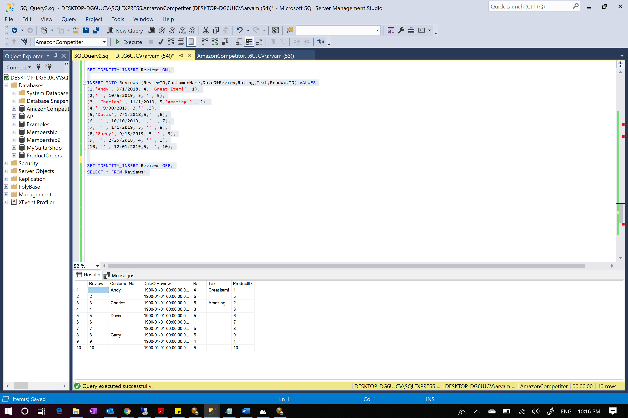

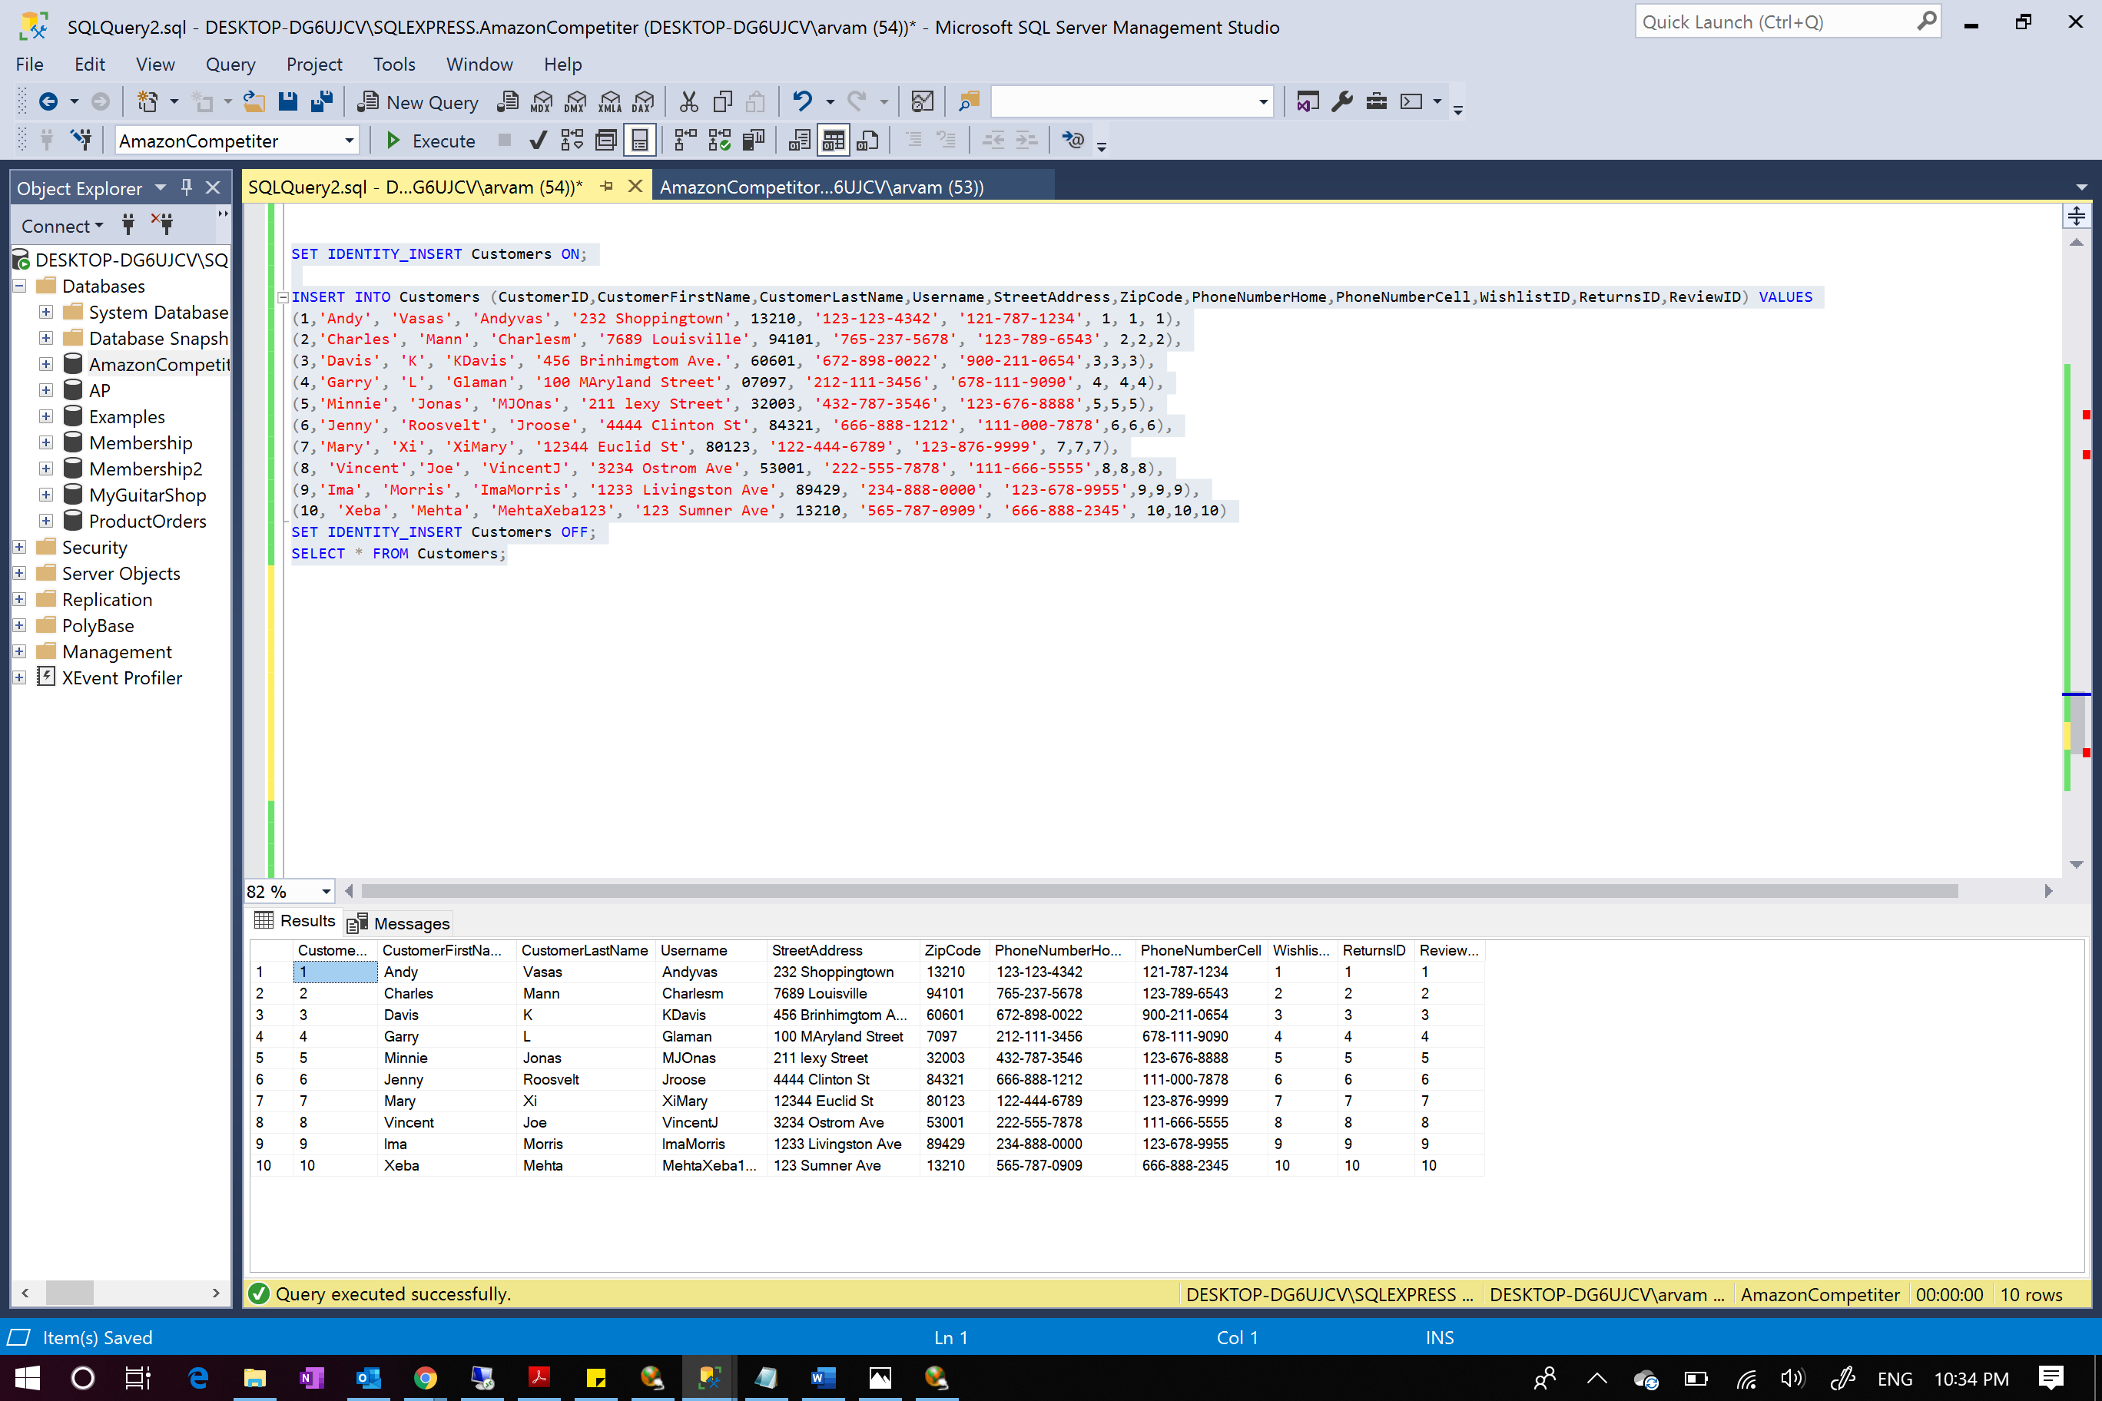

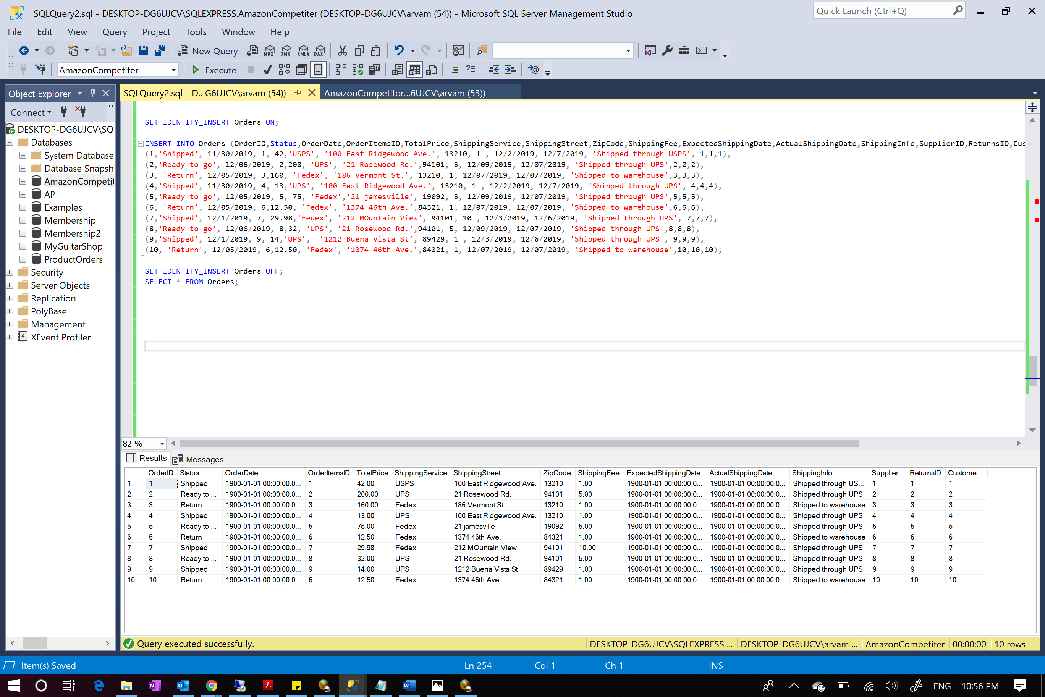

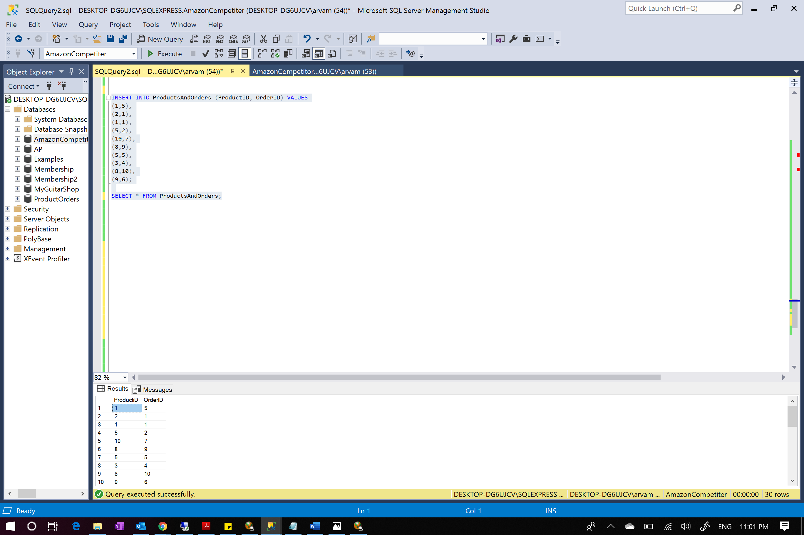

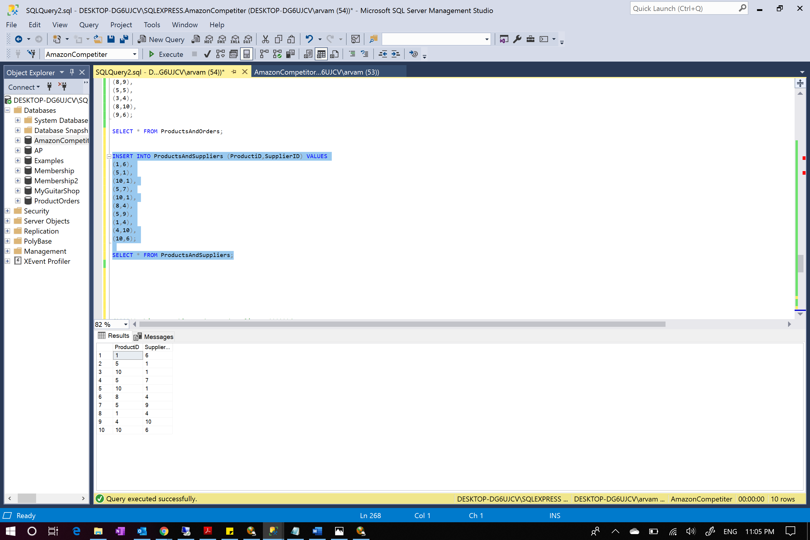

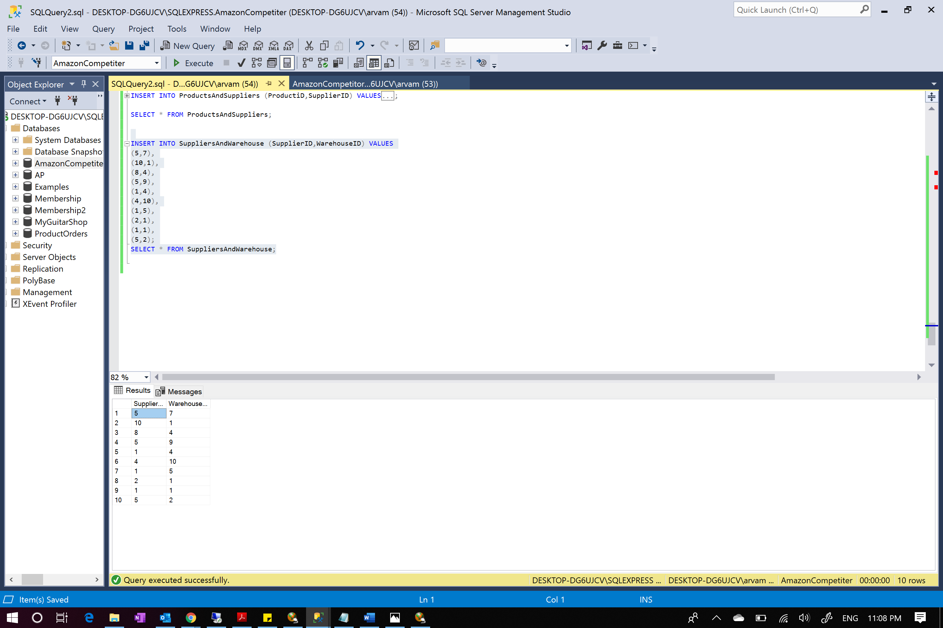

***Views, Stored Procedures, Transactions, Logins, Triggers, Roles:***

***1.***

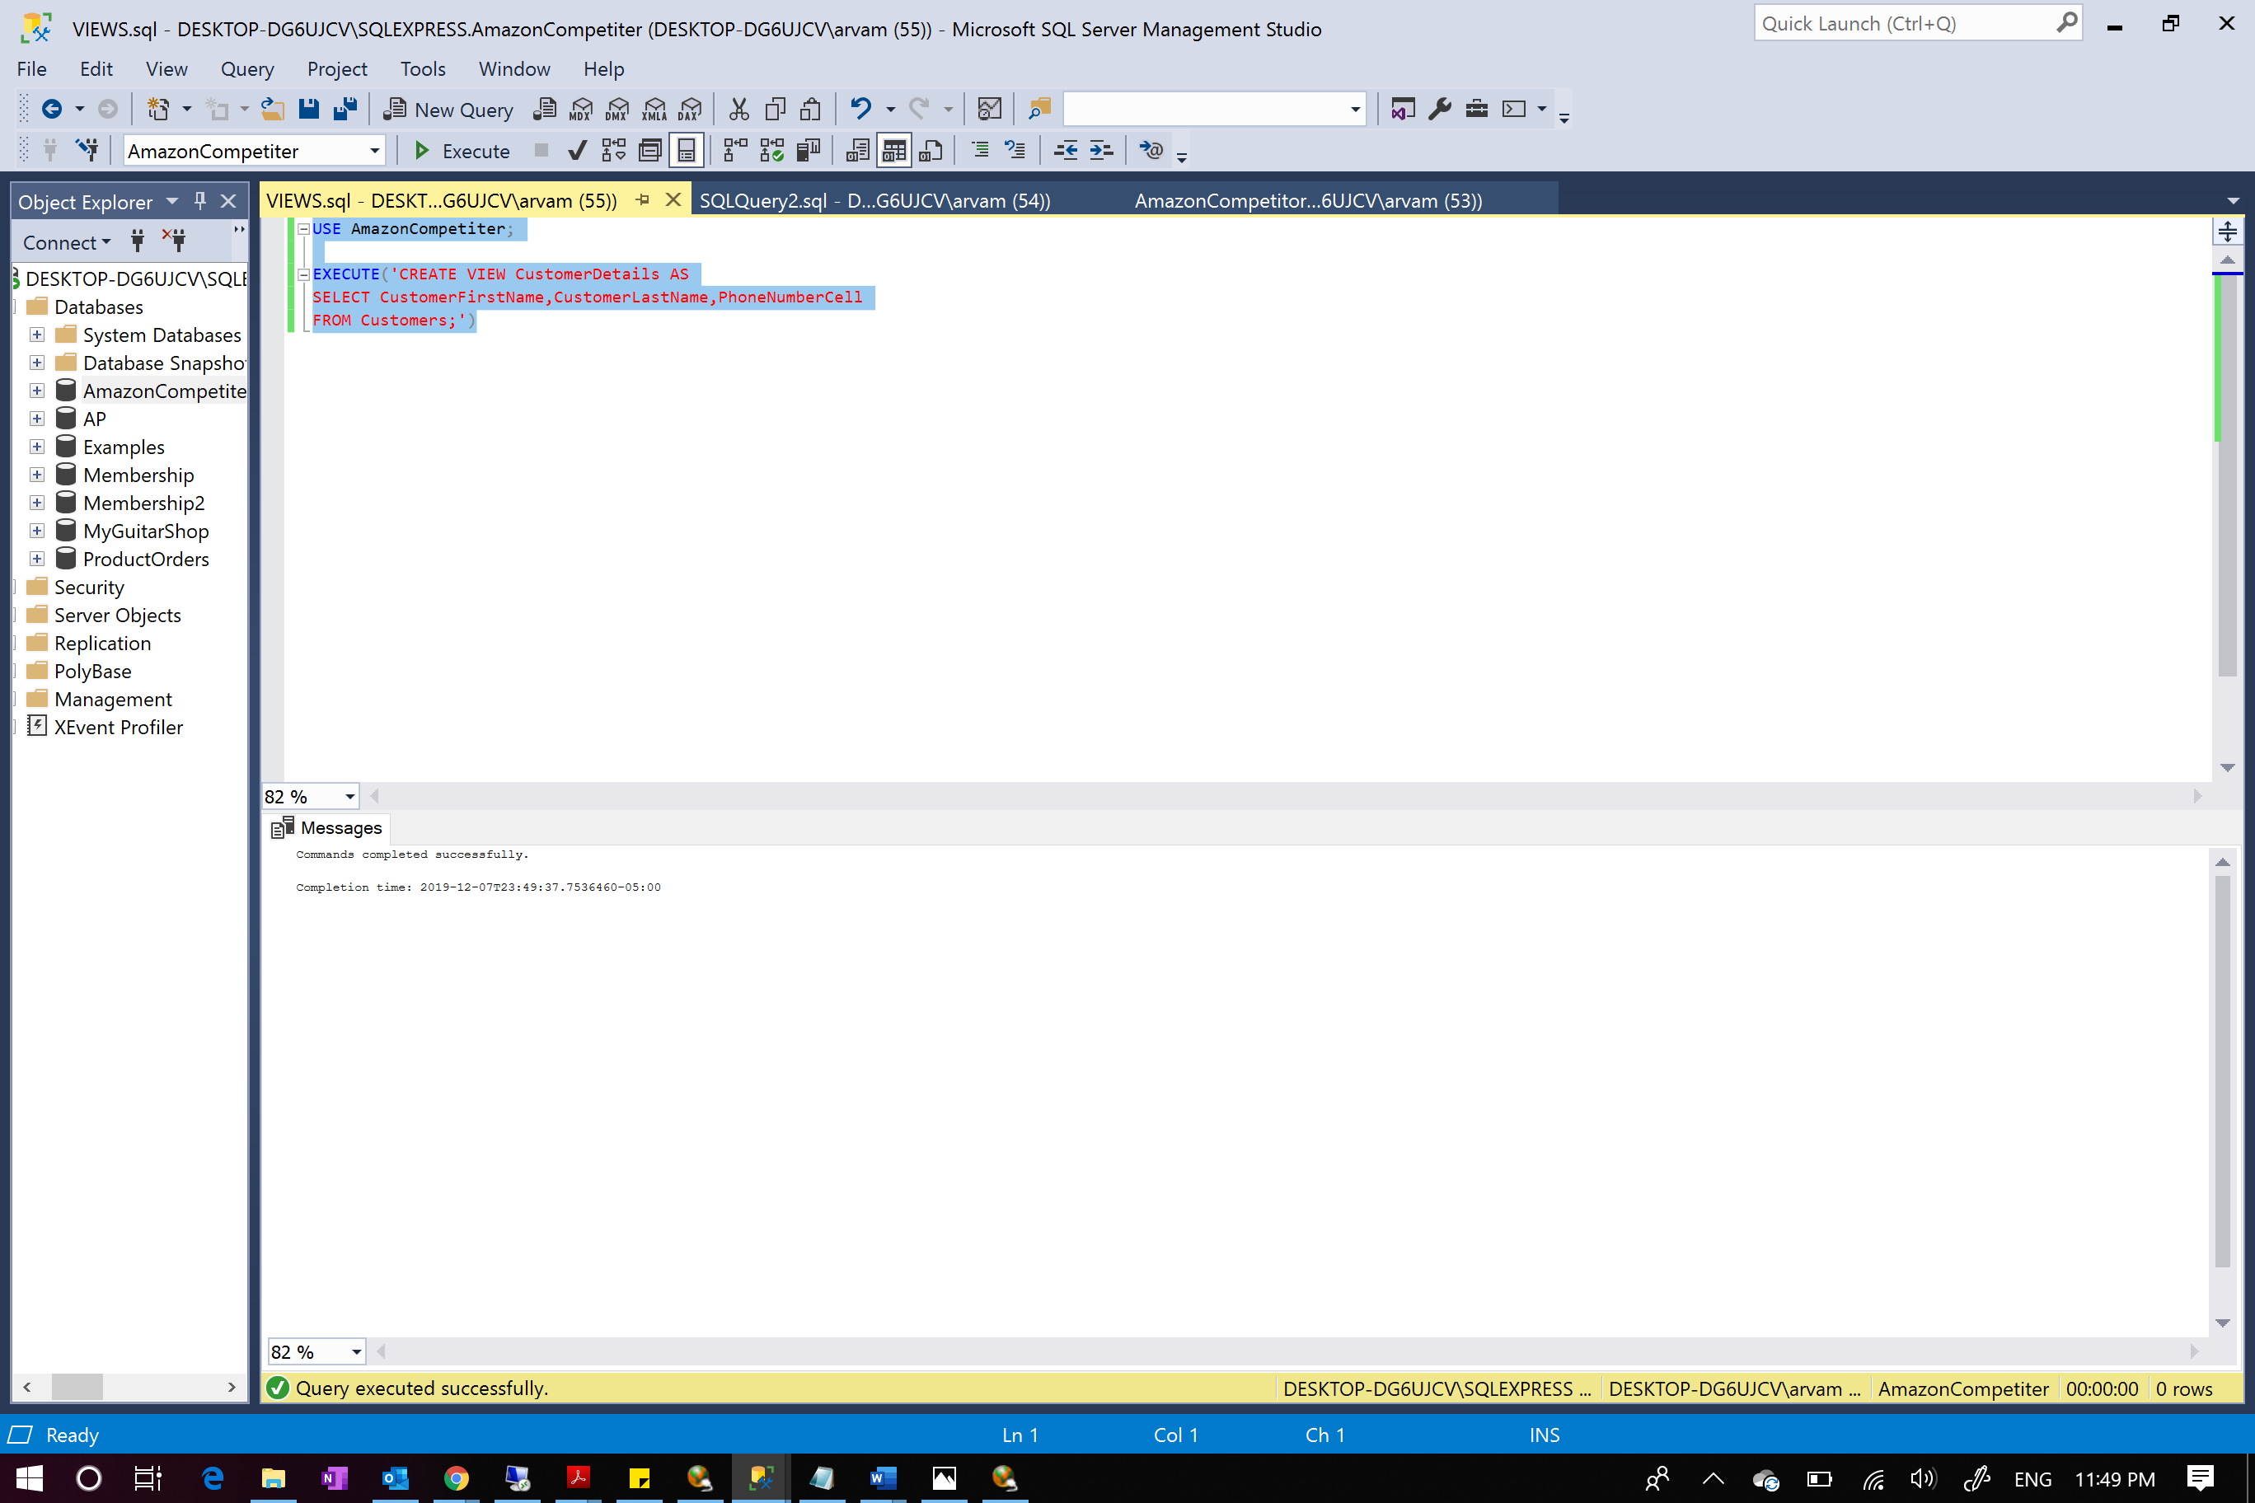

Here, we are create a view that gives the required customer details such as CustomerFirstName, CustomerLastName and PhoneNumberCell. The view was created successfully.

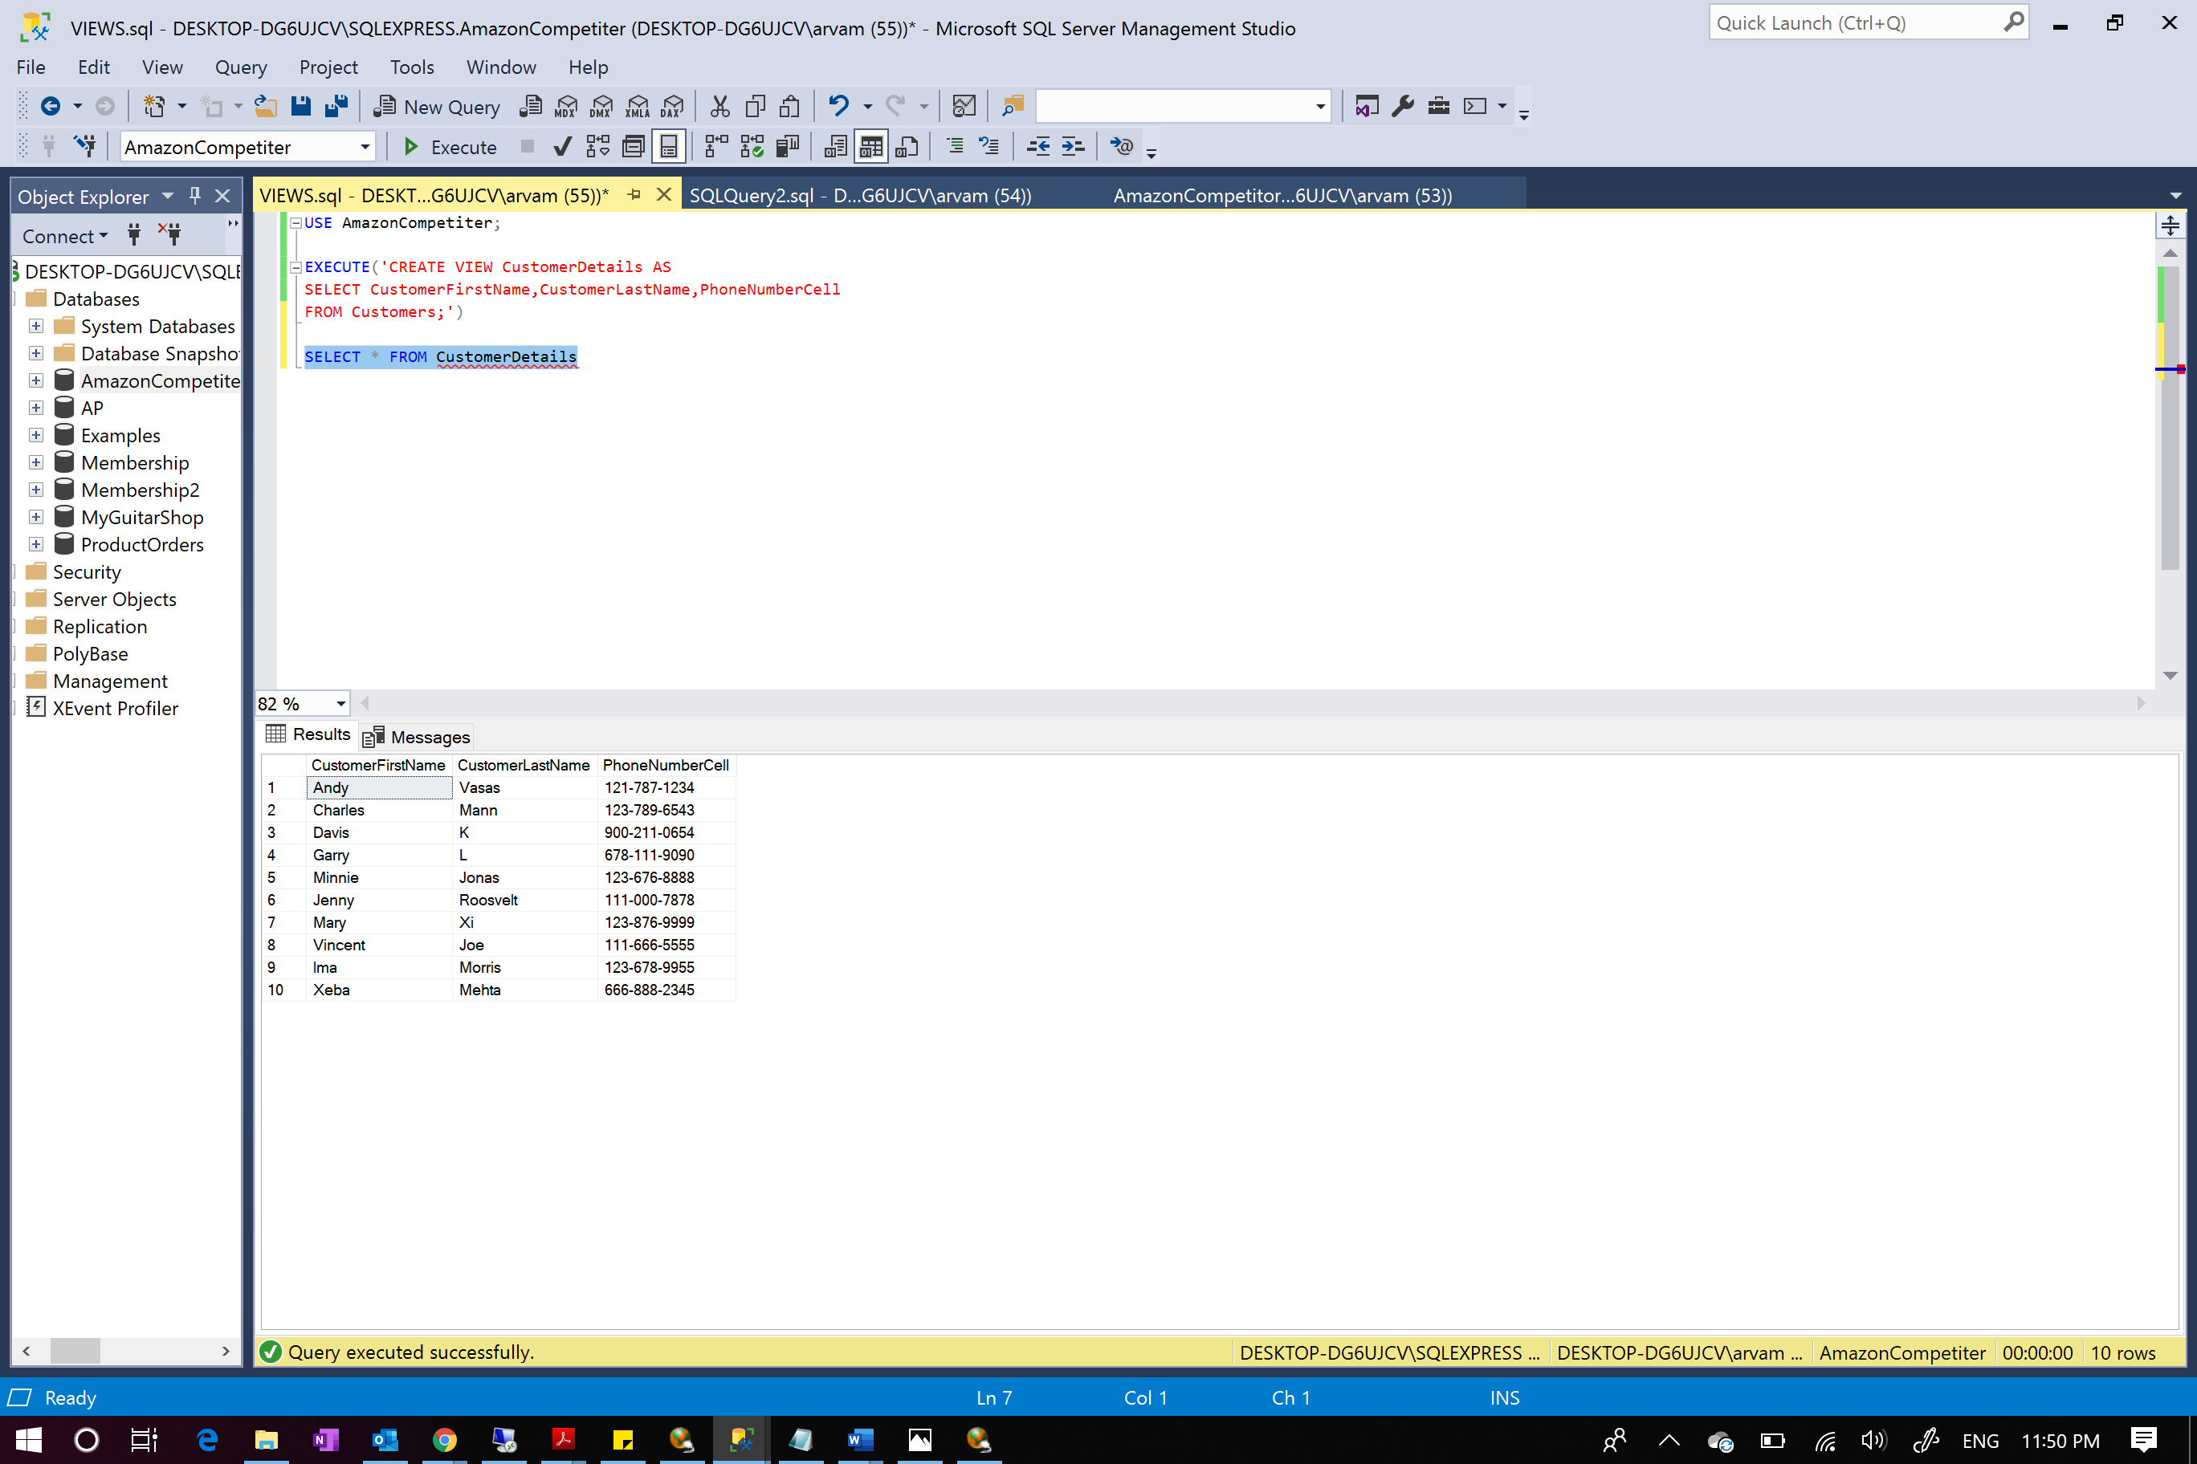

Executing the above view returns 10 results and 3 columns as required

2. Here we are creating a view that gives details of the shippers such as shippers name, PhoneNumber and EmailAddress through which they can be contacted. This view just gives needed information and removes all unnecessary columns.

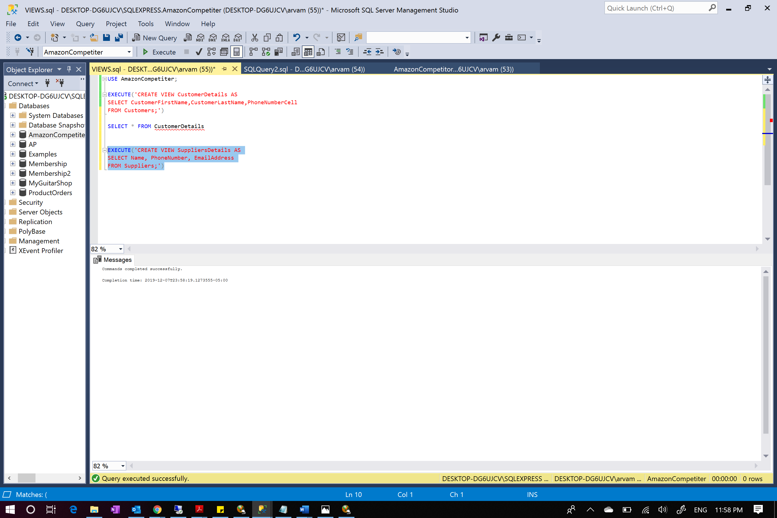

View was successfully created

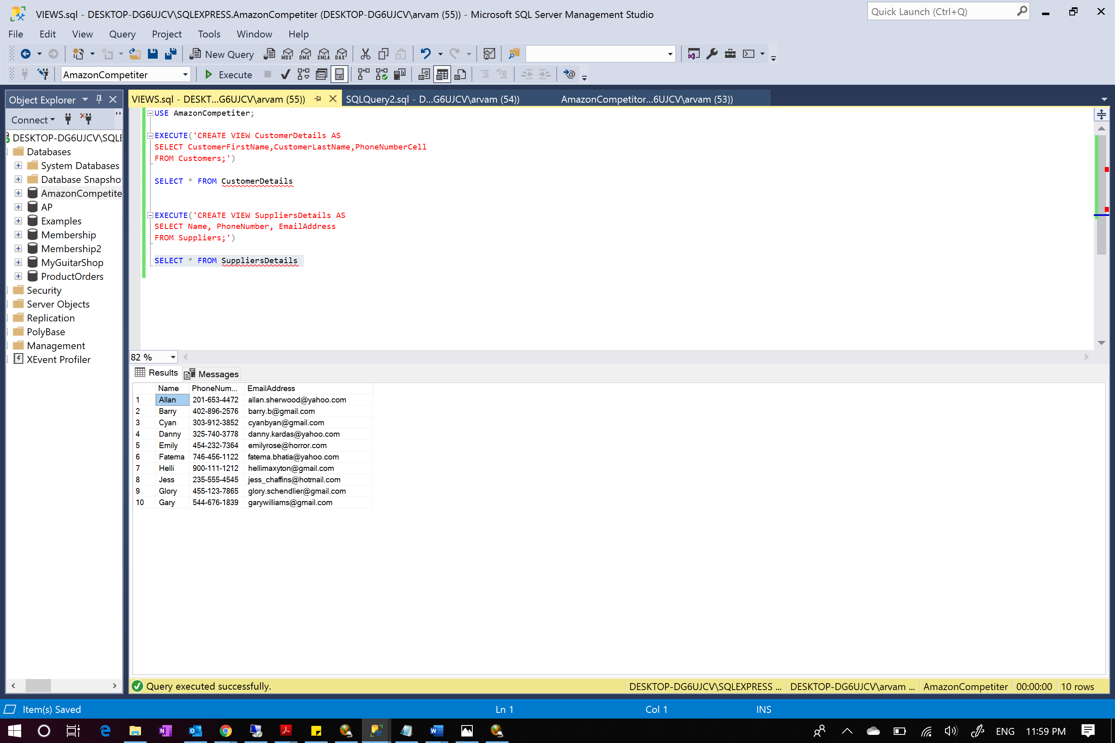

Executing this view returns 10 entries and 3 columns

3. A view was created that returns warehouse full address along with state and city from zipcode table

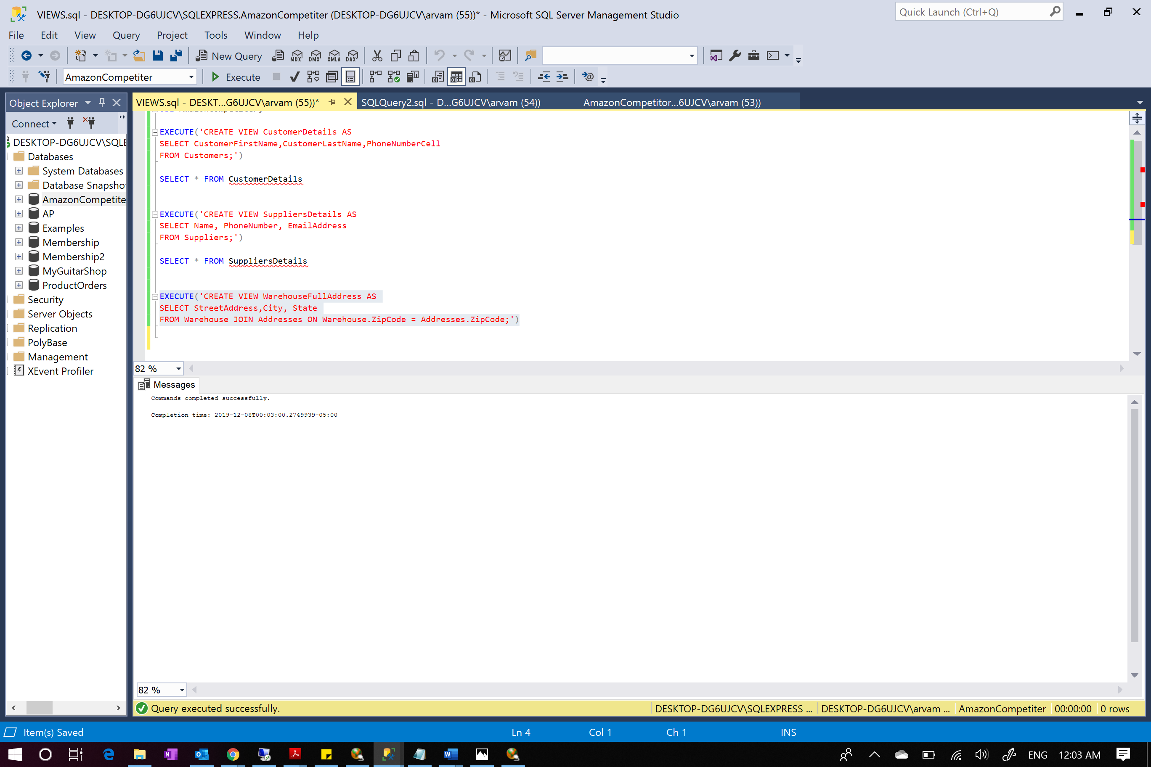

View created successfully

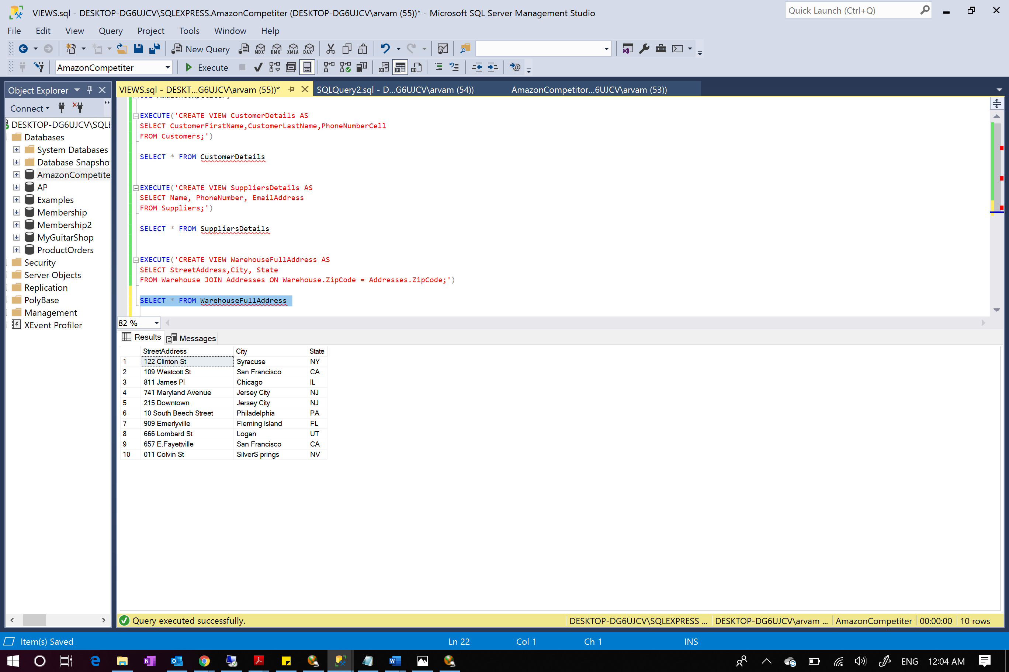

Execution of the view that returns the complete address of all warehouses

4.Created a view that return top 2 rated products.

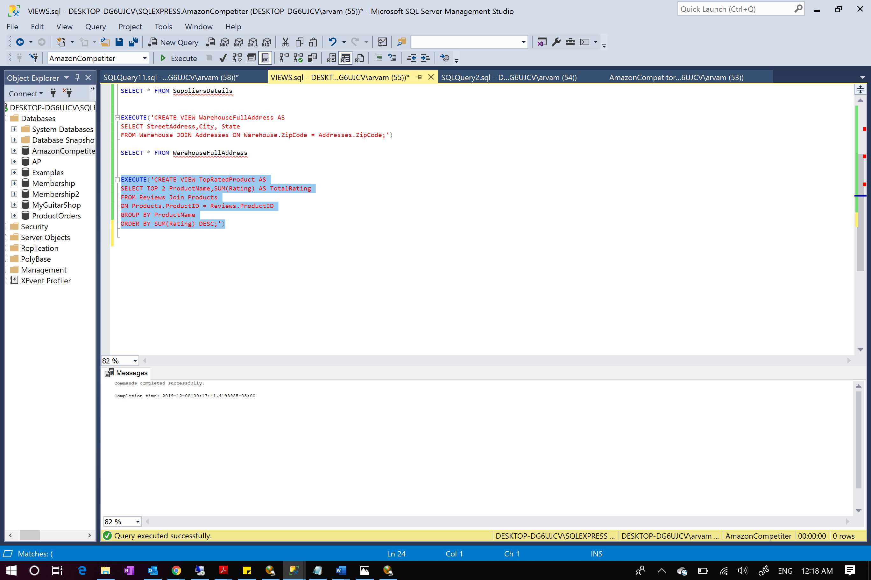

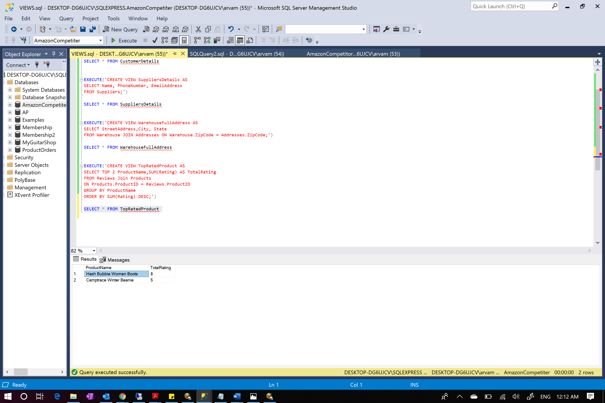

Result shows the best rated top 2 products

5.Created a view that shows all returnID orders that has zero shipping fee which can help analyze the company profits

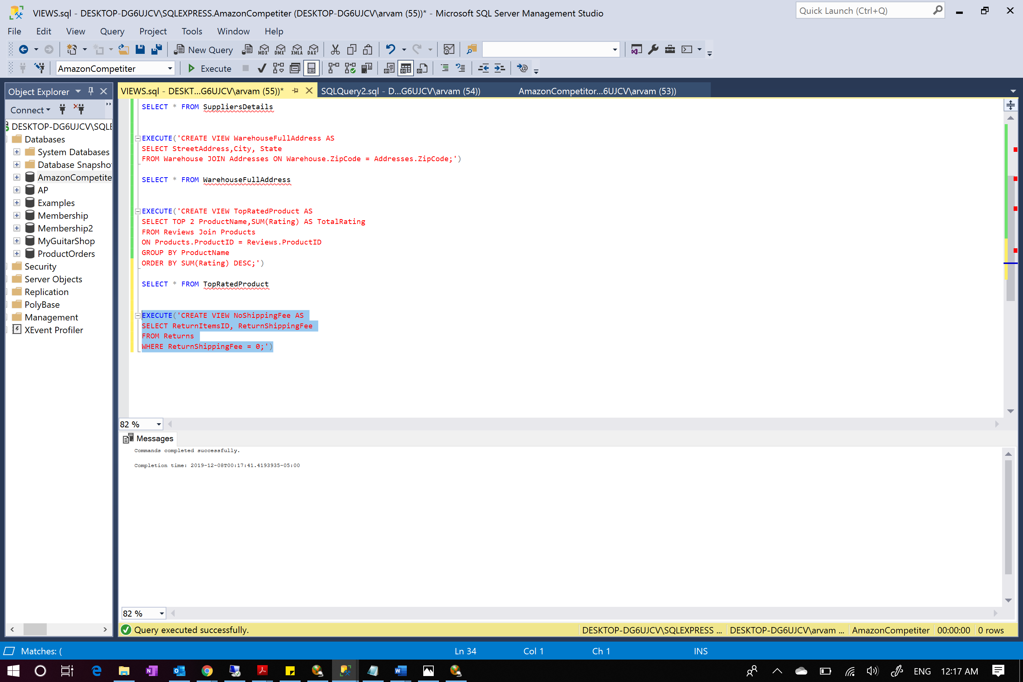

View created successfully

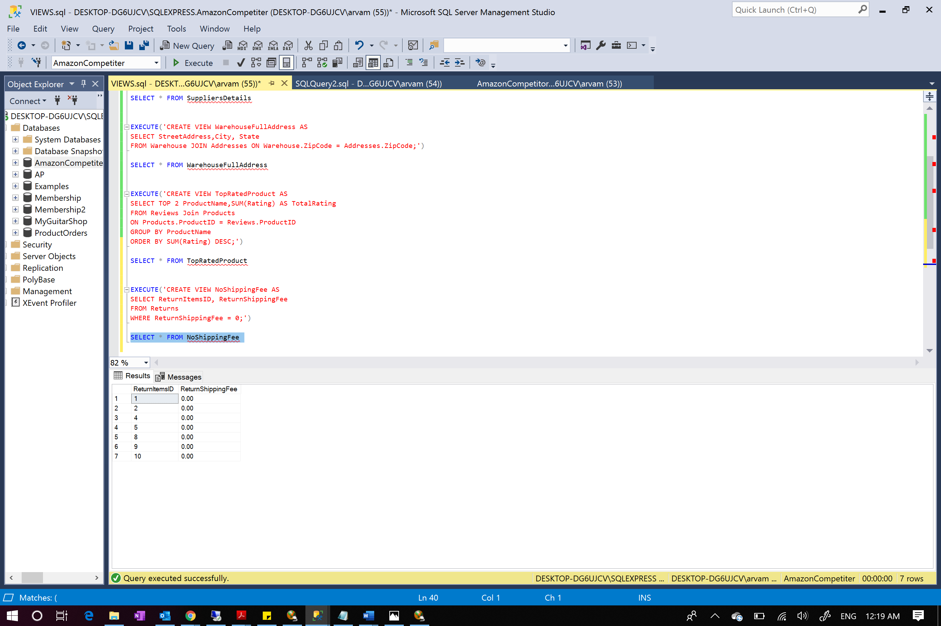

Executed view returns 7 entries with 0 shipping fee

A trigger was created on customers that notified customer with a message whenever there is any update or insert made in Customers table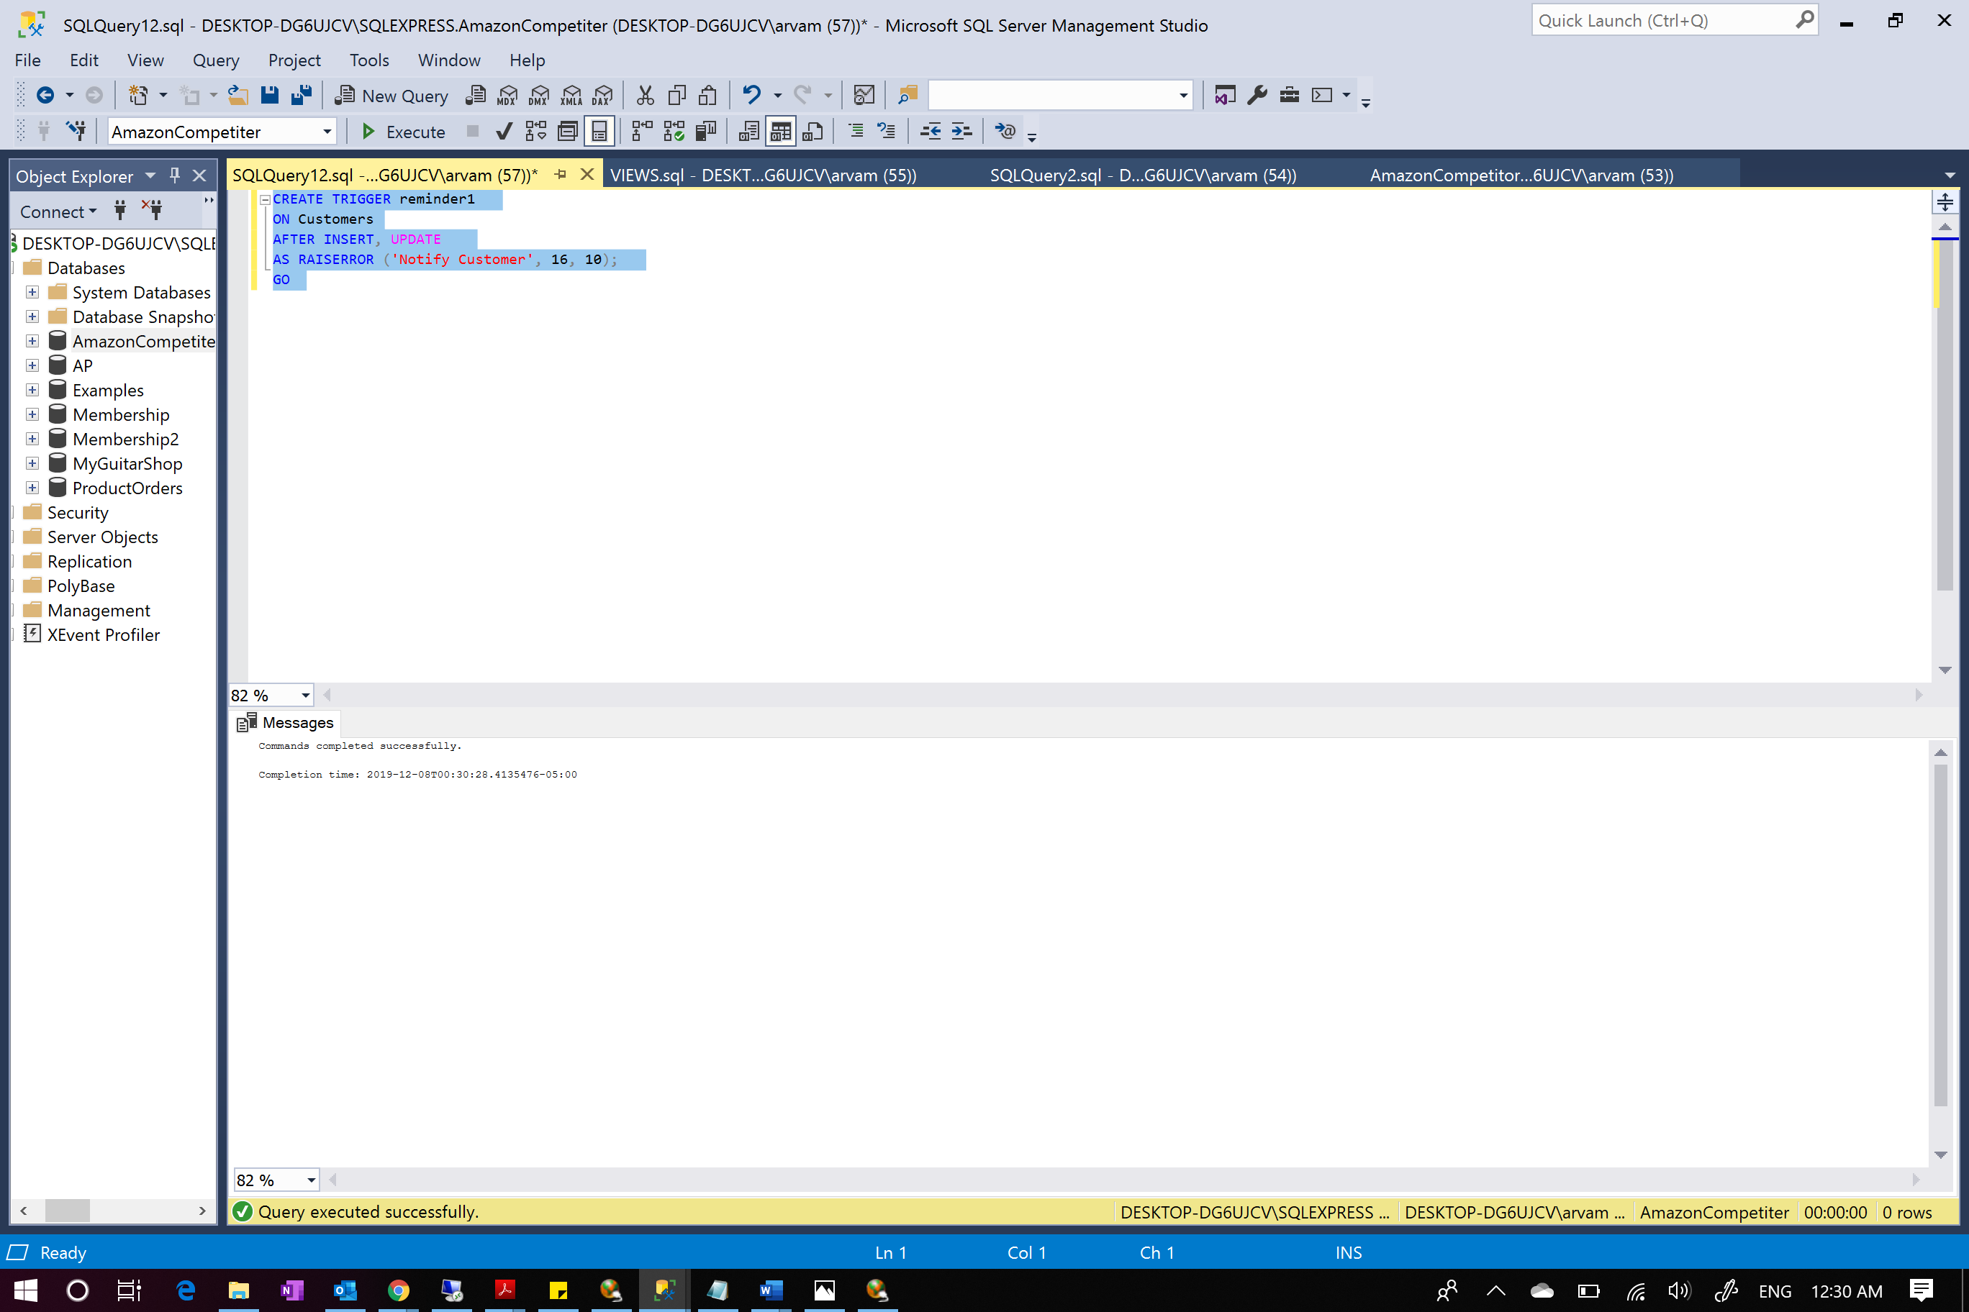Trigger was successfully applied

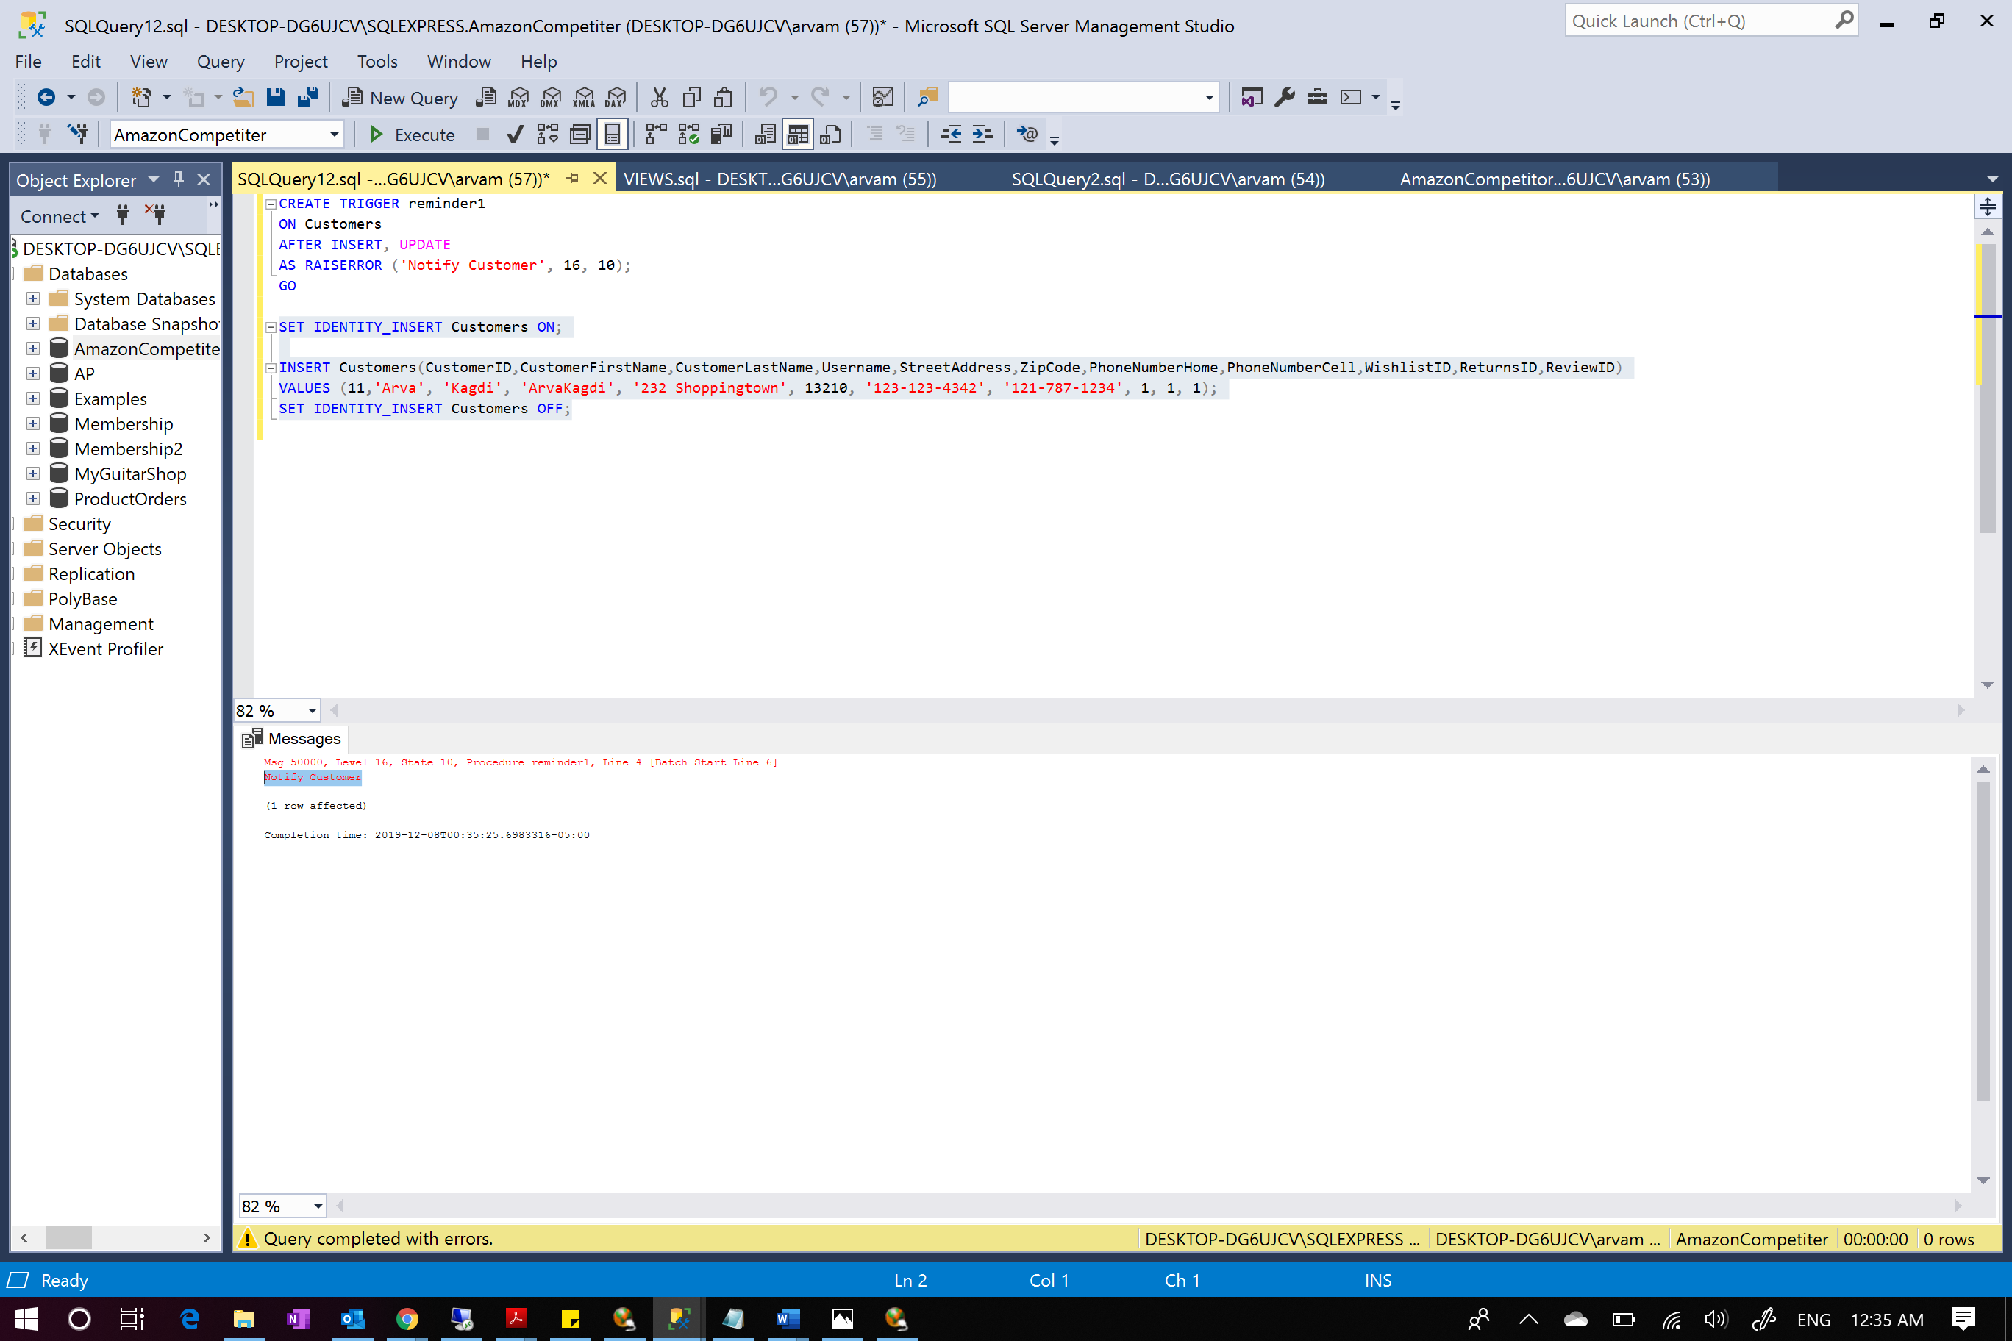

A message was generated saying “Notify Customer” when we inserted a new row in customers table.

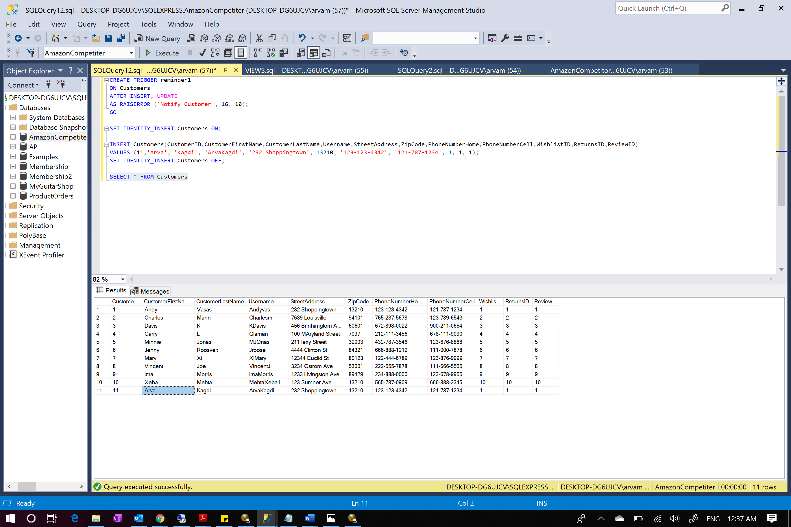

New customer ‘Arva’ was successfully added

A role ‘grant’ was created to add security to the database. It grants permission of update on cutomers, update, insert on Addresses and Update, delete on Suppliers

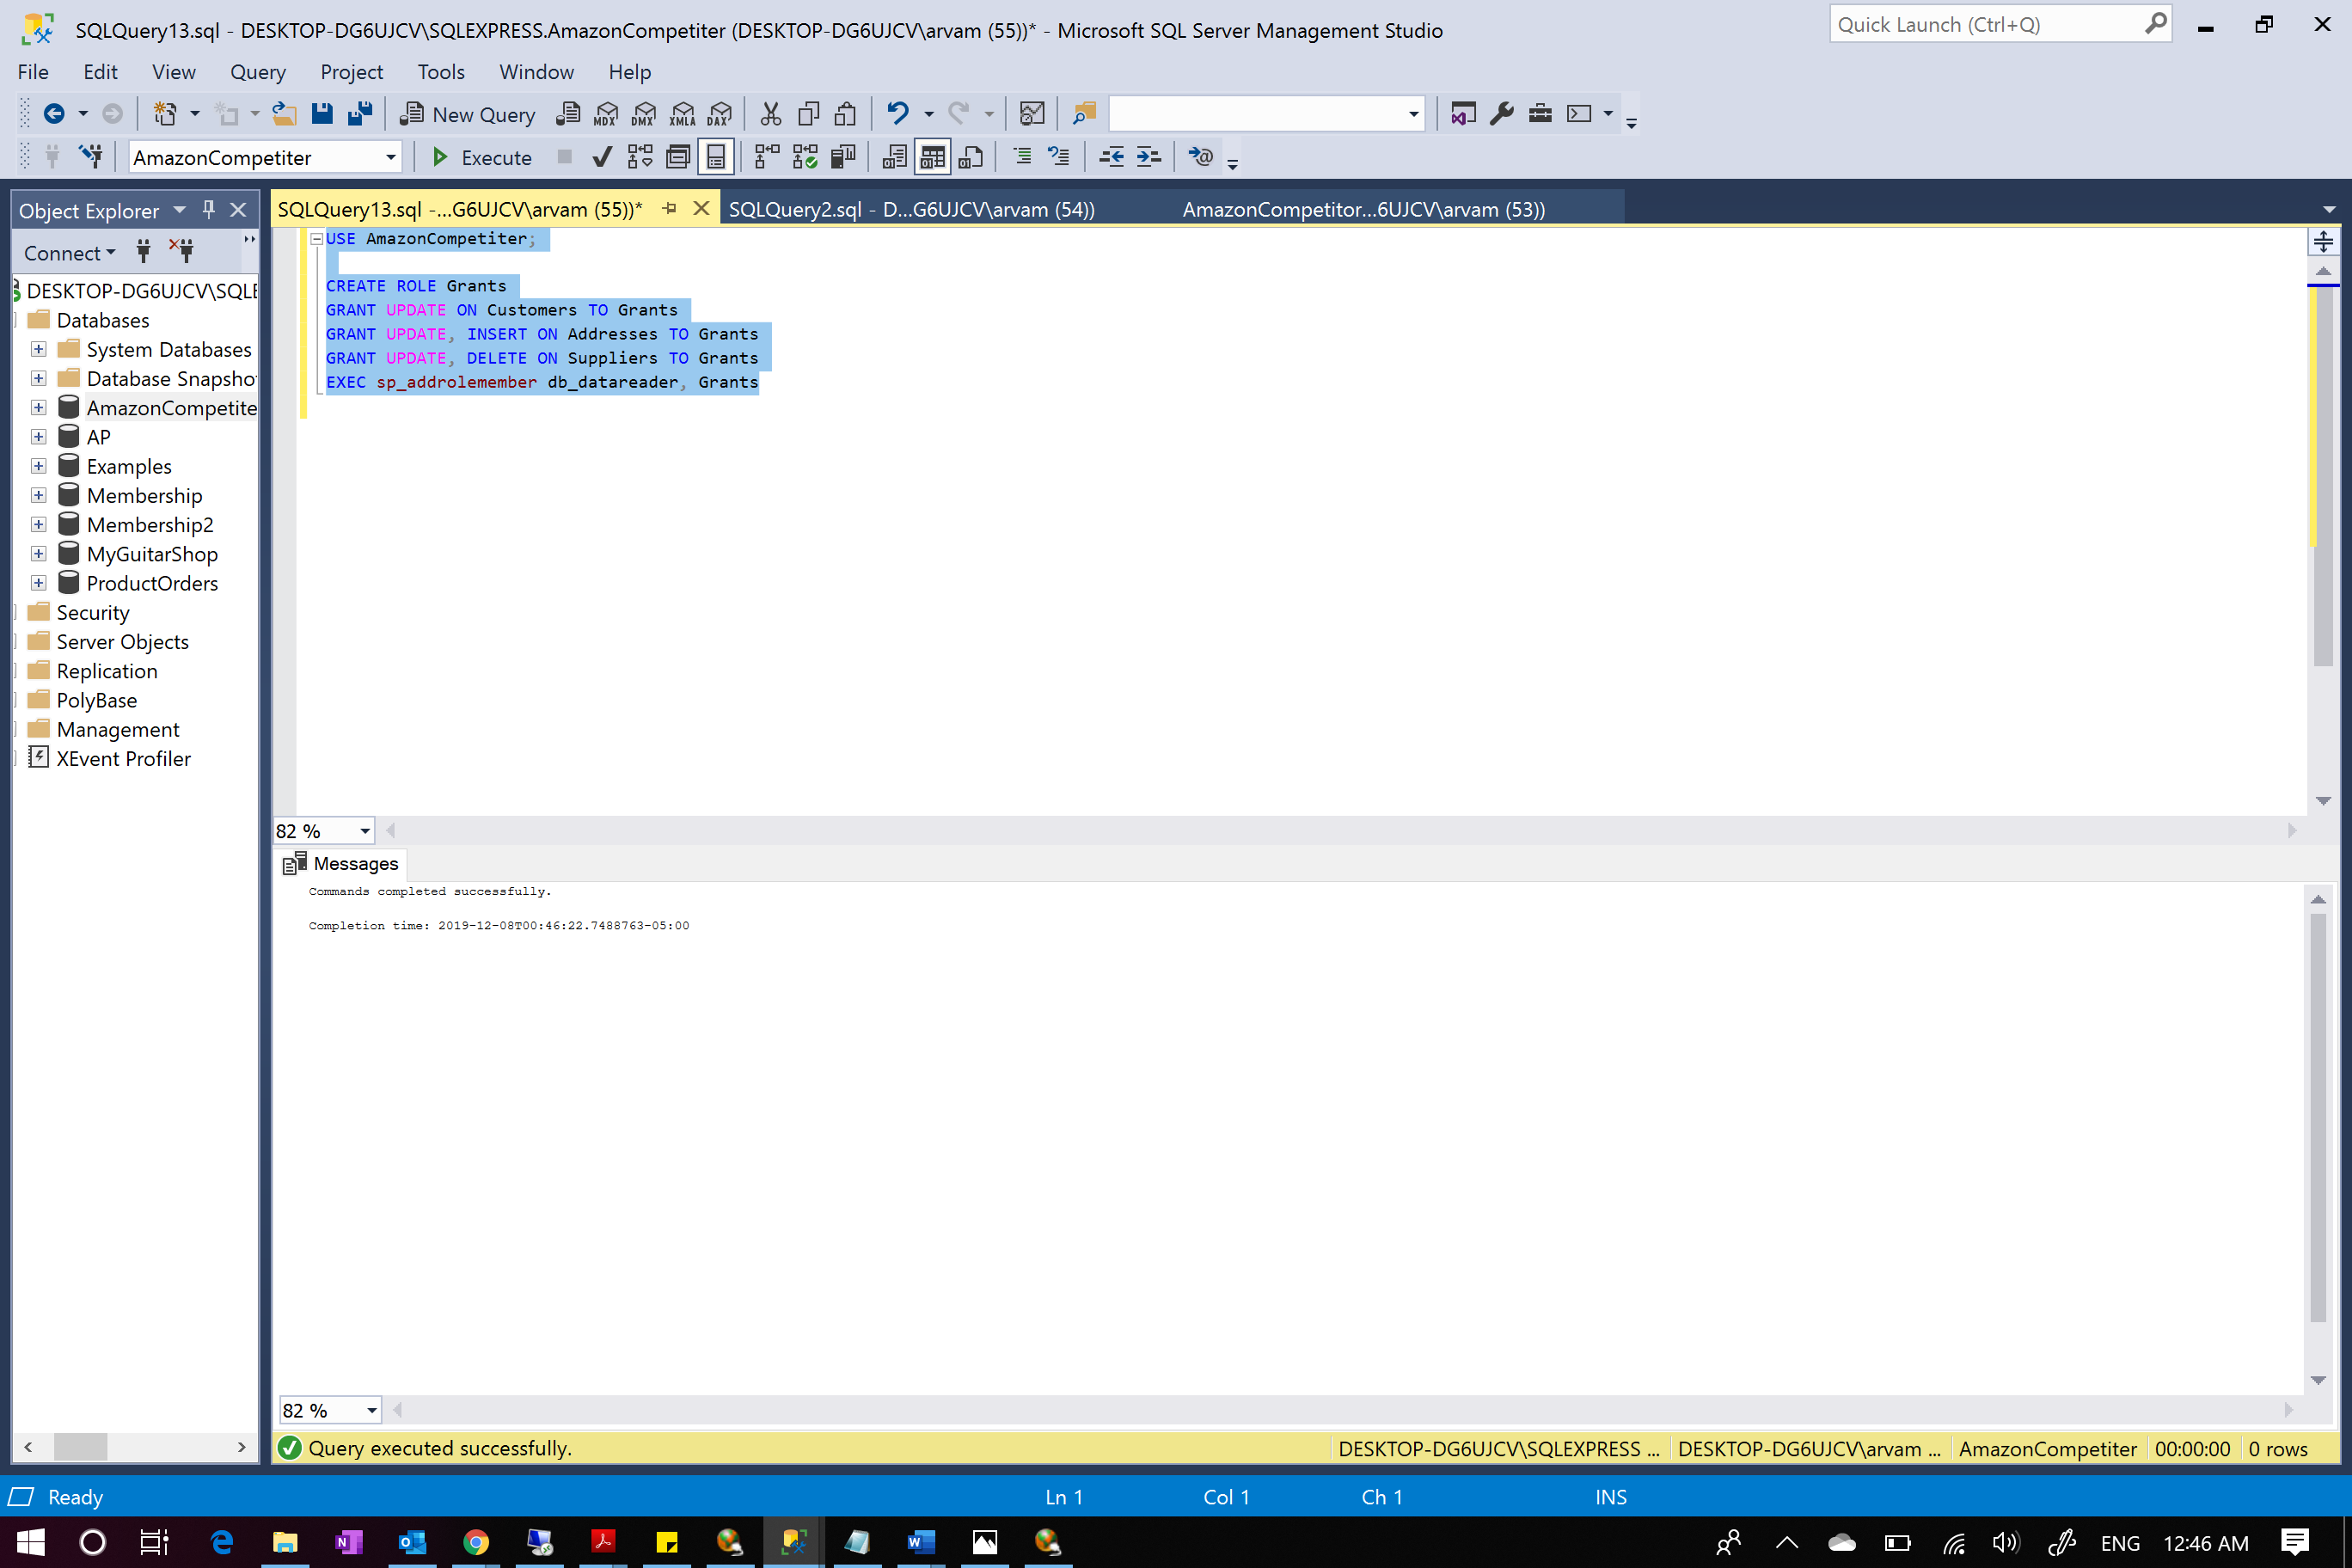

Role successfully created

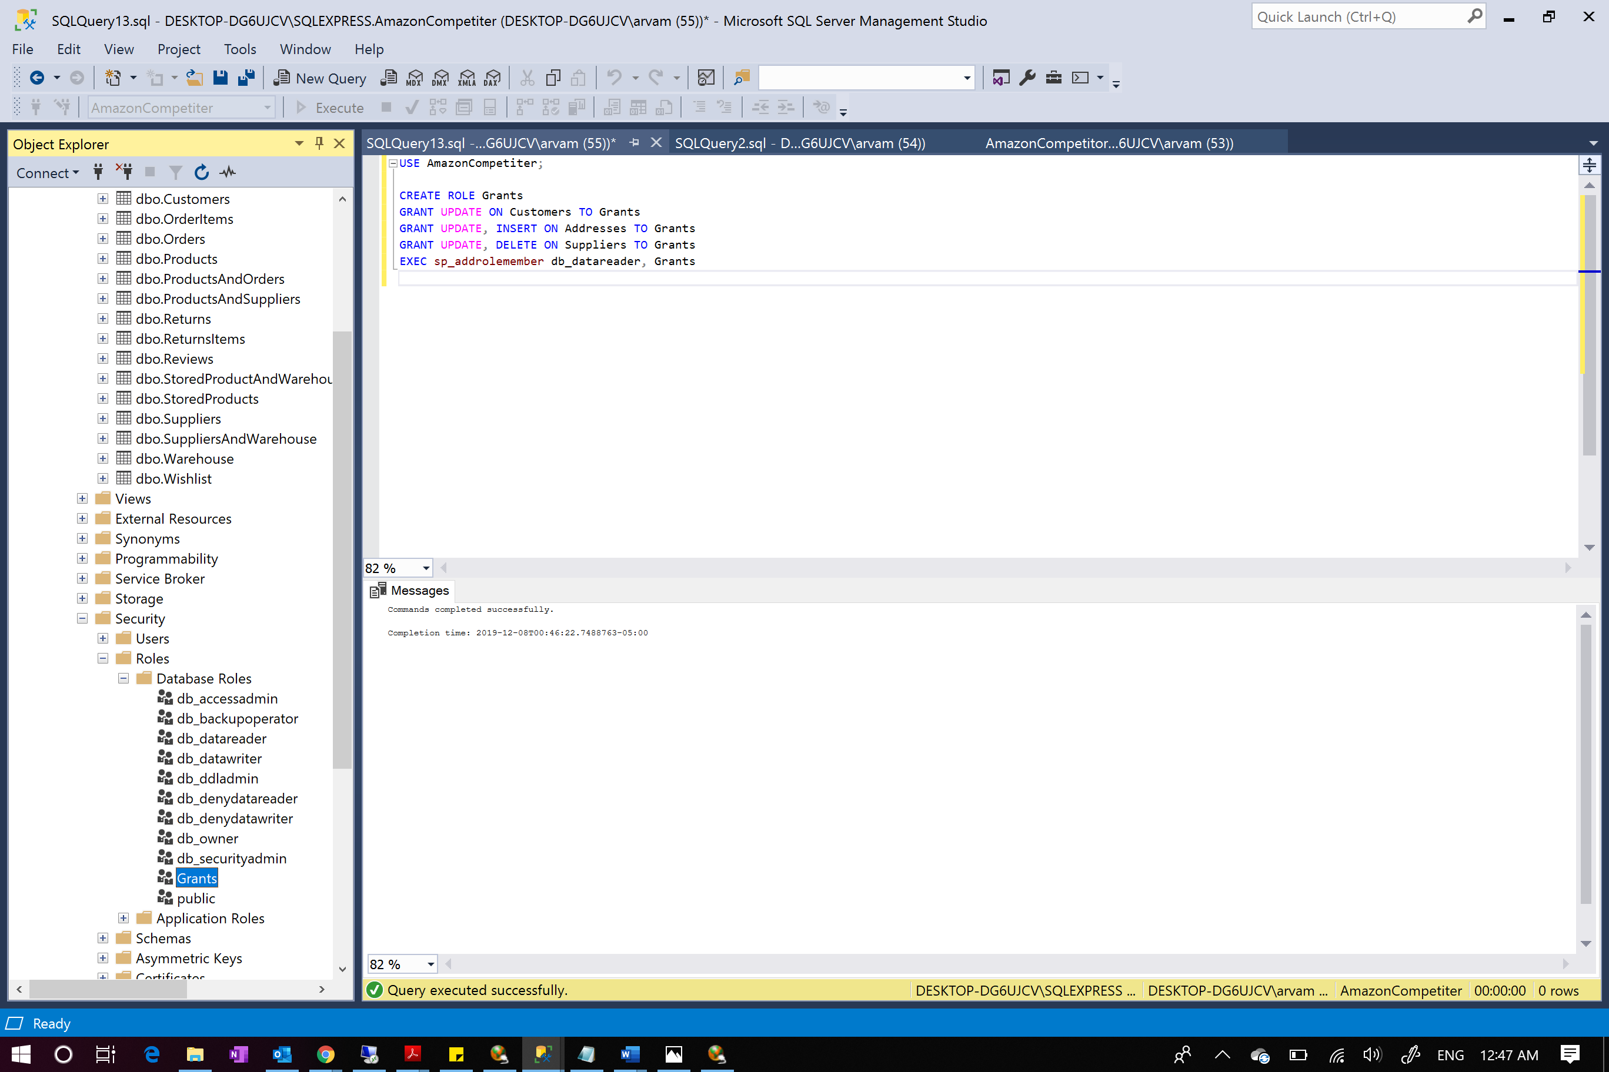

We can see a new role Grant created

A new login named AmazonLogin was created with password 123456 and a user named Arva and permission was granted to the user.

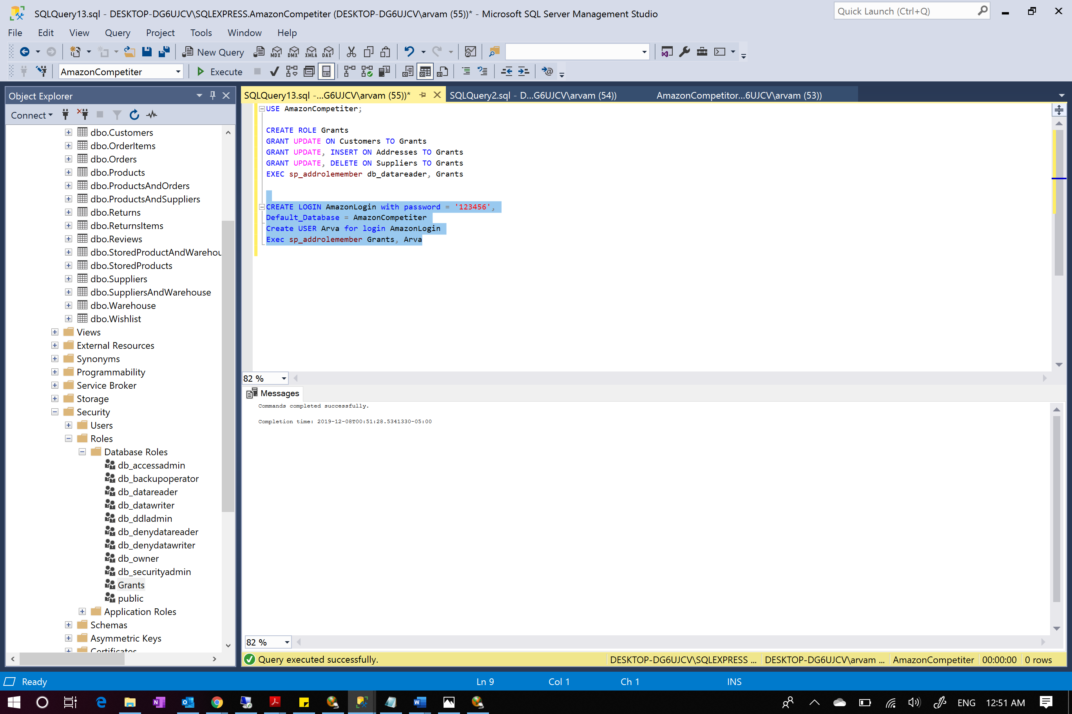

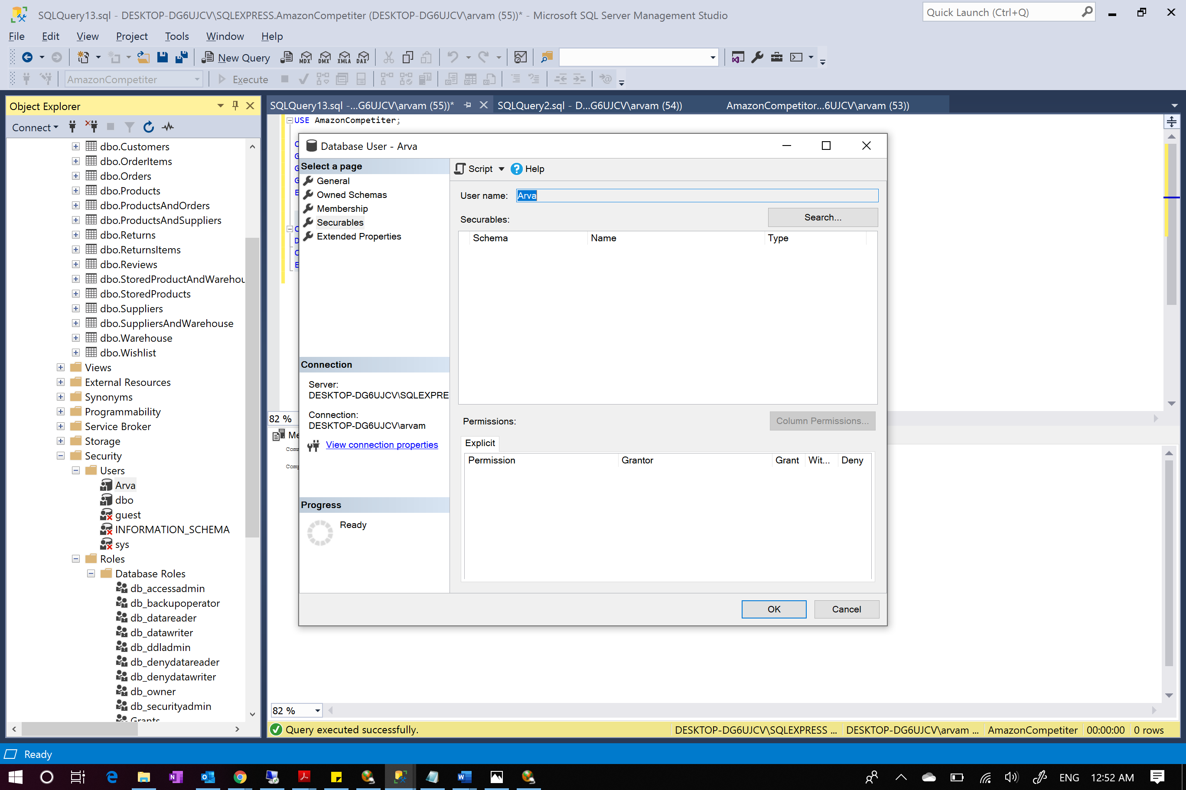

Shows the new user created

Here we write a script that creates schema with my name “NewSchema” and then transfer Customers table to this created schema from dbo schema. Now, assign admin schema as default schema for Arva user granting all privileges except REFERENCES and ALTER to Arva in this new schema.

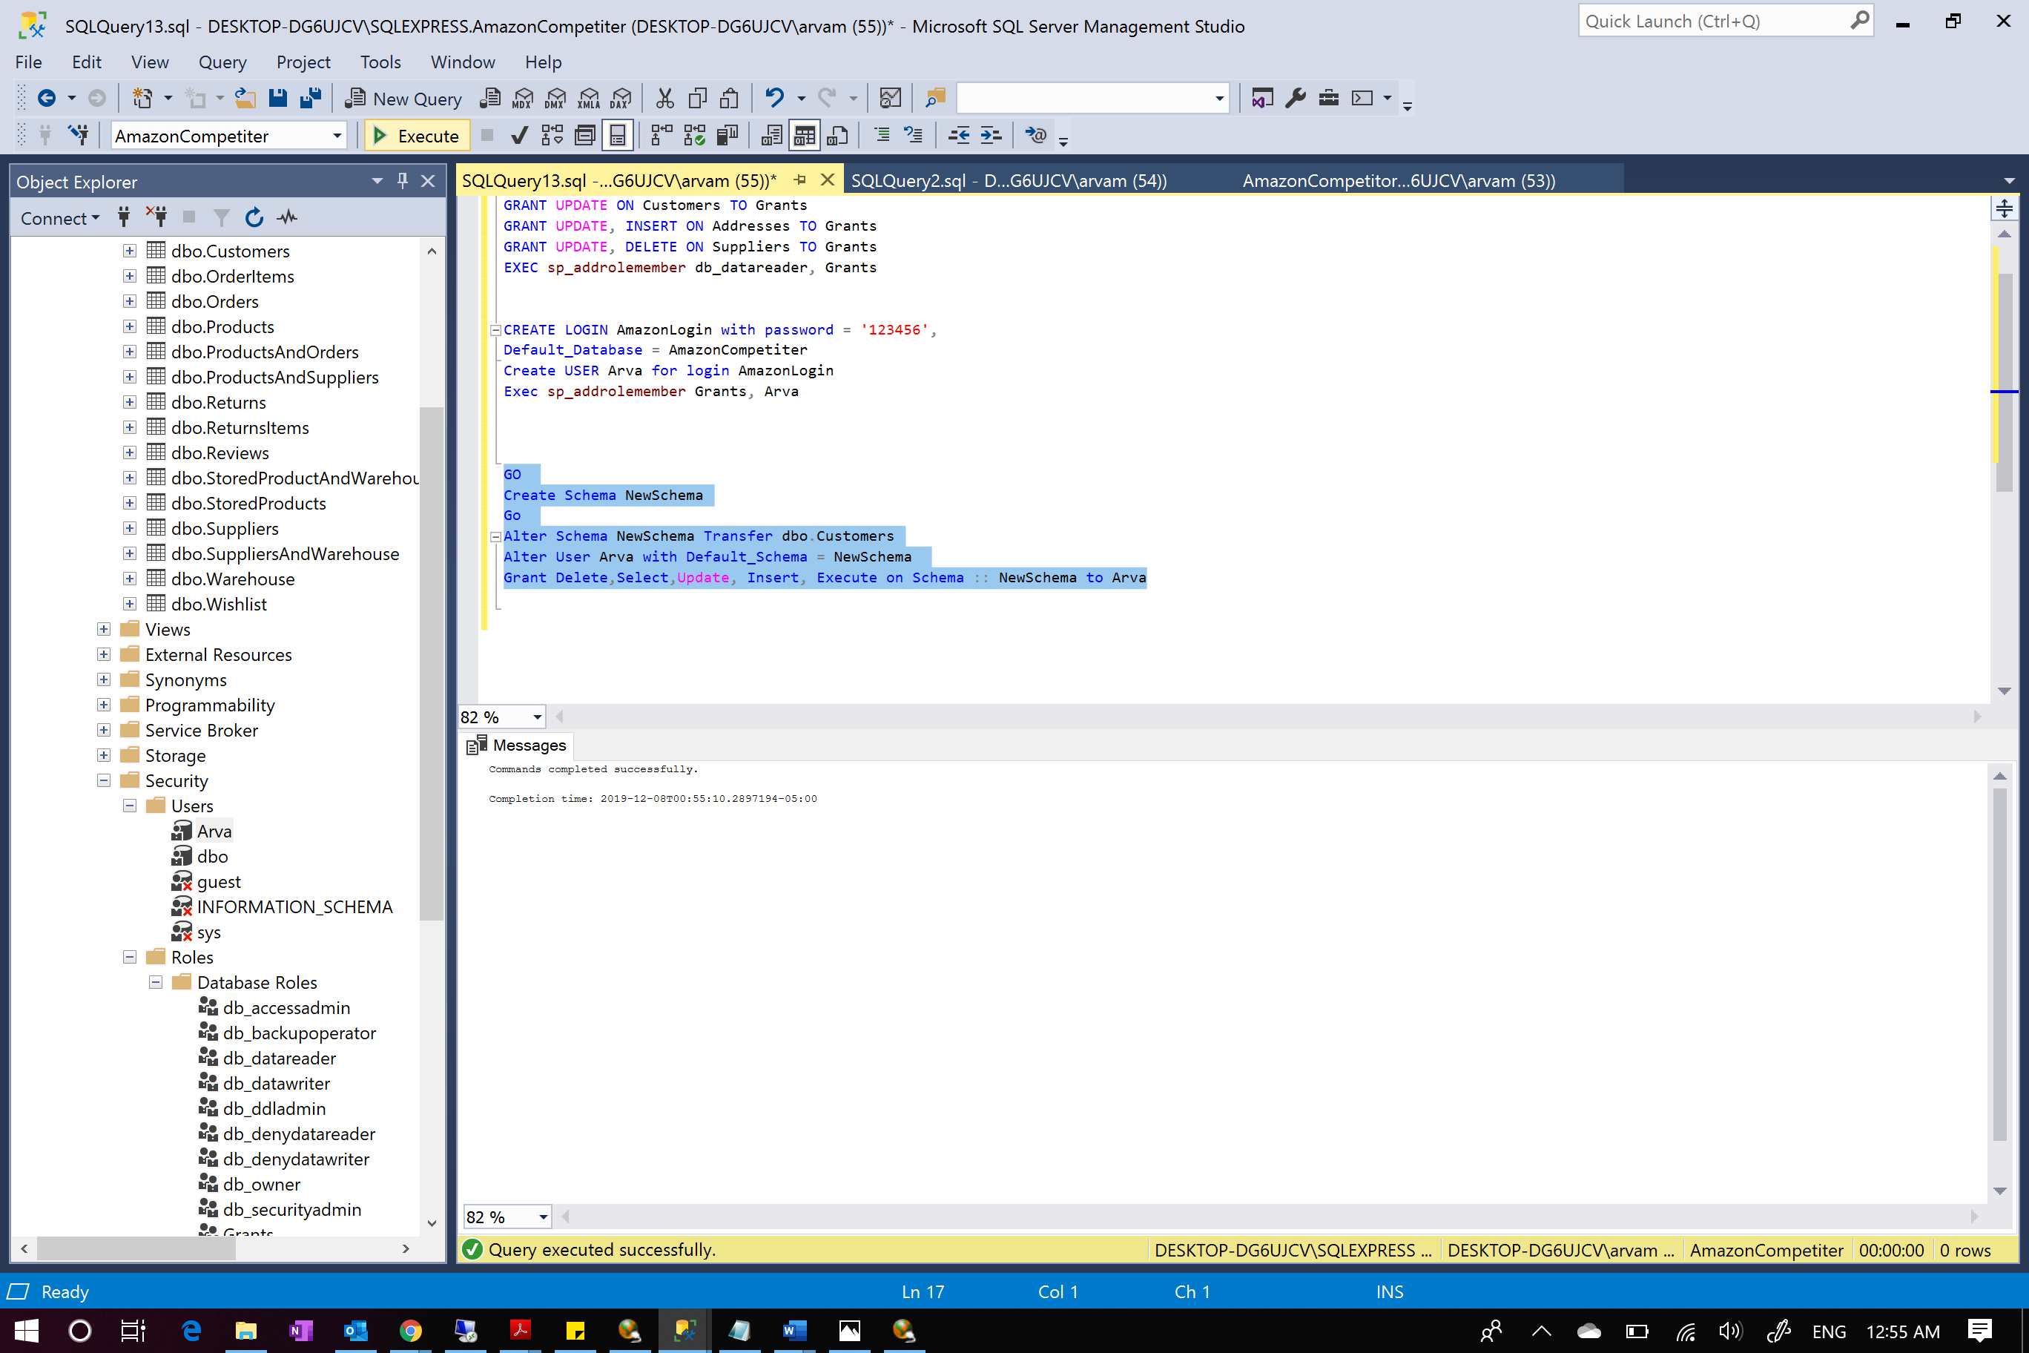

Stored Procedure:

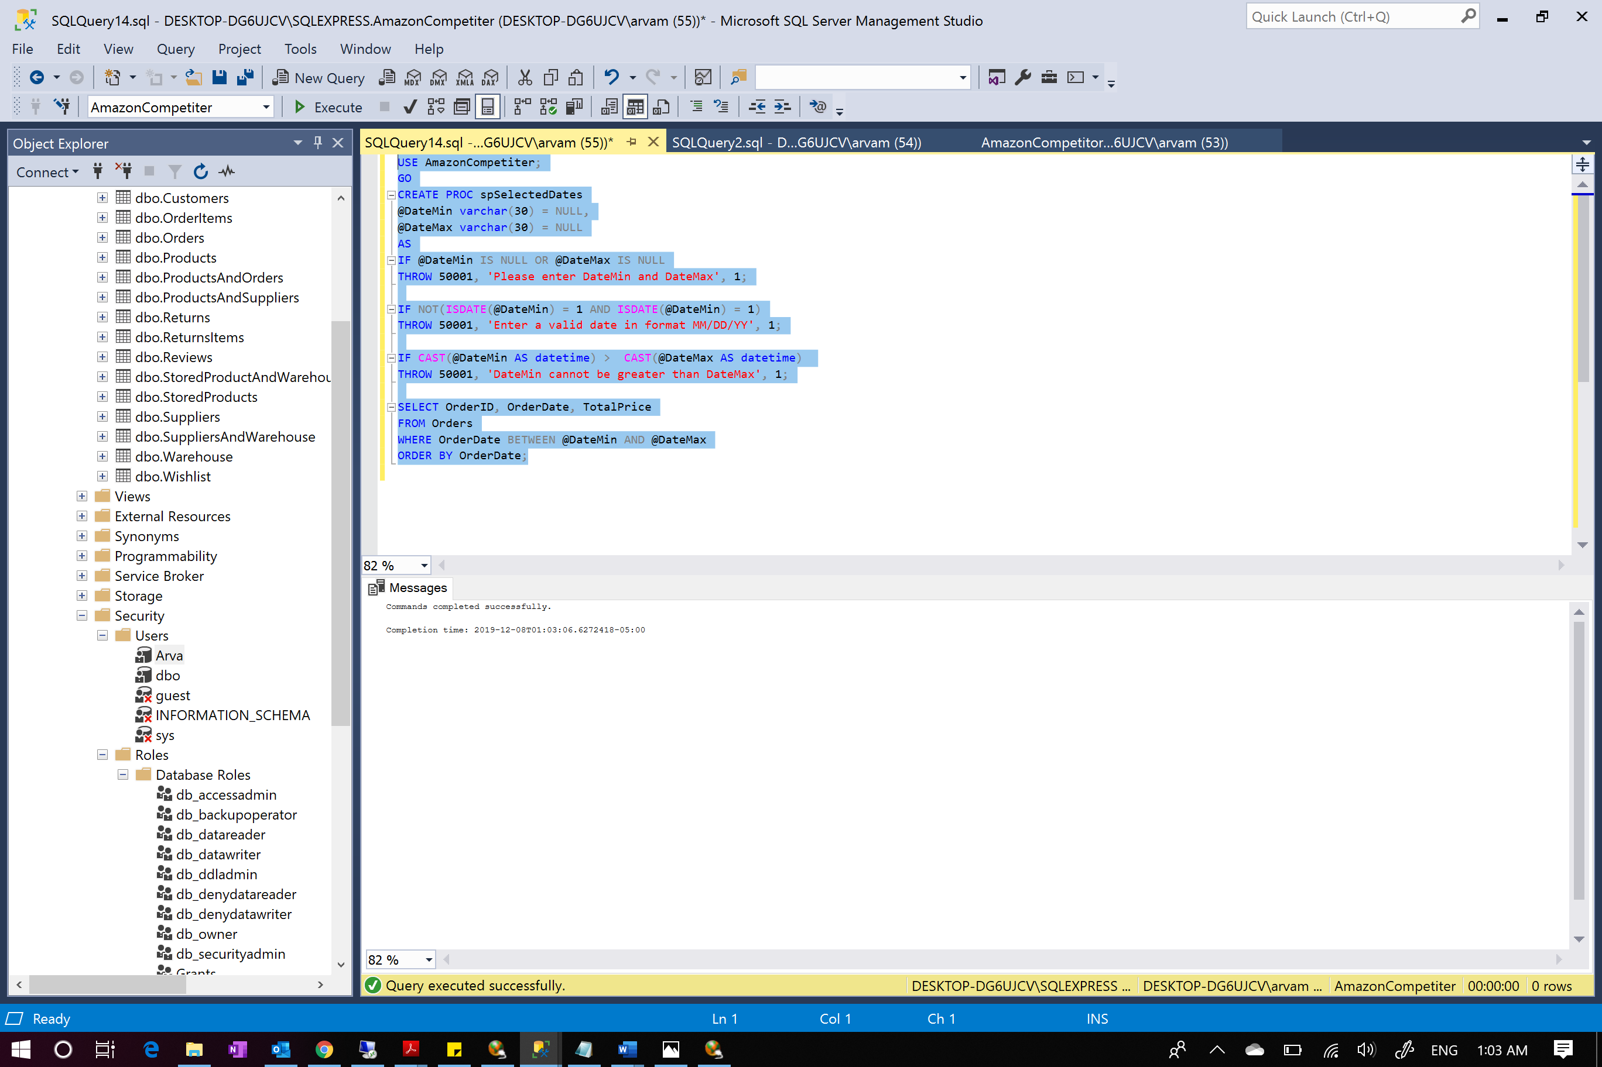

Here we create a stored procedure ‘spSelectedDates’ that returns OrderID, OrderDate, TotalPrice. It has 2 paramteres @DateMin and @DateMax having datatype varchar and default value = NULL. Here we raise different error messages when the procedure is called with no parameter or NULL values. Also, we check for valid date format and that DateMax should be greater than DateMin.

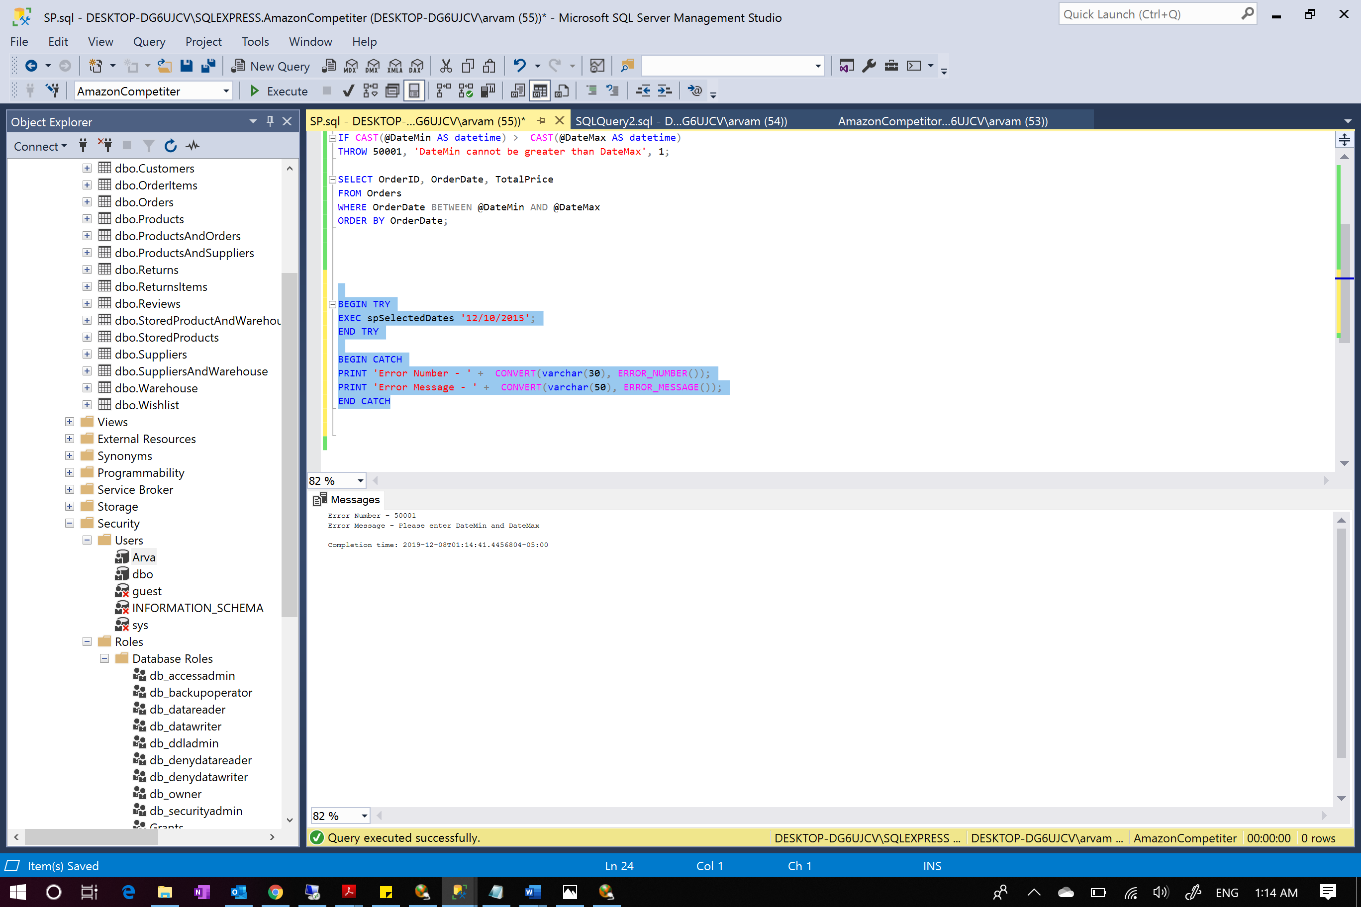

Shows error when the stored procedure is executed and only 1 date is entered which is invalid

Function:

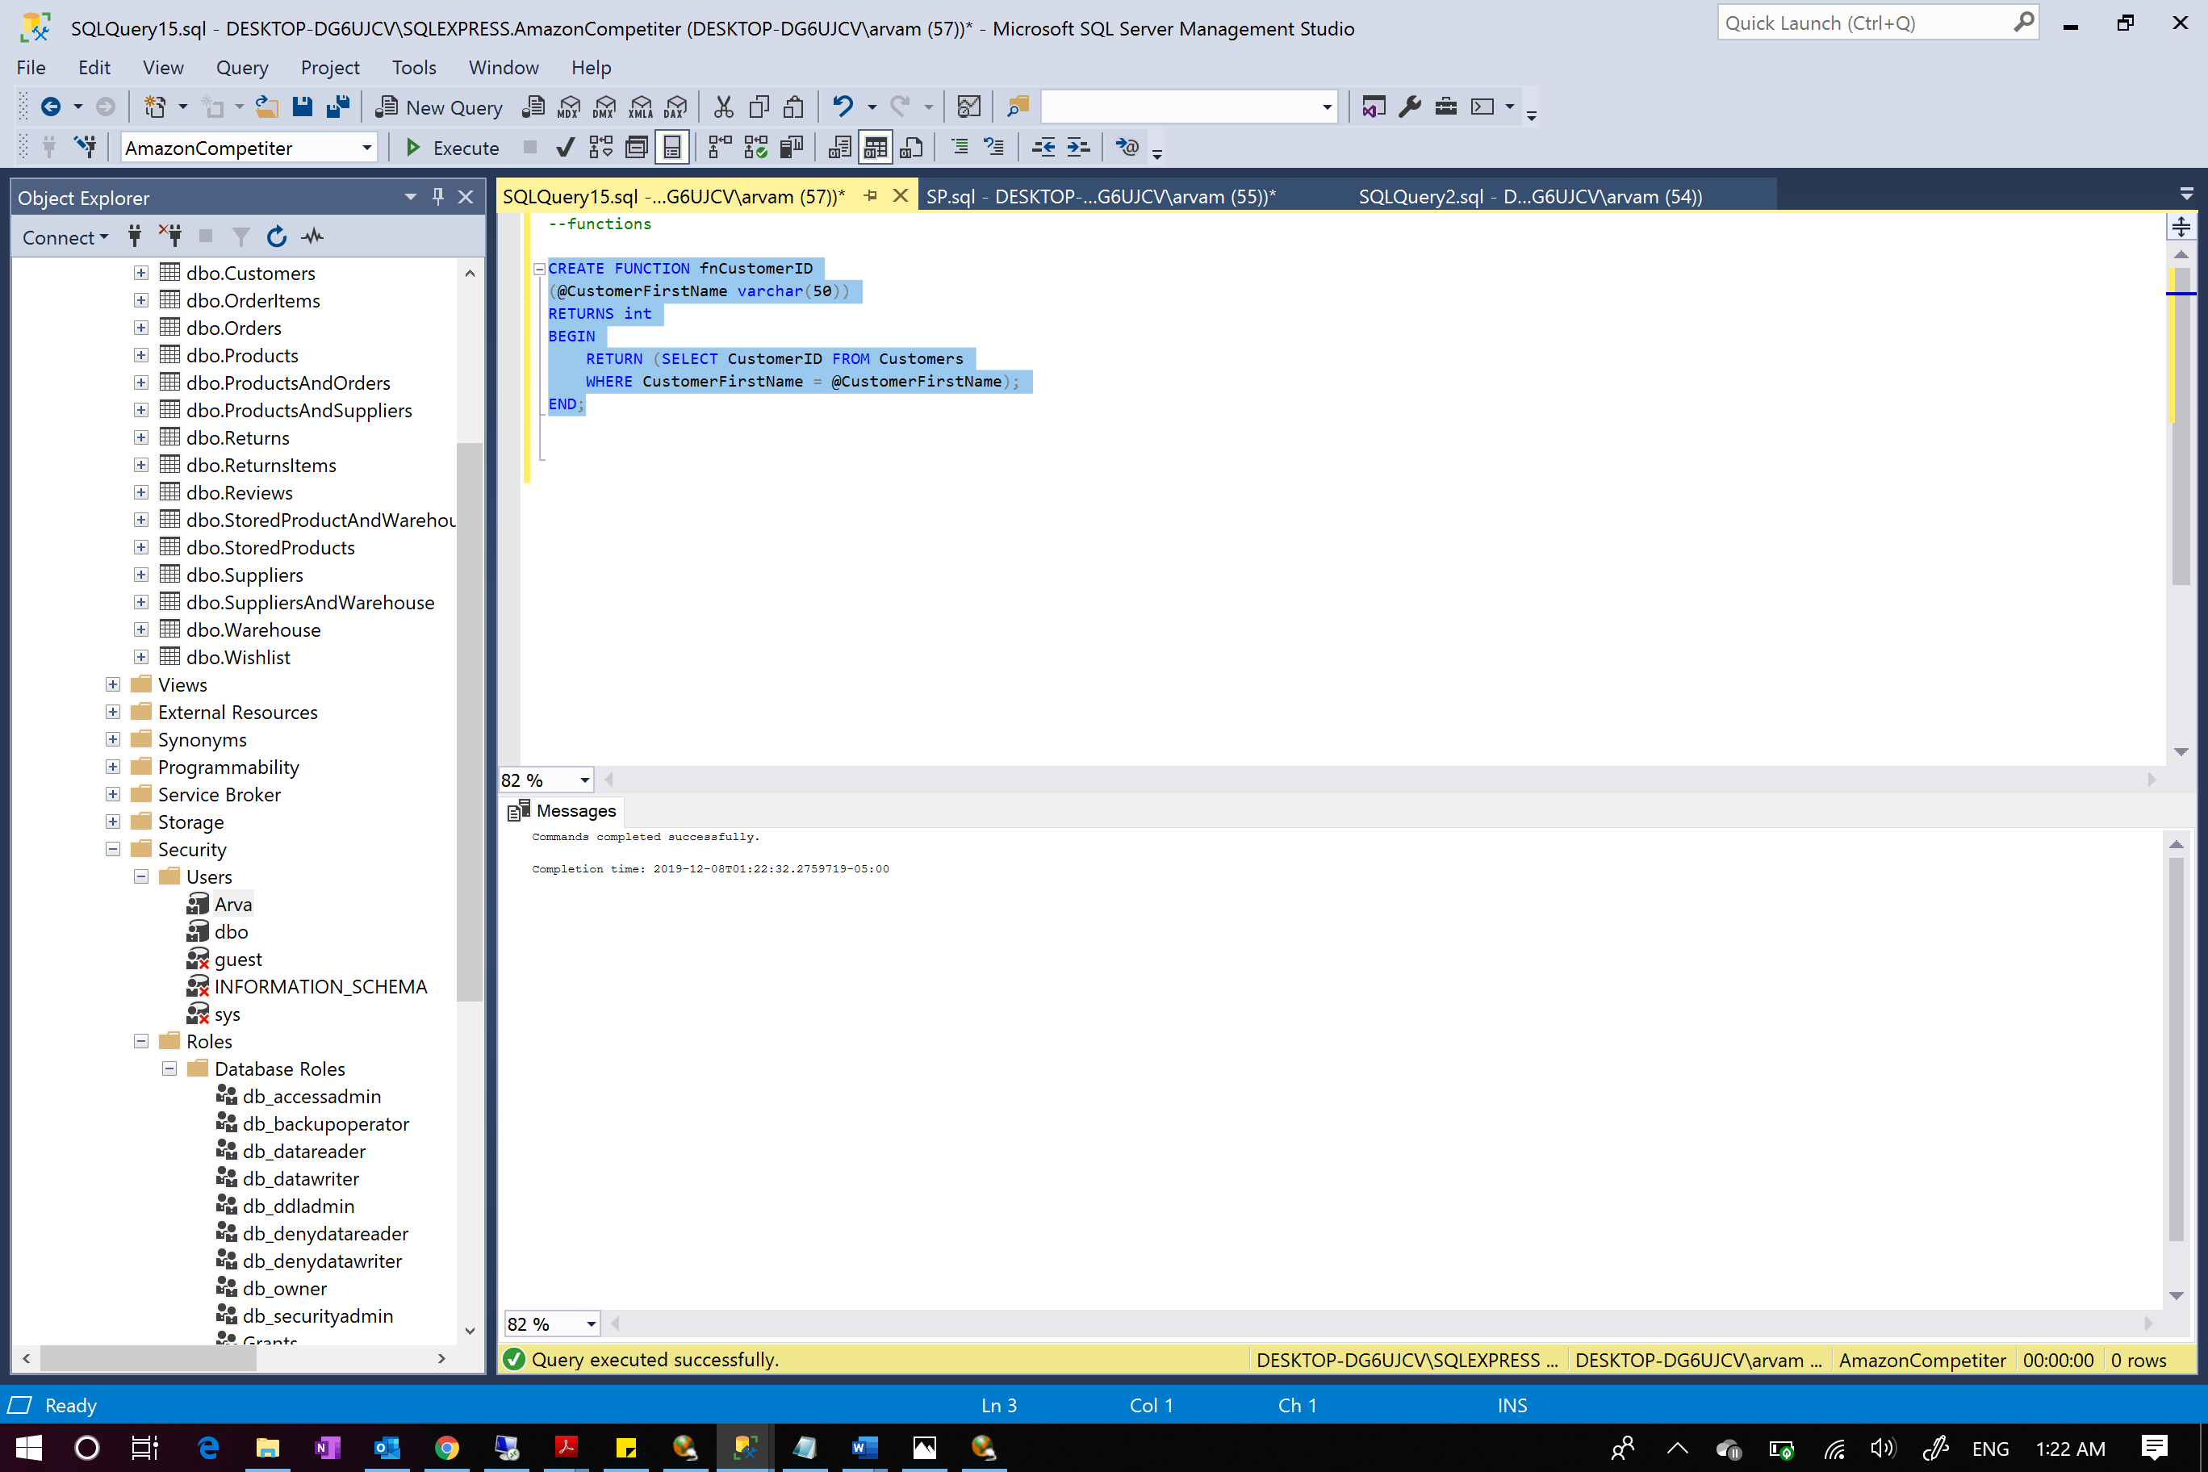

Created a new function that selects customerID it matches CustomersFirstName.

**REMARKS**

* **SQL Management Studio was used to run and successfully create Database and populated data**
* **Visio was used for the database design for a Amazon Competitor**
* **This project gave an in-depth knowledge in designing database and then implementing it**
* **We created AmazonCompetitor Database and executed different scripts to created views, stored procedure, logins, triggers, transactions for better performance and better security**
* **Queries included essential sql skills that uses joining tables, sorting, grouping**
* **Database was designed, and it was reduced to 3NF**
* **Database design was explained with relations on all tables explained**
* **This project was a great exposure to database design and problems related to designing and managing data**
* **Appendix contains entire code for reference**

**Appendix 1 – Database Design**

USE master

GO

/****** Object: Database AmazonCompetitor ******/

IF DB_ID('AmazonCompetiter') IS NOT NULL

DROP DATABASE AmazonCompetiter

GO

CREATE DATABASE AmazonCompetiter

GO

USE AmazonCompetiter

GO

/****** Object: Table Addresses ******/

CREATE TABLE Addresses(

ZipCode INT PRIMARY KEY IDENTITY,

City VARCHAR(40) NOT NULL,

State VARCHAR(2) NOT NULL,

);

/****** Object: Table Products ******/

CREATE TABLE Products(

ProductID INT PRIMARY KEY IDENTITY,

ProductName VARCHAR(255) NOT NULL,

Description VARCHAR(255) NOT NULL,

Price MONEY NOT NULL

);

/****** Object: Table StoredProducts ******/

CREATE TABLE StoredProducts(

StoredProductID INT PRIMARY KEY IDENTITY,

ProductID INT REFERENCES Products (ProductID),

ProductName VARCHAR(255) NOT NULL,

NumberOnTheWay INT NOT NULL,

NumberInStock INT NOT NULL,

NumberInReturn INT NOT NULL,

);

/****** Object: Table Warehouse ******/

CREATE TABLE Warehouse(

WarehouseID INT PRIMARY KEY IDENTITY,

StreetAddress VARCHAR(60) NOT NULL,

ZipCode INT REFERENCES Addresses(ZipCode),

);

/****** Object: Table OrderItems ******/

CREATE TABLE OrderItems(

OrderItemsID INT PRIMARY KEY IDENTITY,

ProductID INT REFERENCES Products (ProductID),

Quantity INT NOT NULL,

UnitPrice MONEY NOT NULL,

TotalPrice MONEY NOT NULL,

);

/****** Object: Table Wishlist ******/

CREATE TABLE Wishlist(

WishlistID INT PRIMARY KEY IDENTITY,

ProductID INT REFERENCES Products (ProductID)

);

/****** Object: Table Suppliers ******/

CREATE TABLE Suppliers(

SupplierID INT PRIMARY KEY IDENTITY,

Name VARCHAR(255) NOT NULL,

SupplierStreetAddress VARCHAR(60) NOT NULL,

ZipCode INT REFERENCES Addresses(ZipCode),

PhoneNumber VARCHAR(12) NOT NULL,

EmailAddress VARCHAR(255) NOT NULL,

);

/****** Object: Table ReturnsItems ******/

CREATE TABLE ReturnsItems(

ReturnItemsID INT PRIMARY KEY IDENTITY,

ProductID INT REFERENCES Products (ProductID),

NumberOfItems INT NOT NULL

);

/****** Object: Table Returns ******/

CREATE TABLE Returns(

ReturnsID INT PRIMARY KEY IDENTITY,

Status VARCHAR(20) NOT NULL,

ReturnDate DATETIME DEFAULT NULL,

ReturnItemsID INT REFERENCES ReturnsItems (ReturnItemsID),

ShippingService VARCHAR(255) NOT NULL,

ShippingStreet VARCHAR(255) NOT NULL,

ZipCode INT REFERENCES Addresses(ZipCode),

ReturnShippingFee MONEY NOT NULL,

ShippingInfo VARCHAR(255) DEFAULT NULL,

);

/****** Object: Reviews ******/

CREATE TABLE Reviews(

ReviewID INT PRIMARY KEY IDENTITY,

CustomerName VARCHAR(255) DEFAULT NULL,

DateOfReview DATETIME NOT NULL,

Rating INT DEFAULT NULL,

Text VARCHAR(255) DEFAULT NULL,

ProductID INT REFERENCES Products (ProductID),

);

/****** Object: Table Customers ******/

CREATE TABLE Customers(

CustomerID INT PRIMARY KEY IDENTITY,

CustomerFirstName VARCHAR(255) NOT NULL,

CustomerLastName VARCHAR(255) NOT NULL,

Username VARCHAR(255) NOT NULL,

StreetAddress VARCHAR(255) NOT NULL,

ZipCode INT REFERENCES Addresses(ZipCode),

PhoneNumberHome VARCHAR(12) NOT NULL,

PhoneNumberCell VARCHAR(12) NOT NULL,

WishlistID INT REFERENCES Wishlist (WishlistID),

ReturnsID INT REFERENCES Returns (ReturnsID),

ReviewID INT REFERENCES Reviews (ReviewID),

);

/****** Object: Table Orders ******/

CREATE TABLE Orders(

OrderID INT PRIMARY KEY IDENTITY,

Status VARCHAR(20) NOT NULL,

OrderDate DATETIME NOT NULL,

OrderItemsID INT REFERENCES OrderItems (OrderItemsID),

TotalPrice MONEY NOT NULL,

ShippingService VARCHAR(255) NOT NULL,

ShippingStreet VARCHAR(255) NOT NULL,

ZipCode INT REFERENCES Addresses(ZipCode),

ShippingFee MONEY NOT NULL,

ExpectedShippingDate DATETIME NOT NULL,

ActualShippingDate DATETIME DEFAULT NULL,

ShippingInfo VARCHAR(255) DEFAULT NULL,

SupplierID INT REFERENCES Suppliers (SupplierID),

ReturnsID INT REFERENCES Returns (ReturnsID),

CustomerID INT REFERENCES Customers (CustomerID)

);

/****** Object: Table ProductsAndOrders ******/

CREATE TABLE ProductsAndOrders(

ProductiD INT REFERENCES Products (ProductiD),

OrderID INT REFERENCES Orders (OrderID)

);

/****** Object: Table ProductsAndSuppliers ******/

CREATE TABLE ProductsAndSuppliers(

ProductiD INT REFERENCES Products (ProductiD),

SupplierID INT REFERENCES Suppliers (SupplierID)

);

/****** Object: Table SuppliersAndWarehouse ******/

CREATE TABLE SuppliersAndWarehouse(

SupplierID INT REFERENCES Suppliers (SupplierID),

WarehouseID INT REFERENCES Warehouse (WarehouseID)

);

CREATE TABLE StoredProductAndWarehouse(

StoredProductID INT REFERENCES StoredProducts (StoredProductID),

WarehouseID INT REFERENCES Warehouse (WarehouseID)

);

**Appendix 2 – Populating Tables**

USE AmazonCompetiter;

SET IDENTITY_INSERT Addresses ON;

INSERT INTO Addresses (ZipCode, City, State) VALUES

('13210', 'Syracuse', 'NY'),

('94101', 'San Francisco', 'CA'),

('60601', 'Chicago', 'IL'),

('07097', 'Jersey City', 'NJ'),

('19092', 'Philadelphia', 'PA'),

('32003', 'Fleming Island', 'FL'),

('84321', 'Logan', 'UT'),

('80123', 'Littleton', 'CO'),

('53001', 'Adell', 'WI'),

('89429', 'SilverS prings', 'NV');

SET IDENTITY_INSERT Addresses OFF;

SELECT * FROM Addresses;

SET IDENTITY_INSERT Products ON;

INSERT INTO Products (ProductID, ProductName, Description, Price) VALUES

(1,'Hash Bubbie Women Boots', 'Women''s Classic Snow Boots Fur Lined Ankle Bootie Warm Short Boots Winter Shoes', '39.99'),

(2,'Nautica Men Boots', 'Nautica Mens Duck Boots - Waterproof Shell Insulated Snow Boot - Channing','65.61'),

(3,'OROLAY Womwn Jacket', 'Orolay Women''s Thickened Down Jacket (Most Wished &Gift Ideas)','159.99'),

(4,'Tommy Hilfiger Men''s', 'Tommy Hilfiger Men''s Classic Hooded Puffer Jacket (Regular and Big & Tall Sizes)', '75' ),

(5,'Camptrace Winter Beanie', 'Camptrace Winter Beanie Hats for Women Cable Knit Fleece Lining Warm Hats Slouchy Thick Skull Cap', '12.50'),

(6,'Winter Beanie Hats Scarf Set', 'Winter Beanie Hats Scarf Set Warm Knit Hats Skull Cap Neck Warmer with Thick Fleece Lined Winter Hat & Scarf for Men Women', '14.99'),

(7,'Burton Men''s Gore-Tex Glove', 'DRYRIDE two-layer fabric with Gore warm technology offers a dry and breathable level of performance', '133.54'),

(8,'Magnificient Baby', 'Magnetic Me So Soft Minky Fleece Magnetic Baby Mittens', '16'),

(9,'Spasilk Baby Blanket', 'Spasilk Minky Raised Dot Baby Blanket with Satin Trim—Double Layer Blanker for Baby Girls, Baby Boys—Gifts for Newborns—Receiving Blanket', '13.99'),

(10,'ikiki', 'ikiki Squeaky Shoes for Toddlers with On/Off Squeaker Switch', '29.95');

SET IDENTITY_INSERT Products OFF;

SELECT * FROM Products;

SET IDENTITY_INSERT StoredProducts ON;

INSERT INTO StoredProducts (StoredProductID, ProductID, ProductName, NumberOnTheWay,NumberInStock,NumberInReturn) VALUES

(50123, 1, 'Nautica Men Boots', 20, 500, 7),

(50220, 2, 'Hash Bubbie Women Boots', 45, 75, 10),

(50504, 3, 'OROLAY Womwn Jacket', 100, 654, 30),

(51234, 4, 'Tommy Hilfiger Men''s', 98, 245, 45),

(50335, 5, 'Camptrace Winter Beanie', 30, 120, 0),

(50225, 6, 'Winter Beanie Hats Scarf Set', 86, 305, 37),

(51100, 7, 'Burton Men''s Gore-Tex Glove', 15, 400, 20),

(50992, 8, 'Magnificient Baby', 150, 723, 22),

(50001, 9, 'Spasilk Baby Blanket', 75,125,35),

(50432, 10,'ikiki', 120, 290, 50);

SET IDENTITY_INSERT StoredProducts OFF;

SELECT * FROM StoredProducts;

SET IDENTITY_INSERT Warehouse ON;

INSERT INTO Warehouse (WarehouseID,StreetAddress,ZipCode) VALUES

(1,'122 Clinton St',13210),

(2,'109 Westcott St',94101),

(3,'811 James Pl', 60601),

(4,'741 Maryland Avenue', 07097),

(5,'215 Downtown', 07097),

(6,'10 South Beech Street',19092),

(7,'909 Emerlyville',32003),

(8,'666 Lombard St',84321),

(9,'657 E.Fayettville', 94101),

(10, '011 Colvin St', 89429);

SET IDENTITY_INSERT Warehouse OFF;

SELECT * FROM Warehouse;

INSERT INTO StoredProductAndWarehouse (StoredProductID,WarehouseID) VALUES

(50123, 1),

(50220,1),

(50504,2),

(50504,3),

(50504,4),

(51234,2),

(51234,5),

(50335,6),

(50225,7),

(50225,5),

(51100,7),

(50992,3),

(50992,8),

(50001,9),

(50432, 9),

(50432,10);

SELECT * FROM StoredProductAndWarehouse;

SET IDENTITY_INSERT OrderItems ON;

INSERT INTO OrderItems (OrderItemsID,ProductID,Quantity,UnitPrice,TotalPrice) VALUES

(1,1,4,13,42),

(2,2,10,20, 200),

(3,3,1,160, 160),

(4,1, 1, 13, 13),

(5, 4, 1, 75, 75),

(6,5,1,12.50, 12.50),

(7,6,2, 14.99, 29.98),

(8,8, 2, 16, 32),

(9,9,1,14,14),

(10,10,1,29.95, 29.95);

SET IDENTITY_INSERT OrderItems OFF;

SELECT * FROM OrderItems;

SET IDENTITY_INSERT Wishlist ON;

INSERT INTO Wishlist (WishlistID,ProductID) VALUES

(1,1),

(2,2),

(3,3),

(4,4),

(5,5),

(6,6),

(7,7),

(8,8),

(9,9),

(10,10);

SET IDENTITY_INSERT Wishlist OFF;

SELECT * FROM Wishlist;

SET IDENTITY_INSERT Suppliers ON;

INSERT INTO Suppliers (SupplierID,Name,SupplierStreetAddress,ZipCode,PhoneNumber,EmailAddress) VALUES

(1,'Allan','100 East Ridgewood Ave.', 13210,'201-653-4472','allan.sherwood@yahoo.com'),

(2,'Barry', '21 Rosewood Rd.',94101,'402-896-2576','barry.b@gmail.com'),

(3,'Cyan', '186 Vermont St.', 13210, '303-912-3852','cyanbyan@gmail.com'),

(4,'Danny', '7361 N. 41st St.',60601,'325-740-3778', 'danny.kardas@yahoo.com'),

(5,'Emily', '19270 NW Cornell Rd.', 07097, '454-232-7364', 'emilyrose@horror.com'),

(6,'Fatema', '21 jamesville', 19092, '746-456-1122', 'fatema.bhatia@yahoo.com'),

(7,'Helli', '100 eastwood',32003, '900-111-1212', 'hellimaxyton@gmail.com'),

(8,'Jess', '1374 46th Ave.',84321, '235-555-4545', 'jess_chaffins@hotmail.com'),

(9,'Glory', '212 MOuntain View', 94101, '455-123-7865', 'glory.schendlier@gmail.com'),

(10, 'Gary', '1212 Buena Vista St', 89429, '544-676-1839', 'garywilliams@gmail.com');

SET IDENTITY_INSERT Suppliers OFF;

SELECT * FROM Suppliers;

SET IDENTITY_INSERT ReturnsItems ON;

INSERT INTO ReturnsItems (ReturnItemsID,ProductID,NumberOfItems) VALUES

(1,10,2),

(2,9,1),

(3,3,3),

(4,8,1),

(5,7,2),

(6,1,1),

(7,2,5),

(8,4,1),

(9,5,1),

(10,6,3);

SET IDENTITY_INSERT ReturnsItems OFF;

SELECT * FROM ReturnsItems;

SET IDENTITY_INSERT Returns ON;

INSERT INTO Returns (ReturnsID,Status,ReturnDate,ReturnItemsID,ShippingService,ShippingStreet,ZipCode,ReturnShippingFee,ShippingInfo) VALUES

(1,'Return', 12/10/2019, 1, 'USPS', '100 East Ridgewood Ave.', '13210', 0, 'To be Shipped' ),

(2,'Return', 12/20/2019, 2, 'UPS', '21 Rosewood Rd.', '94101', 0, 'To be Shipped' ),

(3,'Return', 12/5/2019,3,'USPS','186 Vermont St.', '13210', 15, 'In Transit'),

(4,'Return', 11/30/2019,4,'USPS','7361 N. 41st St.','60601',0, 'Returned'),

(5,'Return', 12/20/2019, 5, 'UPS','19270 NW Cornell Rd.', '07097',0, 'To be Shipped'),

(6,'Return',11/25/2019, 6, 'Fedex', '21 jamesville', '19092', 20, 'Returned'),

(7,'Return',12/10/2019, 7, 'USPS', '100 eastwood','32003',5, 'To be Shipped'),

(8,'Return', 12/1/2019,8, 'Fedex', '1374 46th Ave.','84321',0, 'In Transit'),

(9,'Return',11/30/2019,9, 'USPS', '212 MOuntain View', 94101, 0, 'Returned' ),

(10,'Return', 12/12/2019, 10,'USPS','1212 Buena Vista St', 89429, 0, 'To be Shipped');

SET IDENTITY_INSERT Returns OFF;

SELECT * FROM Returns;

SET IDENTITY_INSERT Reviews ON;

INSERT INTO Reviews (ReviewID,CustomerName,DateOfReview,Rating,Text,ProductID) VALUES

(1,'Andy', 9/1/2018, 4, 'Great Item!', 1),

(2,'' , 10/5/2019, 5,'' , 5),

(3, 'Charles' , 11/1/2019, 5,'Amazing!' , 2),

(4,'',9/30/2019, 3,'' ,3),

(5,'Davis', 7/1/2018,5,'' ,6),

(6, '' , 10/10/2019, 1,'' , 7),

(7, '' , 1/1/2019, 5, '' , 8),

(8,'Garry', 9/15/2019, 5, '', 9),

(9, '', 2/25/2018, 4, '' , 1),

(10, '' , 12/01/2019,5, '', 10);

SET IDENTITY_INSERT Reviews OFF;

SELECT * FROM Reviews;

SET IDENTITY_INSERT Customers ON;

INSERT INTO Customers (CustomerID,CustomerFirstName,CustomerLastName,Username,StreetAddress,ZipCode,PhoneNumberHome,PhoneNumberCell,WishlistID,ReturnsID,ReviewID) VALUES

(1,'Andy', 'Vasas', 'Andyvas', '232 Shoppingtown', 13210, '123-123-4342', '121-787-1234', 1, 1, 1),

(2,'Charles', 'Mann', 'Charlesm', '7689 Louisville', 94101, '765-237-5678', '123-789-6543', 2,2,2),

(3,'Davis', 'K', 'KDavis', '456 Brinhimgtom Ave.', 60601, '672-898-0022', '900-211-0654',3,3,3),

(4,'Garry', 'L', 'Glaman', '100 MAryland Street', 07097, '212-111-3456', '678-111-9090', 4, 4,4),

(5,'Minnie', 'Jonas', 'MJOnas', '211 lexy Street', 32003, '432-787-3546', '123-676-8888',5,5,5),

(6,'Jenny', 'Roosvelt', 'Jroose', '4444 Clinton St', 84321, '666-888-1212', '111-000-7878',6,6,6),

(7,'Mary', 'Xi', 'XiMary', '12344 Euclid St', 80123, '122-444-6789', '123-876-9999', 7,7,7),

(8, 'Vincent','Joe', 'VincentJ', '3234 Ostrom Ave', 53001, '222-555-7878', '111-666-5555',8,8,8),

(9,'Ima', 'Morris', 'ImaMorris', '1233 Livingston Ave', 89429, '234-888-0000', '123-678-9955',9,9,9),

(10, 'Xeba', 'Mehta', 'MehtaXeba123', '123 Sumner Ave', 13210, '565-787-0909', '666-888-2345', 10,10,10)

SET IDENTITY_INSERT Customers OFF;

SELECT * FROM Customers;

SET IDENTITY_INSERT Orders ON;

INSERT INTO Orders (OrderID,Status,OrderDate,OrderItemsID,TotalPrice,ShippingService,ShippingStreet,ZipCode,ShippingFee,ExpectedShippingDate,ActualShippingDate,ShippingInfo,SupplierID,ReturnsID,CustomerID) VALUES

(1,'Shipped', 11/30/2019, 1, 42,'USPS', '100 East Ridgewood Ave.', 13210, 1 , 12/2/2019, 12/7/2019, 'Shipped through USPS', 1,1,1),

(2,'Ready to go', 12/06/2019, 2,200, 'UPS', '21 Rosewood Rd.',94101, 5, 12/09/2019, 12/07/2019, 'Shipped through UPS',2,2,2),

(3, 'Return', 12/05/2019, 3,160, 'Fedex', '186 Vermont St.', 13210, 1, 12/07/2019, 12/07/2019, 'Shipped to warehouse',3,3,3),

(4,'Shipped', 11/30/2019, 4, 13,'UPS', '100 East Ridgewood Ave.', 13210, 1 , 12/2/2019, 12/7/2019, 'Shipped through UPS', 4,4,4),

(5,'Ready to go', 12/05/2019, 5, 75, 'Fedex','21 jamesville', 19092, 5, 12/09/2019, 12/07/2019, 'Shipped through UPS',5,5,5),

(6, 'Return', 12/05/2019, 6,12.50, 'Fedex', '1374 46th Ave.',84321, 1, 12/07/2019, 12/07/2019, 'Shipped to warehouse',6,6,6),

(7,'Shipped', 12/1/2019, 7, 29.98,'Fedex', '212 MOuntain View', 94101, 10 , 12/3/2019, 12/6/2019, 'Shipped through UPS', 7,7,7),

(8,'Ready to go', 12/06/2019, 8,32, 'UPS', '21 Rosewood Rd.',94101, 5, 12/09/2019, 12/07/2019, 'Shipped through UPS',8,8,8),

(9,'Shipped', 12/1/2019, 9, 14,'UPS', '1212 Buena Vista St', 89429, 1 , 12/3/2019, 12/6/2019, 'Shipped through UPS', 9,9,9),

(10, 'Return', 12/05/2019, 6,12.50, 'Fedex', '1374 46th Ave.',84321, 1, 12/07/2019, 12/07/2019, 'Shipped to warehouse',10,10,10);

SET IDENTITY_INSERT Orders OFF;

SELECT * FROM Orders;

INSERT INTO ProductsAndOrders (ProductID, OrderID) VALUES

(1,5),

(2,1),

(1,1),

(5,2),

(10,7),

(8,9),

(5,5),

(3,4),

(8,10),

(9,6);

SELECT * FROM ProductsAndOrders;

INSERT INTO ProductsAndSuppliers (ProductiD,SupplierID) VALUES

(1,6),

(5,1),

(10,1),

(5,7),

(10,1),

(8,4),

(5,9),

(1,4),

(4,10),

(10,6);

SELECT * FROM ProductsAndSuppliers;

INSERT INTO SuppliersAndWarehouse (SupplierID,WarehouseID) VALUES

(5,7),

(10,1),

(8,4),

(5,9),

(1,4),

(4,10),

(1,5),

(2,1),

(1,1),

(5,2);

SELECT * FROM SuppliersAndWarehouse;

**Appendix 3 – Views, Triggers, Constrains, Stored Procedures, Logins, Transactions**

USE AmazonCompetiter;

GO

CREATE PROC spSelectedDates

@DateMin varchar(30) = NULL,

@DateMax varchar(30) = NULL

AS

IF @DateMin IS NULL OR @DateMax IS NULL

THROW 50001, 'Please enter DateMin and DateMax', 1;

IF NOT(ISDATE(@DateMin) = 1 AND ISDATE(@DateMin) = 1)

THROW 50001, 'Enter a valid date in format MM/DD/YY', 1;

IF CAST(@DateMin AS datetime) > CAST(@DateMax AS datetime)

THROW 50001, 'DateMin cannot be greater than DateMax', 1;

SELECT OrderID, OrderDate, TotalPrice

FROM Orders

WHERE OrderDate BETWEEN @DateMin AND @DateMax

ORDER BY OrderDate;

BEGIN TRY

EXEC spSelectedDates '12/10/2015';

END TRY

BEGIN CATCH

PRINT 'Error Number - ' + CONVERT(varchar(30), ERROR_NUMBER());

PRINT 'Error Message - ' + CONVERT(varchar(50), ERROR_MESSAGE());

END CATCH

--functions

CREATE FUNCTION fnCustomerID

(@CustomerFirstName varchar(50))

RETURNS int

BEGIN

RETURN (SELECT CustomerID FROM Customers

WHERE CustomerFirstName = @CustomerFirstName);

END;

USE AmazonCompetiter;

SELECT OrderID,Status

FROM Orders

WHERE CustomerID = dbo.fnCustomerID('1')

----VIEWS

USE AmazonCompetiter;

EXECUTE('CREATE VIEW CustomerDetails AS

SELECT CustomerFirstName,CustomerLastName,PhoneNumberCell

FROM Customers;')

SELECT * FROM CustomerDetails

EXECUTE('CREATE VIEW SuppliersDetails AS

SELECT Name, PhoneNumber, EmailAddress

FROM Suppliers;')

SELECT * FROM SuppliersDetails

EXECUTE('CREATE VIEW WarehouseFullAddress AS

SELECT StreetAddress,City, State

FROM Warehouse JOIN Addresses ON Warehouse.ZipCode = Addresses.ZipCode;')

SELECT * FROM WarehouseFullAddress

EXECUTE('CREATE VIEW TopRatedProduct AS

SELECT TOP 2 ProductName,SUM(Rating) AS TotalRating

FROM Reviews Join Products

ON Products.ProductID = Reviews.ProductID

GROUP BY ProductName

ORDER BY SUM(Rating) DESC;')

SELECT * FROM TopRatedProduct

EXECUTE('CREATE VIEW NoShippingFee AS

SELECT ReturnItemsID, ReturnShippingFee

FROM Returns

WHERE ReturnShippingFee = 0;')

SELECT * FROM NoShippingFee

---TRIGGERS

CREATE TRIGGER reminder1

ON Customers

AFTER INSERT, UPDATE

AS RAISERROR ('Notify Customer', 16, 10);

GO

SET IDENTITY_INSERT Customers ON;

INSERT Customers(CustomerID,CustomerFirstName,CustomerLastName,Username,StreetAddress,ZipCode,PhoneNumberHome,PhoneNumberCell,WishlistID,ReturnsID,ReviewID)

VALUES (11,'Arva', 'Kagdi', 'ArvaKagdi', '232 Shoppingtown', 13210, '123-123-4342', '121-787-1234', 1, 1, 1);

SET IDENTITY_INSERT Customers OFF;

SELECT * FROM Customers

--ROLES

USE AmazonCompetiter;

CREATE ROLE Grants

GRANT UPDATE ON Customers TO Grants

GRANT UPDATE, INSERT ON Addresses TO Grants

GRANT UPDATE, DELETE ON Suppliers TO Grants

EXEC sp_addrolemember db_datareader, Grants

CREATE LOGIN AmazonLogin with password = '123456',

Default_Database = AmazonCompetiter

Create USER Arva for login AmazonLogin

Exec sp_addrolemember Grants, Arva

GO

Create Schema NewSchema

Go

Alter Schema NewSchema Transfer dbo.Customers

Alter User Arva with Default_Schema = NewSchema

Grant Delete,Select,Update, Insert, Execute on Schema :: NewSchema to Arva

--STORED PROCEDURES

USE AmazonCompetiter;

GO

CREATE PROC spSelectedDates

@DateMin varchar(30) = NULL,

@DateMax varchar(30) = NULL

AS

IF @DateMin IS NULL OR @DateMax IS NULL

THROW 50001, 'Please enter DateMin and DateMax', 1;

IF NOT(ISDATE(@DateMin) = 1 AND ISDATE(@DateMin) = 1)

THROW 50001, 'Enter a valid date in format MM/DD/YY', 1;

IF CAST(@DateMin AS datetime) > CAST(@DateMax AS datetime)

THROW 50001, 'DateMin cannot be greater than DateMax', 1;

SELECT OrderID, OrderDate, TotalPrice

FROM Orders

WHERE OrderDate BETWEEN @DateMin AND @DateMax

ORDER BY OrderDate;

BEGIN TRY

EXEC spSelectedDates '12/10/2015';

END TRY

BEGIN CATCH

PRINT 'Error Number - ' + CONVERT(varchar(30), ERROR_NUMBER());

PRINT 'Error Message - ' + CONVERT(varchar(50), ERROR_MESSAGE());

END CATCH